The Voice
Mount Pisgah Missionary Baptist Church, 414 Pittman Grove Church Road, Raeford, NC 28376
Reverend F. Bernard Fuller, Pastor Telephone 910-875-7544 or 875-2669 Fax 910-875-0053
Website: mountpisgahmbc.com email: mtpisgahraeford@gmail.com
97th Edition September-October 2018
----------------------------------------------------------------------------------------------------------------------------------

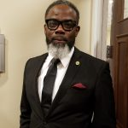
Genesis 18:19 For I have chosen him, that he may command his children and his household after him to keep the way of the LORD by doing righteousness and justice, so that the LORD may bring to Abraham what he has promised him.”
PARENTING IS A TOUGH JOB! Ask any serious parent or grandparent and they will tell you it is among the toughest jobs you’ll ever encounter. A few tips have been copied and are here for your convenience.

- Set realistic expectations for the age of the child.
- Be a good role model.
- Build strong family ties. Live out your Christian values on a daily basis. You must be kind, honest, respectful and fair.
- Encourage good behavior.
- Keep rewards simple. Children must have chores and responsibilities; they do not need a reward or pay for everything they do.
- Clear rules and limits should be explained as they should protect the child’s health and safety.
- Set and apply fair consequences. Tell your child in advance what will happen when rules are broken. Stay firm.
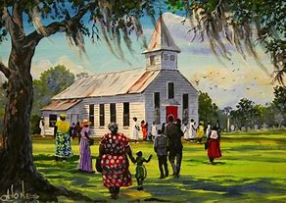
- Teach responsibility. Give each child some type of work to do. No, do not pay them to be a part of the family and to do what is expected of them. They must learn and they learn by doing!

The Scriptures below will help you and your children in school. You may google and find others or flip through your Bible, the best source of information for taking care of your family. If possible, make daily Bible reading with your children a priority.
Proverbs 22:6 Train up a child in the way he should go; even when he is old he will not depart from it.
Isaiah 54:13 All your children shall be taught by the LORD, and great shall be the peace of your children. .
WOMEN OF MOUNT PISGAH
LOTT CAREY 2018

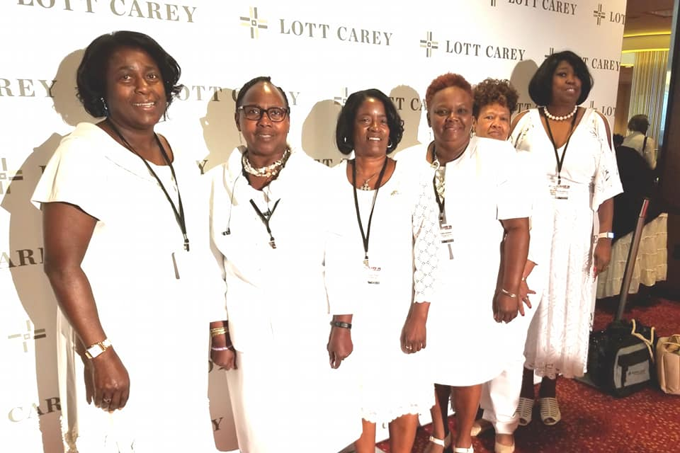
(l-R) Sis. Marie Daniel, Rev. Vermatine Williams, Evangelist Essie Johnson, Sis. Callie Graham, Deaconess Toby Chavis and Deaconess Machalle Love (others were in attendance but not pictured)

Church membership and fellowship are favorably fostered when opportunities are used to travel and learn together. It’s as the childhood song states, “The More We Get Together the Happier We Will Be!”

HOMECOMING
SUNDAY, OCTOBER 21, 2018

In a few weeks, it will be time for our annual Homecoming celebrations. Now is the time to reach out to our family and friends who live in other places. Invite them to come home and celebrate with us. Mount Pisgah has much to celebrate; continuing as an organized Body of Christ is such a blessings. Come and worship with us.

Mark 5:19 Howbeit Jesus suffered him not, but saith unto him, Go home to thy friends, and tell them how great things the Lord hath done for thee, and hath had compassion on thee.
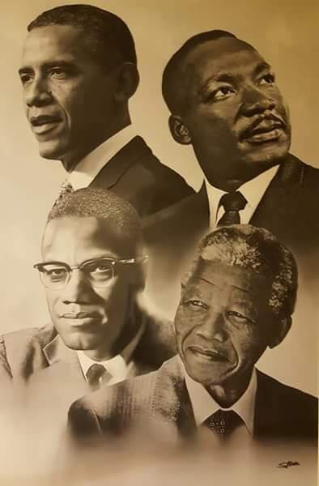
Students – Four Great Men, do you know who they are and what are some of their accomplishments?

(Please do not use the “I have a dream speech as that’s about all that is taught about Dr. MLK in schools.)” Suggested book: Why We Can’t Wait. By Dr. MLK, Jr.

Each man contributed to society in different ways. Name some of them. Talk with your parents and guardians about this picture and what you think it means. Have you ever discussed either of the men with any of your friends? How do you feel when the subject comes up in school?

Copied from TeeMac’s Facebook Page

Just because you fall down is no reason to stop growing. Grow in your environment! You can and should achieve great things. Trust Christ, your Savior, He will lead and guide you.
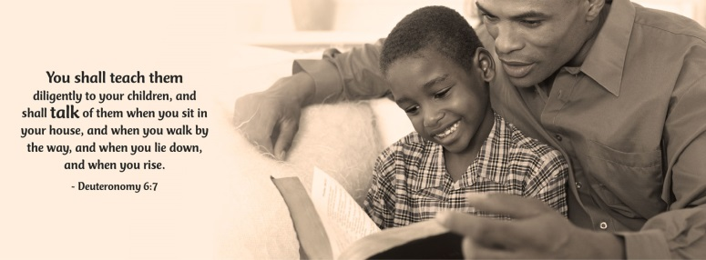

CHURCH IS A FAMILY AFFAIR
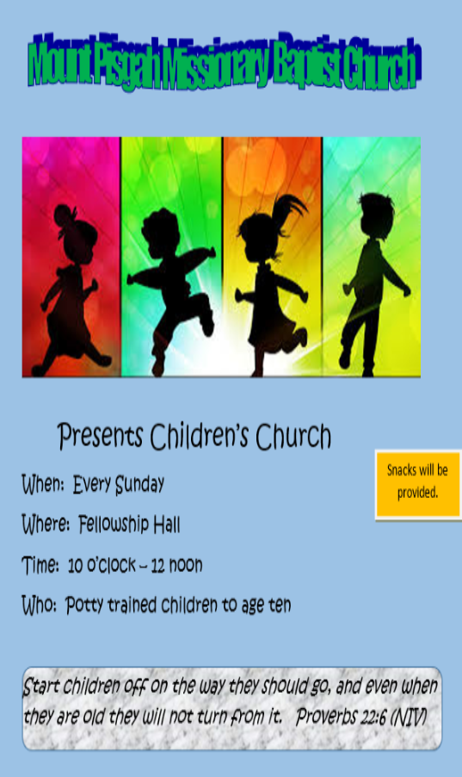

In Mount Pisgah, there is a place for every one of all ages. Bring grandparents, parents, children, and yes, even babies. All are welcome and there is a place for each and every one! Come to Sunday School, Bible Study, Choir and Usher rehearsals, and all other ministries. You are wanted and needed. Recruit and bring back members who are not attending another church or who let their membership drop. The roll was purged in 2015 and again in 2017. Some of your family members definitely are NOT on the roll. They need to rejoin if they wish to be an active member of the fellowship in Mount Pisgah Missionary Baptist Church.

A FAVORITE PICTURE
COPIED FROM FACEBOOK

The older child looks like young pictures of Keith Owens and Nick Mintz (yes my relatives). You can see the love for the baby in the face of the older child. This exemplifies the positive type pictures that we (Blacks) once desired so much to see. It is good to see them now. Thank God!

The wolf also shall dwell with the lamb, and the leopard shall lie down with the kid; and the calf and the young lion and the fatling together; and a little child shall lead them. .Isaiah 11:6
Just What The Doctor Ordered

This column is dedicated to Mental Wellness. It is very important that we all attempt to maintain optimal health in EVERY aspect of our being—Mind, Body, and Soul. That being said, here we will primarily focus on being the best person we can be mentally, emotionally, and behaviorally. We will cover topics such as Stress, ADHD, Dementia, Anxiety, Medication Management, Depression, Mental Exhaustion, and many more. We will also make effort to remove the stigma associated with mental health, mental illness, and seeking help for mental disorders. Secondly, we embrace those suffering from mental and emotional illnesses, who have been afraid to seek help, those whose challenges may have been demonized by others, who have been discouraged from receiving medication to treat their illness(es), or who have been made to feel ashamed for having conditions that are beyond their ability to control.

If there are topics, questions, concerns, and/or interests you’ would .like discussed, please let me know.

Let’s begin by discussing a topic that impacts both called ADD (Attention Deficit Disorder), when the center of attention was on the inability of a person to sustain their Focus or Attention without being distracted.

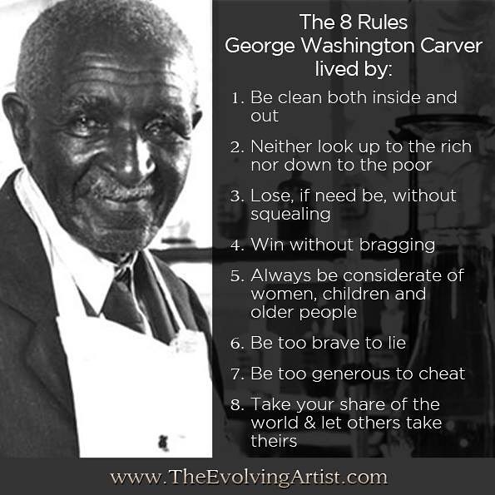
After several revisions of the “Diagnostic and Statistical Manual of Mental Disorders” (DSM), which changed the name of the disorder several times, in 2000 the APA changed the name of the disorder to Attention Deficit Hyperactivity Disorder and also developed the three subtypes of ADHD used by healthcare professionals today:

- Predominately Inattentive Type ADHD: Inattention means a person wanders off task, lacks persistence, has difficulty sustaining focus, and is disorganized; and these problems are not due to defiance or lack of comprehension.

2-Predominately Hyperactive -Impulsive Type: Hyperactivity means a person seems to move about constantly, including in situations in which it is not appropriate; or excessively fidgets, taps, or talks. In adults, it may be extreme restlessness or wearing others out with constant activity.

Impulsivity means a person makes hasty actions that occur in the moment without first thinking about them and that may have high potential for harm; or a desire for immediate rewards or inability to delay gratification. An impulsive person may be socially intrusive and excessively interrupt others or make important decisions without considering the long-term consequences.
3- Combined Type ADHD: A combination of Inattention and Hyperactivity/Impulsivity.

Whether seeing patients or presenting at a workshop, I am often approached by parents who believes they or their child may have ADHD, but they have been told by others “Don’t put him/her on medication;” Just pray for him/her;” Or one of my least favorites: “Just spank him/her.” ADHD, like other illnesses, physical and mental alike, is an illness, not willful, inappropriate behavior. A child or adult with ADHD is no more responsible for having this illness than a person is for having asthma, a heart murmur, or cancer. People suffering need our support, not our criticism and judgment.

Furthermore God has blessed us with diverse gifts. There are countless professionals—those who are able to fix and build, those who can teach and tutor, and those who are able to sing and act, just to name a few. Mental Health Therapists and Counselors are here to bring healing to the mind, as similarly physicians bring healing to the body, and ministers provide healing our souls. Ultimately, our gifts are manifested most greatly when we use them to bless and help others. This is just what the doctor ordered. Stay blessed!

Dr. Adrienne O. Monroe, Clinical Director/Co-Owner, A Peace of Mind, Body, & Spirit Counseling and Consulting, PA

Peace I leave with you, my peace I give unto you: not as the world giveth, give I unto you. Let not your heart be troubled, neither let it be afraid. John 14:27

CROWNS IN MOUNT PISGAH
WOMEN’S DAY

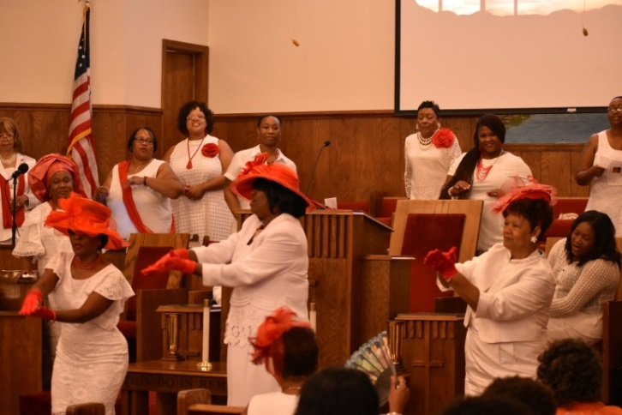
The Women’s weekend was a success in Sisterhood!

National Grandparents Day in the United States
Many families in the United States observe National Grandparents Day on the first Sunday of September after Labor Day. This day honors grandparents.

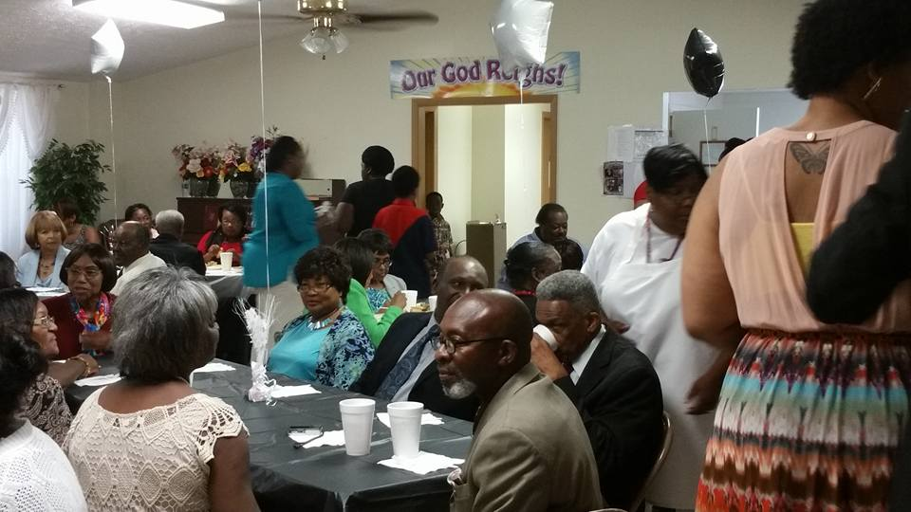

Take time and wish the grandparents in your life and in your church a Happy Grandparents Day!

Stop by the Museum Booth and learn more about Hoke County. We need volunteers to be able to open additional hours. Consider joining the Museum. We just learned that Precious Haven, Inc. and Sister Phyllis Wallace will have booths this year. Blankets by Phyllis will make great Christmas gifts.
A Friends Poem
by Catina Hamm

I said a prayer for you today
So Jesus would help you on your way
I told him you were my best friend
And begged him to protect you until the end
I told him how you were there when I cried
And how you helped me not to lie
I told him you helped me know right from wrong
I told him your friendship kept me strong
I asked Jesus to steady your hand
So you would not raise it to woman or man
I asked Jesus to hold your tongue
So you would show kindness to everyone
I asked Jesus to surround your soul
So that it would never be evil or cold
I asked Jesus to protect my best friend
So we could hang out again
I thanked Jesus for the times we had shared
When you were the only one that was there
I thanked him for the times you talked to me
For the silver lining that only you could see
I thanked him for the times you had my back
The way you helped keep me on track
I thanked him that you could see
The goodness that lies inside of me.
The times you pulled me out of despair
Thank God that you were there.
Submitted by Stephanie Sutton
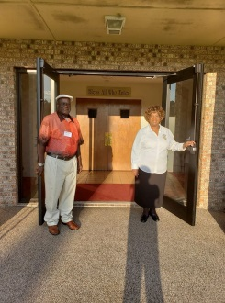
MOUNT PISGAH’S DOORS ON WELCOME HINGES

Each Sunday at 7:55 a.m. you can depend on at least two individuals to greet you as you enter the building. People may change, but the welcome is always friendly and warm. Sister Willie Artis and Brother Robert Spears were on duty the 4th Sunday in August. Thanks for a job well done!
KIM WILSON ON TV

As buses for Cumberland County Schools began rolling a few days ago, Kim Wilson was on point. In the interview she asked drivers to slow down and protect the students. It’s always good to see our Church members in positive roles.
IT ISN’T THE CHURCH, IT’S YOU

If you want to have the kind of a church
Like the kind of a church you like,
You needn’t slip your clothes in a grip
And start on a long, long hike.
You’ll only find what you left behind,
For there’s nothing really new.
It’s a knock at yourself when you knock your church;
It isn’t the church — it’s you.
When everything seems to be going wrong,
And trouble seems everywhere brewing;
When prayer meeting, Young People’s meeting, and all,
Seem simmering slowly — stewing,
Just take a look at yourself and say,
“What’s the use in being blue?”
Are you doing your “bit” to make things “hit”?
It isn’t the church — it’s you.
It’s really strange sometimes, don’t you know,
That things go as well as they do,
When we think of the little — the very small mite —
We add to the work of the few.
We sit, and stand around, and complain of what’s done,
And do very little but fuss.
Are we bearing our share of the burdens to bear?
It isn’t the church — it’s us.
So, if you want to have the kind of a church
Like the kind of a church you like,
Put off your guile, and put on your best smile,
And hike, my brother, just hike,
To the work in hand that has to be done —
The work of saving the few.
It isn’t the church that is wrong, my boy;
It isn’t the church — it’s you.
Author, “Unknown”, Copied from the book, “Best Loved Poems of the American People”
PICTURE
A MINI SERMON

Rarely, do we think of how the younger people are watching us older ones. We do not remember more lessons are caught than are taught.

Would we do better if we stopped to think that the young ones are watching and patterning their lives after ours?

MEMORIALS
(Editorial)

Mount Pisgah has had five good men go to their rewards so far this year. I cannot remember any other season of so many men from our church passing in such a short time.

On the 9th of March Brother Ralph Hooper finished his course. A few days later Brother Pernell Kelly peacefully made his transition. It seems as if we didn’t really have time to adjust before Brother Roosevelt Daniel, after a lengthy illness, passed. Days later we lost a good soldier, the Reverend Jesse L. Timmons. Before a week passed, one of the oldest members of our congregation, Deacon John W. Blue crossed over.

We know that God knows best and He never makes a mistake; yet, that does not make it easier for those who have lost loved ones. We laugh and cry. Memories have a way of making us think more of the good and less and less of the sad days. With that in mind, we trust God and continue with the business of living. We strive to encourage their children, spouses along with other relatives and friends.

We extend our deepest sympathy to the families who have suffered recent losses. We pray God grants you the strength to carry on and to remember it is He who gives life.
“Let not your hearts be troubled. Believe in God; believe also in me. In my Father’s house are many rooms. If it were not so, would I have told you that I go to prepare a place for you? And if I go and prepare a place for you, I will come again and will take you to myself, that where I am you may be also. And you know the way to where I am going.”
John 14:1-4
SUPPORT THE HOKE READING LITERACY COUNCIL
Forty years ago Hoke Reading/Literacy Council became a reality. It is time to celebrate the early visionaries, the many volunteers, and especially those who increased their literacy skills. It is also time to ensure that those still in need of basic literacy and technology skills have the opportunity to acquire them. To do this we are asking you to give at least $1.00 (one dollar) for each year that this organization has provided literacy services to those most in need of them. We hope that you will make a donation of $40.00 or more by September 5, 2018.
The definition of literacy is rapidly expanding. Health, financial, and cultural literacy are just a few of the many challenges those with limited reading and technology skills face. Imagine the adult who lives in fear of taking the wrong medicine or can’t read the pamphlet that explains which foods are harmful. Think of the child who needs extra assistance with reading, but there is no one in the home able to help and there is no available technology. Hoke Reading/Literacy Council is the only place in Hoke County where adults and school-age students can get the help they need on a schedule that allows them to fulfill their other responsibilities. Open enrollment is always available and there is no cost to the participant.
When you support literacy, you are helping to underpin the American way of life. Those lacking literacy skills are more likely to be unemployed or under employed, thus needing government assistance. They are less likely to vote or vote independently, thus a threat to true democracy. They are also less likely to be involved in social/civic organizations, thus leaving fewer volunteers and resources to meet the unique needs of their communities. A low literacy level lowers the standards for us all. Please help us to continue to work toward the literacy level required in today’s world. Your support is greatly appreciated.
Reverend Barry O. Shoffner, Chairman

Show me your ways, LORD, teach me your paths. Guide me in your truth and teach me, for you are God my Savior, and my hope is in you all day long. NIV
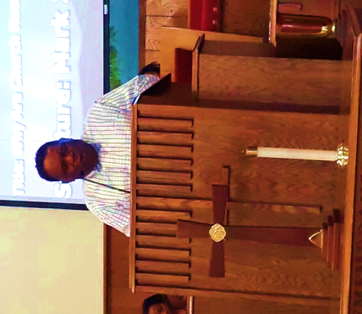
Annual Summer
Revival

\What a glorious time in the Lord! Reverend Perry Irby, Pastor of Restoration MBC, led the three-night Revival at Mount Pisgah, August 20-22, 2018.

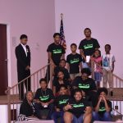
Reverend Irby took us from the barnyard to the altar! On Monday night, coming from Mark 14, he preached about Crowing Roosters that infiltrate our lives, our relationships, our nations, and yes, the church. Crowing Roosters usually indicate a fall or a failure, but recognize it, repent and keep going; Christ’s love is greater than our fall. The second night, he preached about Weeping in the Church, again using Peter as the example. When Peter looked at Jesus and realized he had denied Him, he wept bitterly. So many things cause us to weep, whether caused by others or by our own actions; we weep. The church of the living God is weeping today because of the things going on in the church. Roosters are crowing and the church is weeping but God has the answer and Pastor Irby told us on the last night that the cure for all that’s happening is prayer. He took us to Peter before the scene of the rooster crowing, back to the upper room where he tells Peter, I have prayed for you. Although brash and bold, Peter did not know what lay ahead of him, but Jesus did. He knew Satan was going to attack Peter and he would fail, but He prayed to strengthen him. Therefore, the word for the last night was, The Church Needs Prayer. Because the church and we individually are constantly under attack, we need the power of prayer to strengthen us, empower us, and sustain us, saying that The Best Defense is a Prayer Fence! Thank God for the Revival and thank God for sending Reverend Irby with not only a rich word, but a powerful, needed word! To God be the glory!
Rev. Mary C. Owens, Christian Education Director

Psalm 111:10 - "The fear of the LORD is the beginning of wisdom: a good understanding have all they that do his commandments: his praise endureth forever."
(Flash back to 2017 photo of young people of the Church)
Where kids Connect with Jesus!
Children’s Church Ministry Moving to Every Sunday
For over two years, the Children’s Church Ministry (CCM) has been having CCM only on third Sunday, but under the leadership of Pastor F. Bernard Fuller, will soon become a reality of having it every Sunday. Children’s Church is a worship and teaching experience designed to serve the learning and listening needs of younger children, from ages 4-10 years old. CCM takes place during the same time as regular worship service, 10:00 a.m.-12:00. The staff is well-trained to provide for the children left in their care. Children will participate in Bible lessons geared to their level of learning and understanding. There will be three classes: 3-5 years old, 6-8 years old, and 9-10 years old. They also engage in music ministry, playtime, snack time, and are presented a sermonette that aligns to their lesson for the day. Parents, we encourage you to bring your little ones to this safe, secure and nurturing environment which allows you to enjoy your worship time without distractions or interruptions while they too participate in a worship service just for them. Everyone wins!

Reverend Mary C. Owens, CED

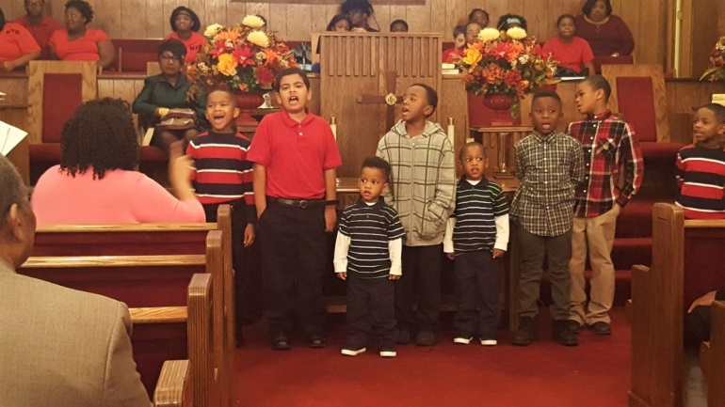
Luke 18:16 NIV
But Jesus called the children to him and said, "Let the little children come to me, and do not hinder them, for the kingdom of God belongs to such as these.

Homecoming 2018
It’s that time of year again. As manicured lawns, lush vegetation and leafy trees take on the vibrant colors of Fall, and as early mornings become cool and brisk, we know that Homecoming is just around the corner. Homecoming celebrates the anniversary of the church, and this year, we are celebrating 118 years within the Puppy Creek Community.

Homecoming, one of the most important events in a church, embodies the history, heritage and longevity of a church. It is a time for coming together and celebrating the goodness of the Lord in favoring and blessing us for bringing us through one more year. It’s also a time for reflecting upon how far God has brought and sustained us from its founding in 1900 when the church was just a Brush Arbor, nothing more than a crude shelter of tree limbs, branches and bushes, and sometimes, chicken wire. When I think of Brush Arbors, I’d like to see one constructed just so all of us, not just the younger generation, could see how rough and tough it was for our founding fathers. Maybe, it would remind us how blessed we are to have central air and heat, running water, and electricity. Maybe it would remind us that once upon a time our music came from wash boards and homemade string instruments, no piano, no organ and no sound systems, just good old handclapping and foot stomping. Homecoming also causes me to reflect upon the richness of our church history, from the time Reverend Anderson McNeill was led to this site which was nothing but a vast sea of pine trees and viewed it as Moses did the Promised Land, from which the church name was derived, Mt. Pisgah.

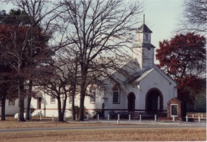
It also invokes the struggles, challenges and victories of the church, such as being burned to the ground twice, being bombed in the 90’s by a Molotov Cocktail, the result of racist, hate crimes, and finally, overcoming and surviving the devastation of impending foreclosure in 2015. Finally, Homecoming celebrates the ingenuity, fortitude, and faith of people in this rural community who worked the farms during the day and worked on building the first stucco building in 1956. With little money but armed with Grit and God, they succeeded! Today we celebrate them and glorify God for all that He has done!
Rev Mary C. Owens, Christian Education Director

2 Corinthians 5:9-19 … But neither exile nor homecoming is the main thing. , Cheerfully pleasing God is the main thing, and that's what we aim to do, regardless of our conditions.
God’s Amazing Grace

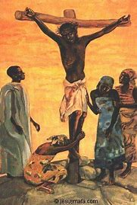
It has been said that our lives we are often affected by certain events or even one event that has a profound affect upon us, one that sometimes causes us to change the course of our lives or at least causes us to modify our lives. I can think of several life changing events, such as getting married, having your first child, but for most of us who are disciples of Christ, that life changing experience takes place when Christ enters our lives and offers us the beautiful gift of salvation. Hopefully, a transformation takes place within us wherein we accept the belief that it is no longer I who live, but Christ who lives in me. We are no longer ruled by our own selfish desires or wishes, but instead, we ruled by a desire to please God and a hunger to be like Him. Much like the ugly, repulsive caterpillar who changes to the beautiful, breathtaking butterfly, we are changed from the sinful, disgraced creature into a transformed soul graced with the beauty of God’s holiness. As we grow through this process, we will continue to miss the mark, to fall, to sin, but God’s amazing, wonderful grace again and again comes to rescue us, dusts us off and restores us, when we repent. When I think of God’s love for me, I am reminded of the hymn writer who proclaims: …I do not know just why He came to love me so; He looked beyond my faults and saw my need .... How marvelous the grace that caught my falling soul. He looked beyond my faults and saw my need.
Rev Mary C. Owens

ANNOUNCEMENTS

The Hoke County Civic League will resume meeting Monday, September 10, 2018 at 7:00 p.m. in McLauchlin Chapel Church. Pastors and the Executive Board meet at 6:30 p.m. Everyone is invited to attend and to participate. You do not be a citizen of Hoke County to attend and become a member.

The Hoke County Missionary Union will meet in its annual session on Sunday, September 23, 2018 in Laurel Hill Missionary Baptist Church. The annual session begins at 3 p.m. The president will give her annual address. Ladies are asked to wear white; however, do not let that prevent you from attending. Come dressed as you wish and be blessed.
BE AN INFORMED CITIZEN, KNOW THE CANDIDATES.

VOTE AS YOU PLEASE, BUT PLEASE VOTE
Church member Darryl Shaw, Sr. is in need of kidney transplant. Help can be given in many ways to include being tested to become a donor on the national register or donating to the fundraiser in honor of Darry Shaw. .Information is posted on the Church Bulletin Board or contact local chairman Ellen McNeill, 910-875-3237. All donations are tax deductible. To do an online secure deduction, www.transplants.org click on “Find a Patient” and search for Darryl. Above all, keep the Shaw family in prayer, as we are praying for a successful outcome.
LOOKING AHEAD
- Veterans Day. November 11, 2018,
- Thanksgiving Worship Services Thursday, November 22, 2018at 11 a.m.
- Christmas Day Worship Services, Tuesday December 25, 2018 at 11:00 a.m.
NEWSLETTER STAFF
Ellen McNeill, Editor 910-875-3237
Reverend Mary C. Owens 910-670-5662
Deacon Joseph Johnson 910-425-3709
Reverend Arlane McKoy 910-875-3325
Sister Melissa McAllister 910-308-6067
Sister Marie Daniel 910-875-5146
Sister Denise Wallace 910-257-1678
Sister Stephanie Sutton 910-488-3087
Welcome Dr. Adrienne Monroe contributing writer

