**The Voice**

***Mount Pisgah Missionary Baptist Church, 414 Pittman Grove Church Road, Raeford, NC 28376***

***Reverend F. Bernard Fuller, Pastor Telephone 910-875-7544 or 875-2669 Fax 910-875-0053***

***Website: mountpisgahmbc.com email:*** [***mtpisgahraeford@gmail.com***](mailto:mtpisgahraeford@gmail.com) ***98th Edition November – December 2018***

***----------------------------------------------------------------------------------------------------------------------------------***

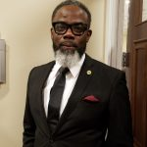**Jesus the Light**

**of the World**

The story of Jesus’ birth, life and resurrection is periodically told in sketches, and especially during this time of the year. It is always good to remind believers, as well as non-believers, of the miracle of the birth of Jesus. It takes an abundance of faith to know the story, accept it and to live by the principles that Jesus taught in the beatitudes, as recorded in Matthew Chapter 5. A few Scriptures are shown for your immediate reference:

* ***Blessed are they which do hunger and thirst after righteousness for they shall be filled.***
* ***Blessed are the merciful, for they shall obtain mercy.***
* ***Blessed are the pure in heart for they shall see God,***
* ***Blessed are the peacemakers for they shall be called the children of God.***
* ***Blessed are they which are persecuted for righteousness sake for theirs is the kingdom of heaven.***

Christmas time is perfect for reading the stories of Jesus and why we worship Him. It is a joyous time as we visit with family and friends, and a time to do self-examination to determine within ourselves if we are living to live again. My desire for you is love, peace and joy.

***“For unto us a child is born, unto us a son is given: and the government shall be upon his shoulder: and his name shall be called Wonderful, Counsellor, The mighty God, The everlasting Father, The Prince of Peace.” Isaiah 9:6***

**Usher me into the presence of the Lord**

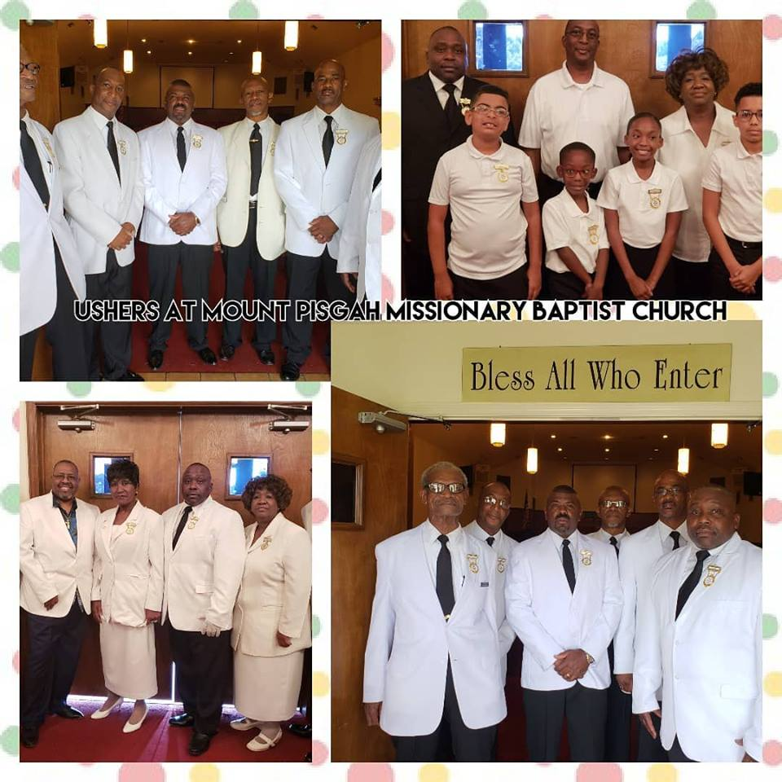

**Usher me, there my healing can begin**

**Usher me, there my broken heart can mend**

**Usher me, I need to be restored**

**So usher me into the presence of the Lord***...*

*(Lyrics copied from the Internet).*

Mount Pisgah Church is blessed to have teams of ushers to invite others to enter into the House of the Lord. They arrive early, stay late, assist others as needed and share in the worship services. It is a joy to see the youngsters ushering. They are learning and show the love and excitement of working in the Church. Many of our adults could learn from their examples of “ushering us into the presence of the Lord.”

[**Psalms 84:10**](https://www.kingjamesbibleonline.org/Psalms-84-10/) - ***For a day in thy courts [is] better than a thousand. I had rather be a doorkeeper in***[***the house***](https://www.kingjamesbibleonline.org/Bible-Verses-About-Doorkeeper/)***of my God, than to dwell in the tents of wickedness***.

**Aaron Thomas**

**Reading to children**

Aaron, the grandson of Rev. Vina and Trustee John (Jake) Clark, is a reporter with WRIC-TV in Richmond Virginia. He is shown reading to kindergarten students in the Patrick Henry School of Science & Arts in Richmond.

February is the month of the African-American Read-In and this is an opportune time for someone to step forward. Time is of the essence as they will need to plan, prepare and be ready in February. Men need to encourage Black children to read and to excel in school. Too many of our people rely on the TV and phone for our news, which may not be accurate. We need to know reliable sources of information and to dig for the truth.

**HAPPY THANKSGIVING**

We are grateful for our friends, family, love and laughter, along with sweet blessings and happy memories. We pray God blesses each and every one of you this Thanksgiving and in years to come.

This Thanksgiving give more time to your family, friends, church members and business associates than you do to half-time!

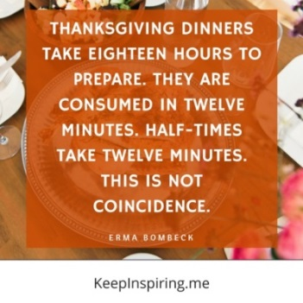

***The Hadley Family walks with Puppy Creek Fire Department Cancer Walk***

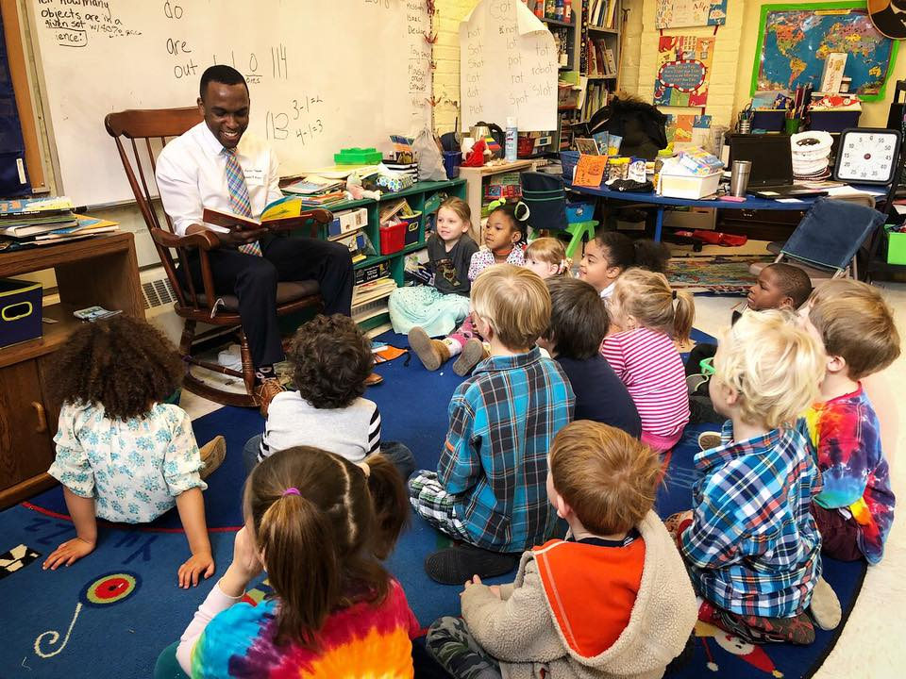

This is the second year that the Hadley Family participated in the Puppy Creek Fire Department Breast Cancer Walk. This is another good example of community support by members of our Church. Thank you for representing us.

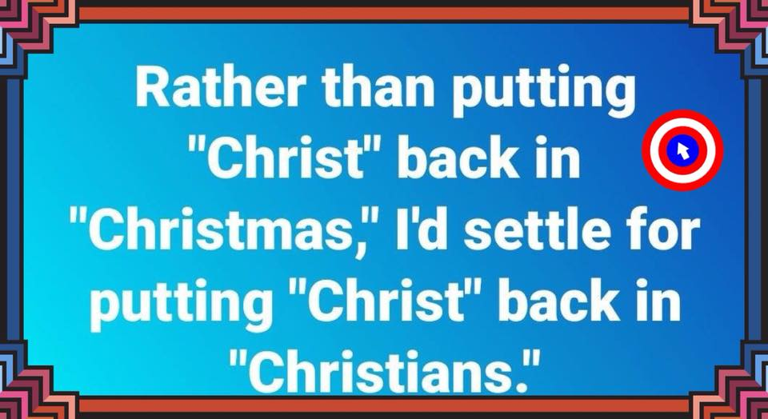

**A CHRISTMAS BLESSING FOR YOU**

May Jesus, our Savior

Who was born on Christmas Day,

Bless you at this season

In a very special way.

May the beauty and the promise

Of that silent, holy night

Fill your heart with peace and happiness

And make your new year bright.!

Helen Steiner Rice

**Eating Good Over the Holidays and**

**Into the New Year**

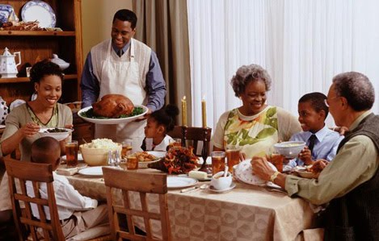

**1. Budget wisely.** Don’t eat everything at feasts and parties. Be choosy; eat the foods you love in moderation.

**2. Take 10 before taking seconds.** It takes a few minutes for your stomach; therefore, after finishing your first helping, take a 10-minute break. Make conversation. Drink some water

**3. Distance helps the heart stay healthy.** At a party, don’t stand next to the food table. That makes it harder to mindlessly reach for food as you talk.

**4. Don’t go out with an empty tank.** Before setting out for a party, eat something so you don’t arrive famished. Excellent pre-party snacks combine complex carbohydrates with protein and unsaturated fat, like apple slices with peanut butter or a slice of turkey and cheese on whole-wheat pita bread.

**5. Drink to your health.**  Drink more water and fruit juice.

**6. Avoid alcohol**.

**7. Put on your dancing (or walking) shoes.** Dancing is a great way to work off some holiday calories. If you are at a family gathering, suggest a walk before the feast or even between dinner and dessert. Line dancing is really great exercise that is clean and wholesome fun.

**8. Make room for veggies.** At meals and parties, don’t ignore fruits and vegetables. They make great snacks and even better side or main dishes — unless they’re slathered with creamy sauces or butter.

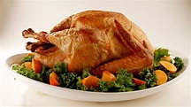**9. Be buffet savvy.** At a buffet, wander ’round the food table before putting anything on your plate. By checking out all of your options, you might be less inclined to pile on items one after another.

**10. Don’t shop hungry.** Eat before you go shopping. Use a list to save time and money.

**11. Cook from (and for) the heart.** To show family and friends that you *really* care about them, be creative with recipes that use less butter, cream, lard, vegetable shortening, and other ingredients rich in saturated fats and cholesterol. Prepare turkey or fish instead of red meat.

**12. Pay attention to what really matters.** Although food is an integral part of the holidays, put the focus on family and friends, laughter and cheer. If balance and moderation are your usual guides, it’s okay to indulge or overeat once in a while.

**Right Now Media**

Members, did you know we have a church subscription to **Right Now Media**? Just what is Right Now Media? It is an online Christian Media/Video Resource Library with over 10,000 discipleship videos for kids, youths and adults! We use it in some of our Sunday School and Bible Study classes, but by being a member of Mount Pisgah, you can also use it at home. Our children and youth are in the age of digital games and interactive technology, so why not offer them some positive alternatives to the usual secular games, movies and videos? Right now, the Youth Bible Study Class is viewing and studying the life of Moses as a Bible hero while the Adult Bible Study is studying Moses in the Book of Exodus. You can do the same thing at home simply by getting your login to the church membership site. See Reverend Owens, CED for details as to how to sign up.

**VETERANS DAY**



President Ronald Reagan, during his presidency, explained why Armistice Day is now known as Veterans Day., which commemorates the armistice that ended the First World War. It was the 11th hour of the 11th day of the 11th month of 1918. Many individuals believe that it is a day for shopping for bargains, sleeping in or a day from the job. It is much more. It now celebrates all who have served in any branch of the USA’s armed services. It is a time to say thank you to veterans.

Veterans in Hoke County hold two services each year on the Court House grounds, Memorial Day and Veterans. Veterans Day services will be at 11 a.m. on Monday, November 12, the legal holiday.

Our Church will honor veterans on the 11th in worship services. Veteran speakers have been asked to attend and to bring an address or message. Before the 10 a.m. services, the Honor Guard of the Hoke County Sheriff’s Office will post the colors.

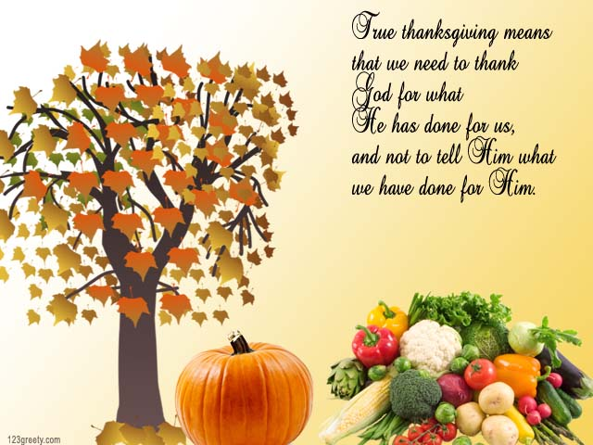

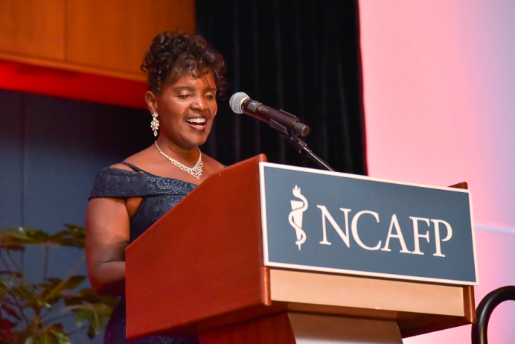

**Holiday Financial Planning**

How can you be a cheerful giver during the holidays and avoid bringing in the New Year with expenses incurred from Thanksgiving and Christmas?

As the holiday season begins, many families find themselves burdened with excessive debt. The average family will spend between $200-$400 dollars on Thanksgiving dinner alone. Then the highly publicized **“Black Friday and Cyber Monday” may become a “depleted account or credit card nightmare”.** Each year consumers declare that next year will be different and they will not overspend during the holidays.

Consider the context from **Proverbs 22:7 “The rich rules over the poor, And the borrower becomes the lender's slave”.** Is your financial situation one that questions your debt to income ratio? And who is the true holder of your monetary gains? We should be in a financial condition that allows helping others less fortunate and not indebted to credit card companies and retail commerce.



**Tips for holiday spending include:**

1. Write down the menu and amount of money to be allotted for Thanksgiving and Christmas meals.

2. Make a list of loved ones and expected gifts with the total amount planned for each individual. Avoid shopping sprees.

3. Do not procrastinate on making purchases, buy single gifts and not on impulse. The gifts will have more meaning to you and the receiver.

4. Study Black Friday and Cyber Monday prices as some prices will go down later and are not a deal.

5. ***Pay monthly bills before shopping.***

6. Make homemade gifts using craft ideas.

7. Do not feel guilty about giving when you do not have the funds.

7. **Above all, tithe to the Lord and** **remember someone less fortunate than yourself and bless them during the holidays.**

***Give Thanks unto the Lord and Celebrate the Birth of Jesus Christ for the Holidays!***

***Sister Pam Shaw***

***Dr. Karen Smith at the Toast and Roast in Raleigh***

Dr. Smith, the immediate past National Family Physician of the Year, speaks at the annual fundraising event for scholarships for medical scholars.

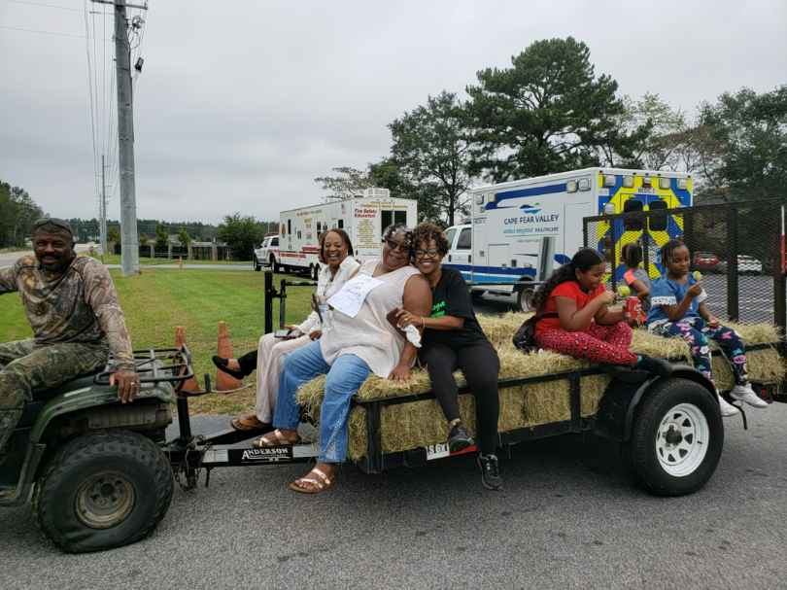**HISTORICAL FESTIVAL & HEALTH FAIR**

Appropriately, the Mount Pisgah Historical Festival was born out of a desire to celebrate the **history, heritage and struggle of our people beyond the designated Black History Month. The** original idea was to hold the Festival about every five years to show younger generations how we once lived and how far God has brought us. Many of us can remember pumping water from a hand pump or getting water from springs or creeks, as well as having to use outdoor toilets, because most of us did not have indoor facilities or running water.

I remember being in ninth grade before we finally had indoor facilities. The average child now has his or her own cell phone, but we didn’t even get a house phone, party line, until I was a freshman in college. Growing up, many of us girls wore dresses made from sackcloth. Feed for farm animals was often packed in colorfully printed sacks which our mothers would then use to make dresses.

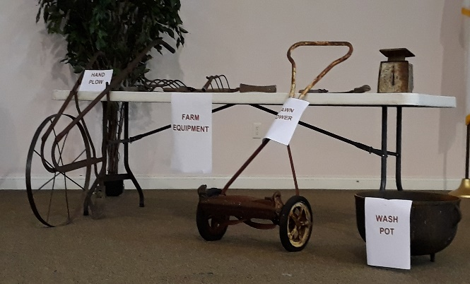Several farm and household tools were on display depicting the way we once lived and struggled. It was humorous to hear someone asks, “What’s an 8-track tape?” Or to see a meat grinder used for making sausage, pudding, souse meat and other meat products.

This year, The Festival and Health Fair were combined as a community event with a focus on raising health awareness for our families and church. Vendors were there from the Hoke Health Department, which included giving flu shots; the Sheriff Department which made children IDs for safety purposes, and the Kidney Foundation for promoting awareness for need of kidney transplants. Of course, there was fun for the children, a bouncy house, a barrel train, and most of all, the hay rides provided by Brother John Baker. Finally, it was great food everywhere with the highlights being Brother Story’s finger licking good pulled pork and ***Brother John Carroll crowned Chili Cook-off Champion!***

It was a good turn out from the community and we hope some left being more aware of our history, as well as being more informed about health issues and community resources.

***Reverend Mary Owens***

**A CHRISTMAS THOUGHT**

If there had never been a Christmas or the Holy Christ Child’s birth,

Or the angels singing in the sky of promised peach on earth,

What would the world be like today with no eternal goal?

What would the temporal body be without a soul?

Just what would give us courage to push on when hope is dead?

Except the Christmas message and the words our Father said---

Except the Christmas message and the words of our Father

***“In love I send My only son to live and die for you, and through His resurrection you will gain a new life, too.”***

**By Helen Steiner Rice book, Christmas Blessings**

**HOMECOMING 2018**

Family and friends celebrated the 118th Homecoming Anniversary of Mount Pisgah MBC which was chaired by Reverend Rosaland Loyd who went all out to make it a memorable occasion. The Homecoming Theme was: *Preserving the Legacy of Jesus Christ: His Love, His Word, His Church.*

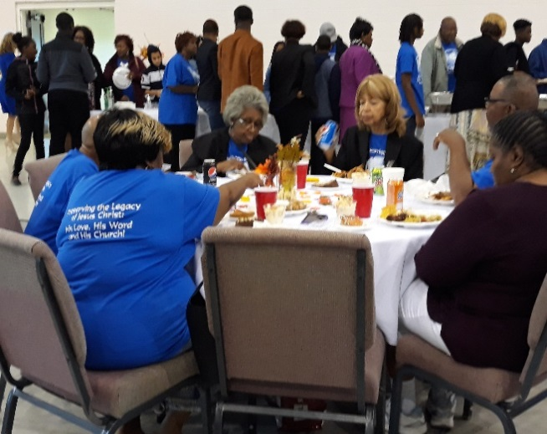We celebrated and honored God for sustaining us these many years through good times and bad times, through sunshine and through adversity. The day began with the 7:55 Worship Service with the guest minister being Reverend Kenneth Kelly, a son of the church and pastor of Nashville MBC. The day continued with Reverend Rayvonda Rowe, an associate minister at Leach Springs MBC, providing the sermonic message at the 10:00 service.

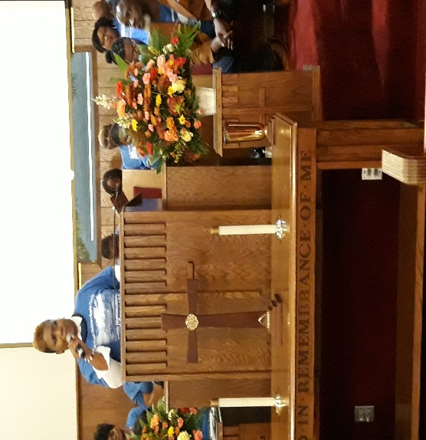

Afterwards, the congregation and guests gathered at the CRC for great food and great fellowship.

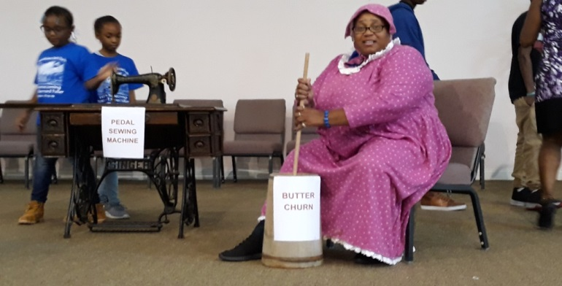

Returning member, Linda Head, graced the stage as her great-great grandmother, Ida Holliday McNeill, wearing an 19th Century calico dress and bonnet while sitting at the butter churn, simulating churning butter. Other home and farm tools were still on display for children to glimpse what life was like when Reverend Anderson McNeill founded the church 118 years ago, as well as other artifacts used down through the early part of the 20th Century. Parents took their children up to look at life the way it was. God has truly blessed us, preserved us and kept us down through the years, and we trust that He continue to bless and keep us as a faithful body of Christ***. Reverend Mary Owens***

***A picture from the past for you to identify the individuals***

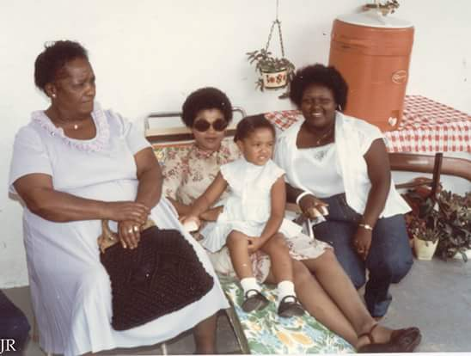

**“So now I am giving you a new commandment: Love each other.  Just as I have loved you, you should love each other.  Your love for one another will prove to the world that you are my disciples.”**  John 13:34-35

.

From the Chorus of *I Want to Say Thank You* by Lisa Page Brooks: *“I'll be thanking You and praising You for the rest of my life, for I've come to know the power of your love and sacrifice. Thank you for your sacrifice, I appreciate all that you do. Everything You do, and I want to say, thank you”*

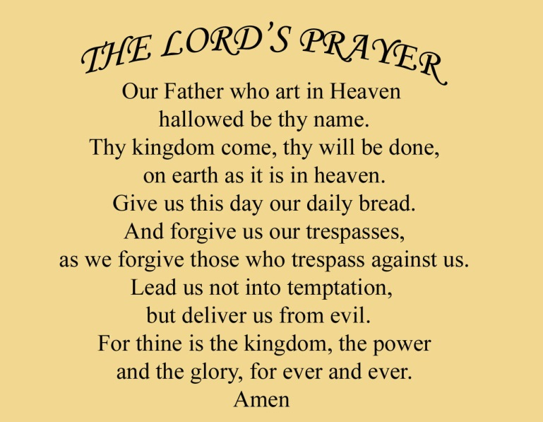November is a terrific month to begin a year and lifetime journey of taking a moment to daily thank God for all of our blessings and for the sacrifice of His son, Jesus Christ. During times of trials and life struggles, taking time daily to simply thank God for the small blessings and wonders of life will soar into acknowledging the many, fabulous blessing that we do not realize God has bestowed upon us.

Sometimes there are questions about being thankful. How can I be thankful when I have lost my job, when I am terminally ill, when I have lost my loved one(s), when I have lost my home, when my children are in trouble, when the family’s health is failing, when I am mentally ill, when I have no insurance, when children are suffering, when I cannot pay my bills, when everyone disappoints me, when my enemies surround me, when the world is in chaos, when the future seems bleak?

1 Thessalonians 5:16-18 says, “Rejoice evermore. Pray without ceasing. In everything give thanks: for this is the will of God in Christ Jesus concerning you”. (KJV)

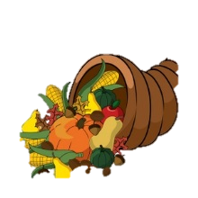Those who give thanks to God sparkle, reducing negative thoughts and feelings. Giving thanks in the midst of circumstances removes the anguish of thinking of life as impossible to bear. God, our Creator knows everything about us. We are to look at the silver lining by knowing that God is working for our good. In all difficulty there is a blessing as we keep our eyes focused on the Lord. Exalt His goodness instead of the problem we are dealing with in distress.

***Here is the challenge: Look around your environment at the many wonders of God and experience the joy of living. Take a deep breath, smile, and begin your journey of thankfulness for a life changing experience.***

Sister Pam Shaw

***Technology can be a Blessing***

Your editor is old school! How I wish I could have had modern technology while rearing my children. Now parents can turn on a media devise and let

their children hear different artists sing or recite ***The Lord’s Prayer***. So many things that parents need to teach can be done with the assistance of modern technology. Get the information and use ***“Right Now Media”*** to help your children learn more about Jesus and His plans for us is to have an abundant life! Before Christmas prepare goals of each young person who is in your life to learn ***The Lord’s Prayer.***

***Let everything that hath breath praise the LORD. Praise ye the LORD. Psalm 150.6***

.***ACTIVITY FOR THE FAMILY***

***African American Spelling Bee***

Children will be out of school for holidays at least 3 days in November, more in December and even 2 in January. They need to put down their electronic devices for periods of time and do other activities that are fun. A few words are shown for starters for a fun activity. To make it even more challenging, see if the children know the meaning of each word.. ***Parents, are you really smarter than a 5th grader on your history?***

Constitution ignorance civil rights quilt

Escape family overcome artist

Tuskegee educator leader King

Politician integration blues peace

Emancipation proclamation triumph black

Biography amendment doctor Africa

Monument immigration strife poet

Boycott Olympian hero family

Segregation obstacles slave vote

Racism republican democrat jazz

Gospel independent election free

Another activity could be an exercise “dance off”. You choose a song and the exercises, and then your teenagers or older youth choose the song and exercises. If it’s younger children, the song, **Father Abraham,** will give both of you a good workout, including your lungs.

You’re gifted, talented and saved, therefore, you will be able to find cleaner, wholesome activities for your children and teenagers as you bond.

**Questions to ask the people you love**

* Who will pay your bills, if you’re unable to do so? A trustworthy individual need to be named and also needs the information needed to do the job.
* Who do you want to have access to your money, banking information and are they authorized?
* If you can no longer drive, how will you get to doctor appointments, church and other places?
* If you cannot live independently, where would you want to live? Does your immediate family know your wishes? Will they carry them out?
* Do you have Advance Directives, Health Care Power of Attorney and Living Will?” If not, free forms are available at Cape Fear Valley Health (Hoke) and other places. Documents are free.
* If you and/or your spouse become incapacitated, would you want to move? Would your home have to be retrofitted? Would you be able to get the work done? Does your spouse//family know your wishes? Are your plans written, and if yes, who has a copy? It’s no good locked away and no one can find the information during the time of bereavement?
* Is there a specific type of Homegoing Service you would prefer? Does your pastor know? Does he agree that your plans are acceptable in our Missionary Baptist Church?

The foregoing is only a few items that we all need to think about, prepare for and ensure that the individuals who need to carry out our plans have all of the information.

**ANNOUNCEMENTS**

***Thanksgiving, 11/22, 11:00 a.m.***

***Pastors’ Christmas Breakfast 12/1, 9 a.m.***

***Christmas, December 25th, 11:00 A.M.***



***LOOKING AHEAD***

* ***New Year’s Eve***
* ***Martin Luther King Services in Hoke and surrounding counties***
* ***African American Read-In***

***NOTICE TO ALL MEMBERS***

***Please remember, before speaking or writing anything in the Church’s name, you could cause legal problems for the whole body. As a Church we are non-partisan and therefore, there are federal laws that govern some of what we do and in the manner that we do it. We do not need any fines or attorney fees to handle unnecessary costs.***

***NEWSLETTER STAFF***

***emcneill1005@aol.com***

***Ellen McNeill, Editor 910-875-3237***

***Reverend Mary C. Owens 910-670-5662***

***Deacon Joseph Johnson 910-425-3709***

***Sister Melissa McAllister 910-308-6067***

***Sister Marie Daniel 910-875-5146***

***Sister Denise Wallace 910-257-1678***

***Sister Stephanie Sutton 910-488-3087***

***Dr. Adrienne Monroe 910-583-3693***

***Sister Pam Shaw 910-229-2500***