THE VOICE

Mount Pisgah Missionary Baptist Church, 414 Pittman Grove Church Road, Raeford, NC 28376
Dr. John D Fuller, Sr., Pastor Telephone 910-875-7544 or 875-2669 Fax 910-875-0053
Website: mountpisgahmbc.com email: mtpisgahraeford@gmail.com
91th Edition September-October 2017
-------------------------------------------------------------------------------------------------------------------------------------

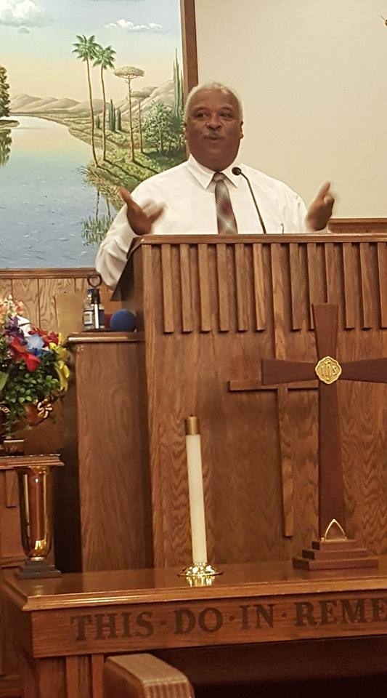
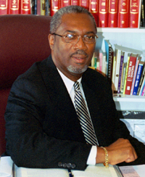
My house shall be called a house of prayer:
Matt 21:13

The best example of living is the life of Jesus Christ. To fully understand the teachings of Jesus, it is required that one must be faithful in learning about the Bible, and carefully read it as you study the Scriptures. Additionally, you need to attend a good Sunday School class and Bible Study. Those will help you to understand and be equipped to perform your duties in an organized, Bible-based Christian church. An example is: “And said unto them, It is written. My house shall be called the house of prayer, but ye have made it a den of thieves.” Jesus had cast out those who were selling and had turned the temple into a marketplace. The temple had become a place to make a living instead of a house of prayer.

Fast forward to today. When the church becomes a place for an individual, and/or members of his family to profit over what The Word teaches, it becomes a way to make a good living. The Church is to be a place of loving care, teaching and where the building and grounds are prepared to be an inviting environment for worship. It is to house God’s people as they study, learn, practice, work, and prepare to worship God. Those in attendance need to be respectful of the House of Worship, careful to ensure it is clean and safe. Each individual is to do his/her part in taking care of God’s house. Are you doing your part? Do you enter into the building in a praise and worship attitude? Do you ensure where you sit is left clean and inviting for the next worshipper? Would Jesus be happy with how you (we) keep His House? Psalm 122:1 states, “I was glad when they said unto me, Let us go into the House of the Lord.”
The Honorable Edward A. “Ed” Pone, District Court Judge, was speaker for Men’s Day

Judge Pone is very active in his church and in the community. He is a member of Willis Creek A.M.E. Zion Church, and has worked with youth and young adults through the ministry of music in the Grays Creek and metro-Fayetteville area.

Judge Pone graduated with honors from South View High School and N. C. Central University. He attended UNC at Chapel Hill School of Law and graduated in 1982. He served as an assistant public defender from the 12th Judicial district, a member of the Rand, Finch and Gregory Law firm, the Finch and Pone Law firm and was appointed as a district court judge by Governor James B. Hunt. He was elected in 1996, and has been re-elected since that time.

Judge Pone is the presiding judge for Cumberland County’s Family Drug Treatment Court and the Judicial Fellow for Cumberland County Reclaiming Fellows, an initiative helping youth with substance abuse issues.

He presented messages in both services. Both messages were proclaimed in the traditional Baptist preacher style which captivated the congregations with words of Bible truths, motivation and encouragement, along with hope for the future. Youth, young adults and seniors alike enjoyed his presentations.

The steps of a good man are ordered by the Lord: and he delighted in his way. Psalm 37:23 (KJV)
Naomi Hargrove won MVP on the Nike basketball camp and best free throw shooter. She was the shortest participant. Of only three trophies given, she was among them.

Naomi is the grandaughter of Darryl and Pam Shaw.
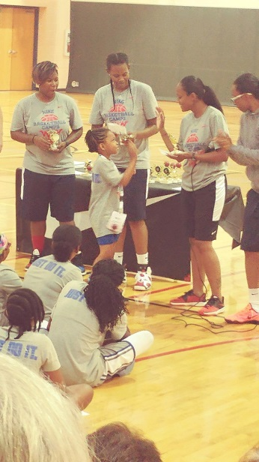
She lives with her parents Jarious and Candace Johnson in Fort Mead, Maryland.

Volunteers Working for Children

On the 5th of July, another load of bikes were delivered to The Bicycle Man by Fayetteville/Cumberland County Ministerial Council, Mount Pisgah Church and an anonymous business. Individuals donated their time and vehicles. No one is named as they desire that the agencies be recognized.

This project began as a Vacation Bible School Project in 2015 and continues. Additional volunteers are needed weekly to work on bikes—cleaning, painting, choosing the ones that are good enough to restore and which should be used for parts, and to perform other odd jobs.

“God is not unjust; he will not forget your work and the love you have shown him as you have helped his people and continue to help them.”
Hebrews 6:10
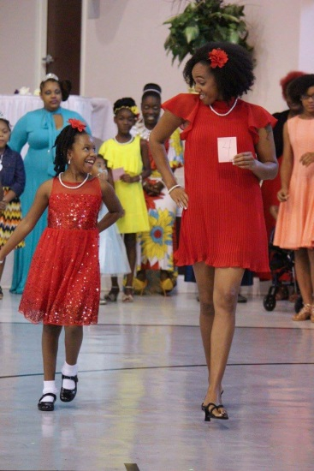
MOTHER-DAUGHTER DANCE

Recently Glam and Elegant Creations held a mother-daughter dance at the CRC. This was a beautiful event and great bonding time for women and girls of all ages. We danced, ate delicious food, played games, and enjoyed the Princesses that were there. We really enjoyed. Sister Ligeia Robinson

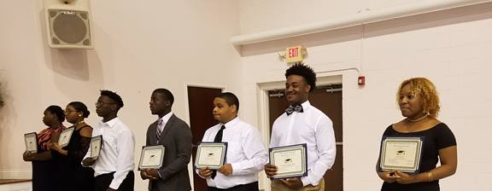
HOKE COUNTY MISSIONARY UNION ANNUAL SCHOLARSHIP BANQUET

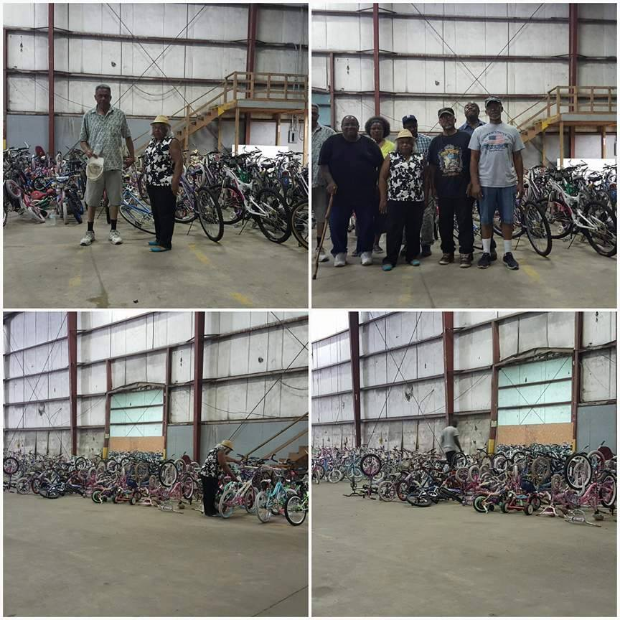
On the 4th of August nine students were recognized for their achievements (Tai Pruit missing as she was already on campus at NCCU). Dr. Robert L. McGowens, Sr. was the guest preacher. Bio sketches were outlined in the program book which shows their many accomplishments. Among the Hoke County Union Scholars, a scholarship was awarded by the Clark-McNeill Family and the White Oak School Community Project. HCMU scholars and the Clark-McNeill recipient will receive $500 each. The White Oak scholar will receive $1,000. The Maynor youth named below again represented our Church as ushers.

YOUTH IMPACT REVIVAL

On the 21st of July La'Dameonna, and La'Tayveonna, and Na'Varius Maynor represented our Church in the annual Youth Impact Revival in Leach Springs MBC. Rev. Rayvonda Rowe, Associate minister, was the guest speaker. It was an inspiring ministry presented to encourage Youth through evangelistic efforts of the Hoke County Missionary Union. Sadly, too many youth and parents failed to attend and to receive the powerful Words of Wisdom. “Do you hear what these children are saying? They asked him “Yes, replied Jesus, have you never read, “From the lips of children and infants you have ordained praise?” (Matthew 21:16 (NIV)
MAKING HOMEWORK EASIER
(Article based on one from The Mini Page
Issue 31, Fayetteville Observer 8/6/17)

Homework should: Exercise the brain, teach responsibility, and review material students have already learned so it will remain fresh. Homework should be a valued tool to help students learn and retain more information. Tips follow:
- Before starting, immediately after school and eating a snack, relax a short while.
- Set a pattern that works for you (the student), and stick to it.
- Gather everything before you start-pencils, books and any other items you may need.
- Be as comfortable as you can. It’s up to you to make your situation work for you.
- Turn off the TV. If you have a cellphone, turn it off; do not use social media as you do your homework. If using the computer, stay focused on your homework.
- Prepare all of your homework, and organize it in the way you will use it the next day in school.
- Do the most difficult subject first, and get it out of the way while you’re fresh and it is earlier in the day.
- Ask yourself these questions “Why is this homework necessary? What is the lesson it is to teach me? What do I most need to remember from this assignment?
- Students should ask themselves, “What can I do to be better prepared to respond in class or to be successful when a test is given? How do I gain the confidence to go beyond the subject and learn more than is taught in the classroom? If I am not challenged enough by my teachers, how to I push myself to still do my very best each day with each assignment?”
Parents reading this article are encouraged to have their children periodically read aloud to them. It can be their school work, the Bible, Sunday School or Bible Study lessons, church newsletter or The Mini Page or even comics. The important thing is to make reading a daily project.

The fear of the Lord is the beginning of true knowledge. (Prov. 1:7)
\
Brother Thomas Smalls Initial Sermon

On the 30th of July Brother Smalls delivered his initial sermon. His subject was “Mission Minded” and was based on Matthew Chapter 3, verses 1-3. The service was inspiring and warmly welcomed by the congregation. We were challenged to become mission minded and to encourage other believers to do the same.

Minister Smalls was introduced by his wife, Sister Regina Fuller-Smalls.

MOUNT PISGAH MBC SUMMER REVIVAL
August 21-23, 2017

I can remember faithful saints saying, What a time, what a time! If we did not have a time during Revival!!! Reverend Thomas Farrow came with a Word for such a time as this. I called it a liberating and deliverance message from the Lord. The topics were Anxiety, Worry, and Fear, respectively. It was liberating because if received, one could be released from either of those three things holding you down or keeping you from moving forward. In fact, the first night, he said, Let It Go! Sometimes, we may not even realize that we are still holding on to things that happened months or years ago. Let It Go! The only way you can let go of anxiety, worry, or fear is to rely on God and the strength and courage found in His Word. None of those things can add a day to our lives, only add other problems and stresses. The message was indeed exceptional, but the atmosphere and sense of expectation were as well. The deacons set the tone with a flavor of old time revivals. They sang, exhorted and prayed with power, and the choirs and congregations sang with joy and enthusiasm. Even a five year old little boy asked to sing This Little Light of Mine. What a time. I came tired but left energized and lifted up!
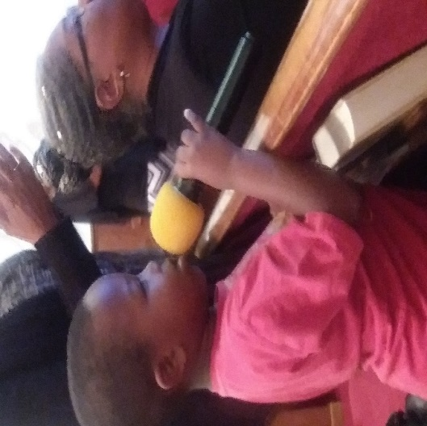
JaWarren Blue, Sister Katrina McNair’s grandson,
Singing This Little Light of Mine at Revival!

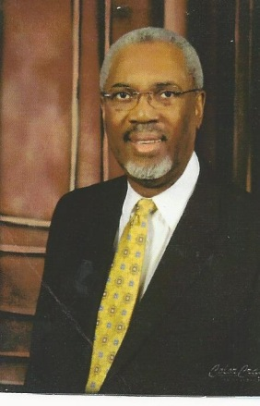
PASTOR’S APPRECIATION SERVICES

September 17th 7:55 a.m. and 10:00 a.m.

Our sincere “thanks to you” and grateful appreciation do not seem to be enough. You have done so much!

By the Grace of God we (Mount Pisgah Church congregation) are still here. God touched the heart of Dr. John D Fuller, Sr. to delay his retirement for three years, and to stop the devastation that was facing our church. To God be the Glory!

Many members of our congregation felt that all was lost; however, with Dr. Fuller agreeing to come over and to help us, hope was revived. With wisdom from God and many years of pastoring, he was able to encourage officers and members that our trust was in Jesus Christ and if we worked together, God would bring us through, and He did! What a testimony! Our pastor, after seeing the large sum of money needed to restore our loan, the dilapidated condition of the windows in the fellowship hall, need of repairs in the Sanctuary, and overall lack of attention to the upkeep of God’s house, recognized the mammoth task ahead. Add to that were the broken spirits of many of the members and the gigantic tasks of raising about $350,000. The problems were enough to overpower the average human being. However, Dr. Fuller is not ordinary, he is an extraordinary servant of God. That made the difference.

First, he began by encouraging the membership. Through carefully prepared sermons he helped us to believe with God all things are possible—and they are. He looked for positives among us and built on successes, one step at the time. Only a person with the love of God would be able to build up a torn down people who had been badly hurt. Without speaking ill of anyone, he provided Godly wisdom and pastoral guidance.

Although Pastor Fuller was facing some personal health challenges, he pushed ahead. Working with the Church Attorney, he was able to provide information and prepare three years of budgets that he felt could be reached. With additional research and mathematical skills, he was able to convince the lending agency, not only would we meet those budgets, we would exceed them. Thankfully, we are continuing to make double payments each month. One payment is for the monthly amount due and the extra payment goes 100% to the principal. To the naysayers and doubters, if you place your trust in Jesus Christ and the leader, God can really do extraordinary things through his ordinary people.

As more and more of the members who had dropped out came back, the work load became lighter. As new members came in with talents, skills and abilities, Pastor Fuller was able to lead ministries to again become active. Space in this newsletter does not allow space to list all of the accomplishments reached under Pastor Fuller’s leadership. A mini-list follows:

- Hired a minister of music
- Activated the Angel Choir, and reactivated the young adult choir
- Elected a church financial secretary and assistant
- Hired a full-time administrative assistant
- Additional trustees added (including two females, a first for Mount Pisgah)
- New windows in the Fellowship Hall, repaired carpet in the Sanctuary, and Carpeted the breezeway
- Four Deacons were ordained, added several deacon assistants
- Registered the Church with the National Baptist Convention-USA, Inc.
- Members were encouraged and attended the General Baptist State Convention meetings and the Woman’s Auxiliary.
- Church Softball Team
- Reinstituted Radio Ministry at 100 WMFA and added WCCG 104.5 in Fayetteville
- Girls Praise Team formed
- Van purchased, cash paid
- New/improved technology: Webpage, Facebook, Push Pay online paying, total revamping of Sound/Media equipment, Right Now Media Library and Videos for church and home
- Reactivated the newsletter
- Husband and Wives ministry formed. A retreat was planned and carried out.
- Financial teams formed and work only one Sunday per month.
- Implemented a 5 year-8-month plan to pay off the mortgage!

Many more ministries, events, and projects have been prepared and carried out in a manner that we pray is pleasing to our Lord and Savior Jesus Christ. Without the love, care, guidance and financial support of Pastor Fuller, we probably would not own anything except the cemetery. How do you show appreciation for the saving of not only land and buildings, but the restoration of Souls to Christ? We can’t, but we pray that God richly rewards his Servant Leader, who believes, “If you build a people, they will build a church!” Thank you God for Pastor Fuller! A New Day Called for a New Way!
SENIOR CITIZENS DAY IN PISGAH
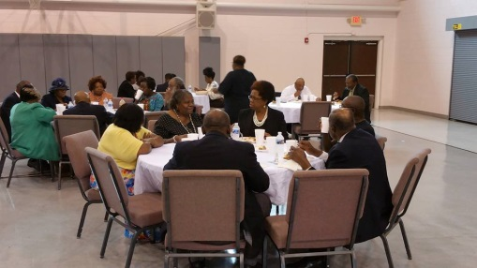
`Exodus 20:12 Honor your father and your mother, that your days may be long in the land that the Lord your God is giving you.
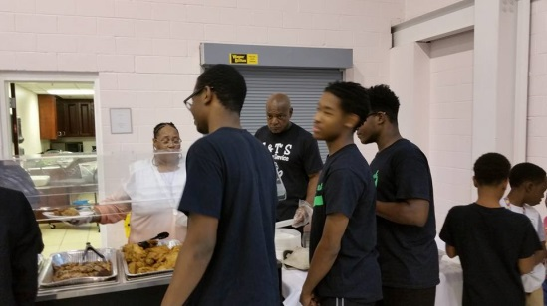
Learning to treat elders with dignity and respect begins with parents. It should be instilled in each and every one of us to honor our parents by showing filial affection for them, and reverence and esteem of them, and by yielding obedience to them, and giving them relief and assistance in all things in which they need. Just as we honor our parents we should honor all senior citizens.
Senior citizens have a lifetime of experience. There is much to be learned from those that have gone before us. Although their eyesight, hearing or memory isn’t what it was in the past, they have great wisdom and morals to impart. They have experienced love, heartbreak, faith, kindness, patience, death, and mercy. All of these experiences lead us to a deeper understanding of life’s seasons, and a greater wisdom of God’s presence.
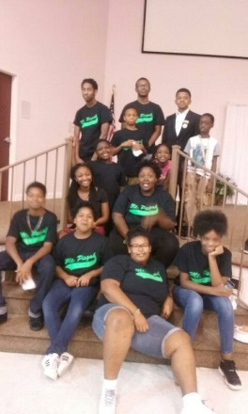
The younger generations must learn the importance of respecting their elders and being thankful for their wisdom and guidance. This generation must be aware that only by spending quality time with and listening to our Seniors can we learn from their mistakes and improve on their successes. The younger generation must learn that understanding yesterday can brighten their tomorrow.
1 Timothy 5:17 The elders who direct the affairs of the church well are worthy of double honor, especially those whose work is preaching and teaching.
` Those who have devoted many years to serving the church, and glorifying Christ’s message, are worthy of respect and honor. They have spent time preaching and teaching others what they, through time and experience, have learned. We honor their commitment to their church, their families, their community, as well as their commitment to serving God in many capacities.
On Sunday, July 16th 2017, Mount Pisgah celebrated our 60 and above Seniors at the CRC with the one of the greatest social customs for mankind, eating. The Youth Adult and Youth Ministries hosted the Senior Citizens Luncheon. We gave thanks for their love, wisdom and guidance. A great time was had by all.
Sister Stephanie Sutton

Mount Pisgah Represented at Lott Carey
During the week of August 14-18, three Mount Pisgah members were blessed to attend the 120th Annual Lott Carey Missions Convention in Birmingham, Alabama. Attending were Sis. Callie Graham, Sis. Machalle Love and Sis. Marie Daniel. The theme was “Missions Matters to the Poor”. We arrived in the city early Monday evening, so we did not participate in the Mission Blitz teams at about 50 sites earlier in the day, nor the Community Feast where about 300 area homeless were guests joining paying Conference attendees from several states. Conference bags were picked up early Tuesday followed by attending the Opening Session that morning during which Dr. David Emmanuel Goatley, Executive Secretary/Treasurer conducted Mission Foci conversations with Lott Carey Partners: Rev. Brenda Harewood, Guyana; Rev. Karl Johnson, Jamaica; and Mrs. Linotte Joseph of Haiti. Dr. Goatley stressed that Lott Carey walks along with and assists as partners to help the poor in these and other places. Each of these partners and others during the week stressed how good it is to see people who look like them coming to help as mission partners and through short-term mission teams. Mission Foci conversations took place each day during the morning General Session and in evening Witness and Worship service with different partners from other parts of the world.
Prayer and Praise service started each day from 5:30 to 7 a.m. (which I did not make). The Lott Carey Global Christian Missional Community Mission (continued top of page 6, Lott Carey)
(continued from page 5) Lott Carey

Study Class met from 7:30 to 9:15. This year’s study was based on a book Great Commission, Great Compassion by Paul Borthwick. The Big Picture: Matthew 28:18-20 shares the Great Commission and Matthew 25:31-46 shares the Great Compassion. Our class instructor was Dr. Victor M. Davis. A thought provoking question he posed was “Does your church care?” and “How does caring look?” The General Session started each day at 9:30 a.m. The afternoon sessions were Men on Missions, Women In Service Everywhere (WISE), Hope Missionaries, International Youth Development and Pastoral Excellence Network. Each day concluded with a Witness and Worship service at 7:00 p.m.
Missions need support. We encourage your giving beyond your obligation to our church. A donation can be made using Givelify App. Select Lott Carey located in Hyattsville, MD in the Charities Section of Givelify. To donate $10 to Missions Empowerment Projects you, as well as family and friends, can text “lottcarey” to 20222. You may also go to website and donate: www.lottcarey.org. Lott Carey is open to anyone who has a heart for missions and helping others who are less fortunate than ourselves.
The site for next year is Atlanta, GA. We encourage you to start planning for August 12-16, 2018.
Sister Marie Daniel, Mission Circle President

Homecoming October 15, 2017
The Shaw Brothers
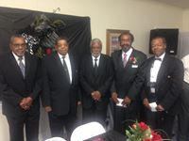
Photo copied from Facebook

The Fall of the year brings to memory days of Homecomings in the past. Plan now to be here and to worship in Mount Pisgah at one of the services 7:55 or 10:00 a.m. Share food and fellowship.
FAYETTEVILLE CUMBERLAND COUNTY MINISTERIAL COUNCIL’S
60th Anniversary Celebration

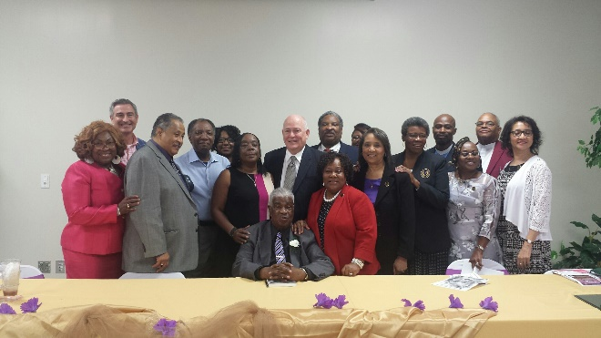

An air of excitement permeated the room as members, friends and community leaders gathered at Mount Sinai Missionary Baptist Church at a luncheon to celebrate FCCMC’s 60th year of Service to the community. FCCMC was formed in 1957 under the leadership of Dr. Aaron Johnson, the Founding President. Dr. Johnson kept us spellbound with his reflections as to how and why the organization was established. It was a chaotic and fearful time when Blacks were being lynched all over the South and Jim Crow Laws openly blocked basic civil rights to Blacks. Dr. Johnson was only 24 years old at the time, but he knew ministers had to come together for the good of the community, particularly after a young soldier right here in Fayetteville had been hung.

FCCMC, with a history and heritage of service, strives to keep the legacy alive by its commitment to serving the community, whether in sunshine or rain. It’s almost unimaginable that 60 years later, we are now confronting some of the same issues of 1957, such as discrimination, voter suppression, and laws created to undermine rights of citizens of color. He concluded that when we become complacent and uninvolved, these type things will rise again. We must ask ourselves how engaged are we safe-guarding our rights and the rights of your children and the seeds you’ll never see? If a survey were taken today, how many would belong to NAACP? We celebrated the history but forge forward to hopefully a greater future through Christ our Lord.
“Let Everything that has breath praise the Lord”
WOMEN OF WORTH CELEBRATION

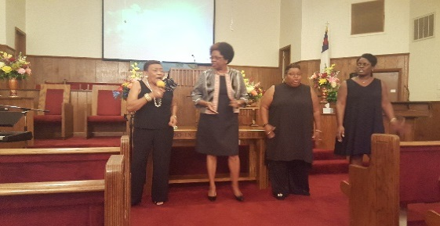
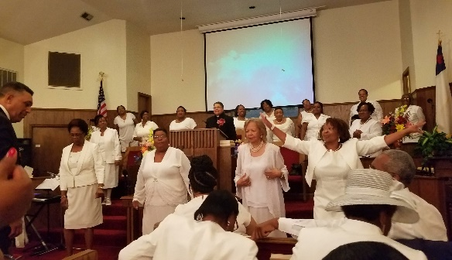
The month of August saw a whirlwind of ministry in action, beginning with the Women of Worth weekend events which included a Saturday Comedy & Talent Show culminating with Women’s Day on the following Sunday. For those who didn’t know about the hidden talent at Mt Pisgah, they saw it all at the talent show. There was an Old Time Gospel Quartet composed of Sisters Faye Williams, Bettye Fuller-Dixon, Regina Smalls, and Rev. Rosaland Loyd. Young Adults did a skit on What Kind of Tator Are You? Mama Dot presented a comedy routine, and other guests presented singing, poetry and more. Sisters Ellen McNeill and Zamiah Robinson also recited poems. Then on Sunday, Reverend Yulla Hines from Buffalo Springs MBC and Reverend Genobia King, Mt. Zion MBC, Reigelwood, NC., brought messages that edified and encouraged women to continue kingdom building. Overall, the entire weekend was blessed with a spirit of joy, laughter, harmony concluding with the Word of God for the Women of God.
Ole Time Gospel Singing

Sisters in White: Gospel Two-Step Praise

Young Adults “What Kind of Tator Are You?

What Kind of Tator Are You showed how we have all kind of Tators in the church, but admonished us to be imitators of Christ. Read carefully to see which kind of Tator are you:

Spectator: Sits on the sideline, a lot to say but never gets involved.
Commentator: An authority on everything, can tell how it should be done but doesn’t do anything.
Agitator: Stirs up trouble, is a hindrance rather than a help.
Hesitator: Is always hesitant or slow about helping in the kingdom, always excuse why I can’t do it.
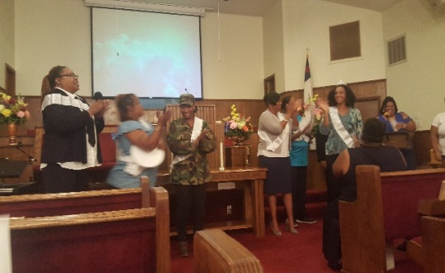
Imitator: Best of all. Be an Imitator of Christ. Be imitators of God, as dear children. (Ephesians 51).

CHURCH WIDE TRAINING
Autopsy of a Deceased Church

In September, the church will hold its second Church-Wide Training for 2017. The first one was held in February, but as we prepare for another transition and new challenges that lay away, it was recommended to provide this study as an overview as to how we look as a church. Are we in danger of dying? Do we have any of the symptoms of terminal illness that kills a church? This will be held on Wednesday nights during Bible Study hour. Three teams of teachers will facilitate the autopsy. They will be trained in spiritual surgical analysis and procedures needed to perform an autopsy to carefully assess, scrutinize and diagnose the symptoms. They will guide the participants towards making an official prognosis: we are dying; we demonstrate some symptoms; we are well and healthy!

As students in the science of performing an autopsy, you will go into the medical examiner’s room to see what symptoms indicate that your church is near death.

Grab your scalpel (Bible), an open mind (heart) and a desire to live long and healthy serving the body of Christ as a church.

Walk with the Puppy Creek Fire Department in October
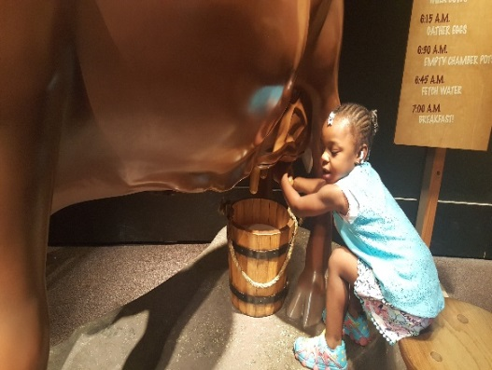
KaMiyah Dawson, brother Dawson’s daughter
at the NC Museum of History during the Church Outing

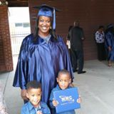
Congratulations on your Graduation

Christal Renee Mosley

Our Church family is very proud of you and of your achievement. Best wishes for continued successes in the future.

Naomi Hargrove-Johnson celebrated her Birthday at the Circus
Naomi’s big surprise was to visit the Universal Circus in Raleigh along with several members of her family. It was a family outing to remember.

Ney & Kam join others on an elephant ride
(Photos by Darryl Shaw)

Looks as if it’s another birthday with the Murchisons – Family Fun Time!
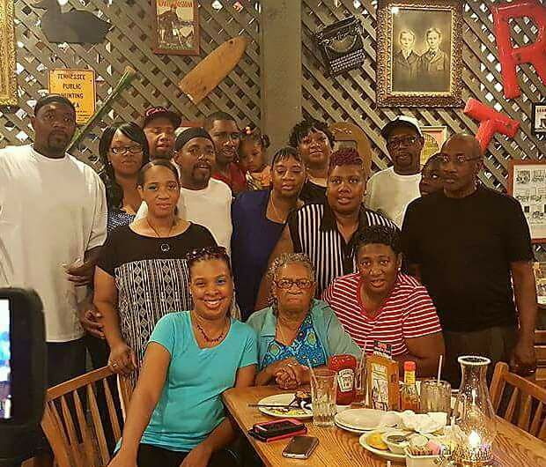
(Picture copied from Facebook)

Proverbs 22:6 Direct your children onto the right path, and when they are older, they will not leave it. (NLT)
HOKE/
READING LITERACY COUNCIL

Annual “$ for Literacy Drive

Aug 27 – Sept 8, 2017

Each one is asked to donate at least $1 for the annual literacy drive. Serve as a committee and ask others to donate. Turn in funds for Mount Pisgah to Sis. Ellen McNeill on or before September 7th . Report is due on the 8th of September in the Literacy Council Office.

Upcoming Events

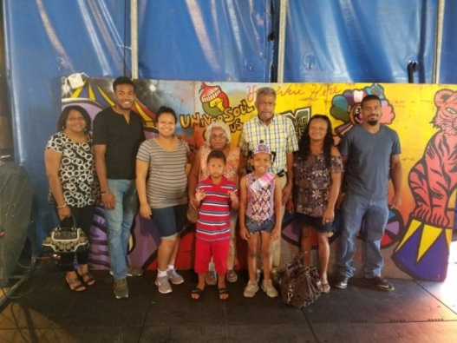
Sept 11th Civic League Meeting at 7 p.m. in McLauchlin Chapel Church

Sept 17th Pastor’s Appreciation 7:55 and 10 a.m. Reception following in the CRC

Sept. 24th Hoke County Union in Lewis Chapel West 3 p.m. Annual Session

Oct 1st Pastor’s Anniversary, Beauty Spot at 4 p.m. in Beauty Spot MBC

Oct 15th Homecoming Services 7:55 and 10 a.m. Invite family, friends, business associates and others to come and share with us

Nov 11th Veterans Services at Hoke County Court House at 11 a.m. all are invited to share in this service

Requesting you and others to support your newsletter staff

emcneill1005@aol.com
Sister Ellen McNeill, Editor 910-875-3237
Reverend Mary C. Owens 910-670-5662
Deacon Joseph Johnson 910-425-3709
Reverend Arlane McKoy 910-875-3325
Sister Melissa McAllister 910-308-6067
Sister Marie Daniel 910-875-5146
Rev. Charles Jackson 910-565-3448
Sister Denise Wallace 910-257-1678
Stephanie Sutton 910-488-3087

