The Voice
Mount Pisgah Missionary Baptist Church, 414 Pittman Grove Church Road, Raeford, NC 28376
Telephone 910-875-5744 Fax 910-875-0053
Website: mountpisgahmbc.com email: mtpisgahraeford@gmail.com
119th Edition November-December 2020
----------------------------------------------------------------------------------------------------------------------------------

Dr. Terence Z. McCrimmon, Pastor
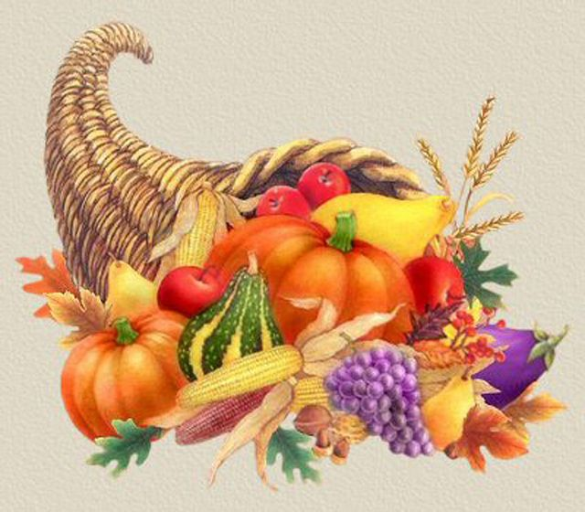
I recently preached in a sermon, and I talked about how placing trust in God has been the hallmark of our Judeo-Christian heritage. From the very beginning, the patriarchs and matriarchs of the Bible demonstrated trust in God. Ronald Regan once said, “Live simply, love generously, care deeply, speak kindly, leave the rest to God.” I believe the late president was reminding us to live life while placing our trust in God. There is a lot occurring in our world – a pandemic, a heated political climate, social unrest, economic turbulence, and so on. Circumstances have a way of shutting us down, but we must be determined to live, give, and persevere. Family and friends depend on us, hopeless people desperately need our words of encouragement, misfortunate individuals await our generosity. On top of that, there is destiny to pursue and greater things to accomplish. Therefore, we cannot allow the cares of the world to place us in a box, weigh us down, or limit us. One may say, “I have nothing to give,” “My energy is gone,” “I feel depleted,” “I cannot see my way.” That is understandable. You must know your limits and breaking points. If you are in that place, I encourage you to take a breath and allow God to refill and revive you. Psalm 23:3 states, “Thou restores my soul.” After you have gotten your breath, you must get back up and continue to trust God and live!
On another note, this year Mount Pisgah celebrates 120 years of ministry. Throughout its history, this church has gone through the same things we are facing today. Its fortitude is due to the forefathers placing their trust in God. As we celebrate, let us reflect on God’s goodness and look forward to the greater things God has in store. I believe we have not seen anything yet!
HAPPY THANKSGIVING
LOVE ONE ANOTHER
For this whole quarter, we have been studying Love Ye One Another and the different challenges we face in trying to love one another, not only towards the world, but within our own families and churches. We saw how jealousy and envy nearly destroyed Jacob’s family, more than once. We see how churches often struggle because of lack of agape love. Now, we see our nation being ripped apart for the same reason, the lack of love. We get into conflict over so many issues, even fight over religious differences, but to me, Christ summed it all up when He left us these two commandments: Love the Lord thy God with all thy heart , all thy mind, and all thy soul and the second is like it: You shall love your neighbor as yourself. On these two commandments hang all the Law and the Prophets. In other words, if we can do these two commandments, then we fulfill all the rest. Why? Because love will keep us from breaking the other ones and then of course, Christ fulfills them all. If we are His beloved disciples, then we, to the best of or abilities, will strive to walk in love.
Matthew 22:37-40.
Reverend Mary Owens, Christian Education Ministry

1 John 4:8 - But anyone who does not love does not know God, for God is love.
IS EVERYTHING GOD
CREATED ALIVE?

It seems that everything God created is alive.

- Consider the earth beneath our feet:
- Dirt makes things grow, especially when water is added by rain or irrigation.
- There is slow movement below the earth’s surface caused by high pressure. When there is enough movement, an earthquake occurs. This can be a very violent and destructive event.
- The inner core of the earth is very hot. This creates pressure. This pressure breaks through the surface of the earth in the form of a volcano. The lava on the ground destroys everything in its path. There can be ash clouds so big that planes have to stop flying.

- Consider the air above us:
- The air can be still or move as a small breeze. If conditions are right, a thunderstorm forms and we can experience high winds. (I recently had two large limbs to break off of trees in my yard due to storms.)
- Certain storms can cause tornadoes to form. The winds are very violent.
- Hurricanes form over water and the warmer the water, the higher the wind speed. Major hurricanes can cause severe flooding along with wind damage.
- Consider the space above the air.
- This is where the sun is that gives us daytime. This is where the moon is that gives us a small amount of light at night by reflecting sunlight. The moon also causes high tides and low tides.
- Space is big. Some comets have such large orbits that astronomers can only see them every few years.
- Meteors can only be seen when they enter earth’s atmosphere and start to burn up. There are many of them out in space. Some are too big to completely burn up. It is said that a huge meteor’s damage is what caused the dinosaurs to become extinct.
- Space is very big. The stars that we see are light years away. Light travels 186,000 miles per second. Figure out the number of seconds in a year and multiply by 186,000 to get the number of miles in one light year. (The sun is our closest star).

- And then consider mankind:

Wait! That’s us! We are the only part of God’s creation with a sentence of death hanging over our heads. But God in all of His goodness and love gave us a way out through His Son Jesus. However, God gave us freewill. We must choose to be saved from death. Read Romans 10:9. A part of the growth process in Jesus is understanding a new birth. See what Jesus says to a man named Nicodemus in the first part of John Chapter 3.
Deacon Joseph Johnson
Genesis 1:29-30
Then God said, “I give you every seed-bearing plant on the face of the whole earth, and every tree that has fruit with seed in it. They will be yours for food. And to all the beasts of the earth and all the birds of the air and all the creatures that move on the ground—everything that has breath of life in it- I give you every green plant for food.” And it was so.
HOLIDAYS CELEBRATIONS DURING the
PANDEMIC
As we approach the holiday season celebrating Thanksgiving and Christmas, families are adjusting to a new dynamic due to COVID-19 and the current pandemic crisis. Individuals and families are struggling with isolation, financial changes, places to worship, social distancing and other challenges that are new and different. The one constant is “God never changes or leaves us”. This is a season to become creative and explore various means of achieving joy and celebrating special holidays with enthusiasm and innovative inspiration.
Continue Your Traditions Safely
Many activities may resume as planned. Family gatherings may be held in accordance with state recommended guidelines by limiting numbers indoors and holding gatherings outdoors with tents, grills, fire pits and/or covered areas from the weather. Ensure that precautions are taken by COVID testing, wearing masks, gloves, face shields, disinfecting areas, using hand sanitizer, hand washing techniques and proper social distancing. Choose paper plates and utensils, instead of dishes and silverware. Limit close contact with hugs and kisses to “air hugs” and elbow bumps and make it fun, rather than mundane.

Seek Festive Pandemic-inspired Events
Events in the area are adjusting to pandemic guidelines. Check the local city and county activities for the holidays and look for “drive by” Christmas lights, outdoor nativity scenes, and other church sponsored activities. Begin to explore outdoor parks, lakes other areas and look for new adventures. Also, check the internet for safe activities for children and adults. Continue to decorate your homes inside and outside with signs of autumn and the Christmas season to spread joy to others as well as for yourself. Colors heighten our sensitivity to changes in the seasons and the occasion.
Use ZOOM as a Meeting Place
Many people are deciding to remain at home for the holidays. ZOOM is a great method for including family and friends for games and celebrations. Before Thanksgiving and Christmas arrive, begin meeting to gather ideas in order to plan for special days. Virtual ornament contests and other ideas for sharing are available. Also, more family members may come together.
Make Cooking and Baking Fun
Our time spent at home can be a time to pull together ingredients and plan holiday meals with what is in the home, rather than spending an extravagant amount of money for one large meal. Research recipes and begin new cooking traditions for one or the entire family. Table settings and decorations for the home may be gathered from outdoors and give the centerpiece pizazz. Share ideas for baking and cooking dishes that can be taken in portions to different homes to make complete meals. Spread the love of food with someone less fortunate this year. (Be sure to stay in your bubble; be safe).

Celebrate, Celebrate, And Celebrate!!!
This is a season to rejoice! Be honest with others about your feelings in order to avoid stress and anxiety. Participate and share with others and do not overextend yourself during the holidays.
2 Thessalonians 3:5 “May the Lord lead your hearts into a full understanding and expression of the love of God and the patient endurance that comes from Christ.”
Sister Pam Shaw

perkins orchard

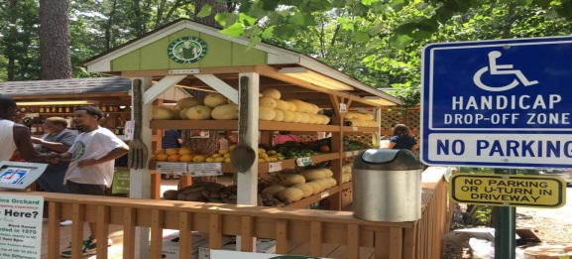
Perkins Orchard is surrounded by a residential neighborhood and is located in the heart of southeast Durham, North Carolina, Founded 50 years ago by Rev. Dr. Joseph E. Perkins, the orchard was uniquely grandfathered into the City of Durham. It started out as a simple roadside stand with tomatoes and cucumbers. Before long, Dr. Perkins was planting trees around the House in which Perkins Orchard Rests. Plum Trees, Apples, Pears, Cherry Trees, Pecan, Blueberry bushes, Peach trees, and Grape vines, along with the annual vegetable garden, grew in lush abundance.
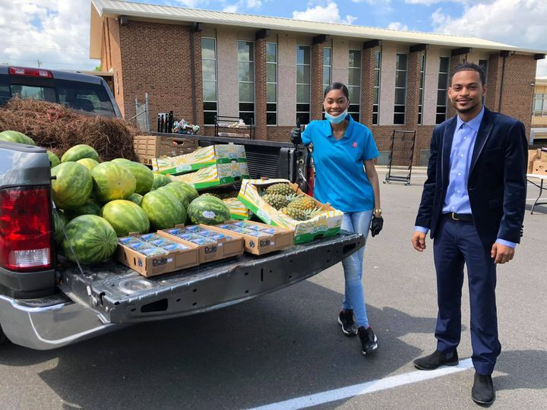
Dr. Perkins’ Grandson, Donovan Alexander Watson, took over daily operations at the age of 10 years old! He steadily built up the business each and every season throughout middle and high school. Once he graduated from Jordan High School in 2012, he tore down the old fruit stand and moved it behind the house. As time passed, connections were made with farmers across the state of North Carolina and to this day, they rely mostly on those trusted connections to ensure consistent delivery of quality produce. Mr. Watson says,
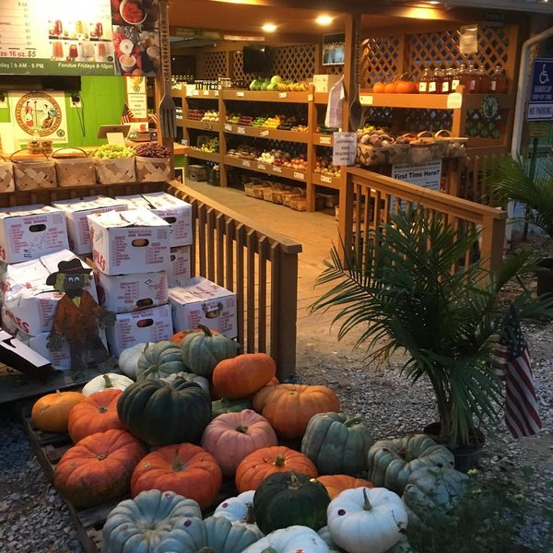
“Our company is based on the Belief and Trust of the honor system.” In earlier years, there was a Drop Box through the door in which customers could drop their money or change after they had completed their purchases. With the expansiveness of technology and their website, Perkins Orchard is able to meet the need of almost any fruit or vegetable need. Another tidbit of information I learned while working on this article was that his grandfather was not only a pioneer in the orchard area, but he was also a pioneer in seminary education. The late, Dr. Perkins was the founder and president of the historical, Apex School of Theology. Mr. Watson, following the entrepreneurial spirit of his grandfather is forging his own path towards excellence. This past year, at the age of 26 years old, he ran for Secretary of Agriculture for the State of North Carolina and fared very well in the elections. Praying God he shall return in four years to win the office! Mr. Donovan Watson, we salute and honor all you have done to carry on and further expand the legacy of Perkins Orchard. Rev. Mary C. Owens, CED
Genesis 1:29-30
²⁹ And God said, “Behold, I have given you every plant yielding seed that is on the face of all the earth, and every tree with seed in its fruit. You shall have them for food. ³⁰ And to every beast of the earth and to every bird of the heavens and to everything that creeps on the earth, everything that has the breath of life, I have given every green plant for food.” And it was so.
CULTIVATING THE SPIRIT OF LOVE:

Parable of the Wolf of Good and Evil

We know that we wrestle not against flesh and blood but against powers, against rulers of darkness of this world, against spiritual wickedness in high places. Ephesians 6:12. There is a constant war going on between Good and Evil, but God has given us weapons of warfare in this battle. As we grow in our faith, we are admonished and encourage to seek God, pray, and stay in His Word. This will help us grow stronger. I have always loved the old Indian Parable, The Good and Evil Wolf. The old grandfather tells his grandson: in life, there are two wolves inside each of us which are always at battle. One is a good wolf which is love, kindness and courage. The other is a bad wolf which represents hatred, greed, and fear. The grandson stops and asks which one wins? The grandfather replies, “The one you feed.”
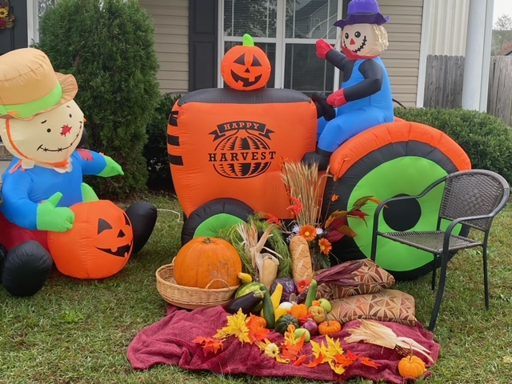
So, it is with us. If we feed and nurture our spirits with Love, then we can win the battle over good and evil. Paul further encourages us with a long list of good, pure, and godly things upon which to think: My brethren, whatsoever things are true, are pure…whatsoever things are of good report…if there be any virtue, think on these things. Philippians 4:8
Rev. Mary C. Owens

The cartoon below portrays what often happens in the workplace.
THE BEAUTY OF AUTUMN
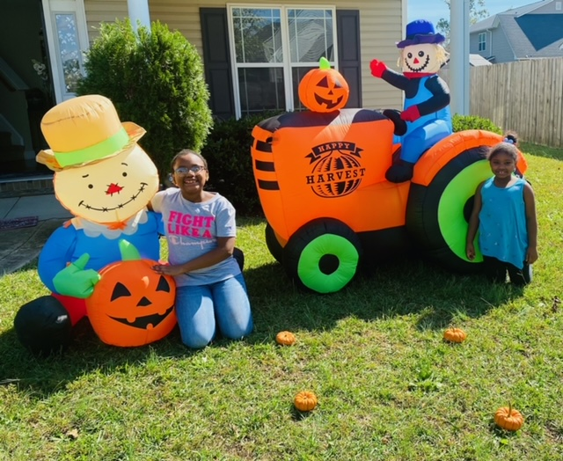
As cousins, Abby and Iris enjoy time together, they are encouraged to put down electronic devices, get off social media, stop texting and/or looking up TIKTOK videos, and simply enjoy the beauty of Autumn in NC. From morning until long after the sun departed, while outdoors, both girls basked in warm sunshine, collected falling leaves with vibrant colors, and were energized with the excitement of creating the Harvest Time display on the lawn...Outside, still has so much to offer!

JOKE: After the christening of his baby bother in church, Jason cried all the way home in the back seat of the car. His father asked him several times, “What’s wrong son?” Finally, Jason answered between sobs, “That preacher said he wanted us bought up in a Christian home, but I wanna stay with you guys.”

~THE MOUNT PISGAH CHURCH FAMILY~

There is an old saying that transcends time, race, geography, and culture, which proclaims, “Though WE might not always get along, NOBODY’S gonna mess with OUR FAMILY! Can we agree that this same sentiment applies to Church Families—The Family at The Mount? This may sound Unchristianly or perchance, even worldly, yet the fact remains true, that no matter how families disagree, for the most part, whether we are related through Blood, Spirit, or Assembly, people typically will not allow anybody to mess with Their Family! And better yet, these feelings are felt by “new church family members” as well as those who may consider themselves as the Matriarch and Patriarch of their family’s lineage. Yet when all is said and done, at the end of the day ALL MEMBERS of The Mount Pisgah Church Family, are Family, and we will unite, work together, and “Get ‘Er Done!”

You can probably relate to this sentiment, because The Mount Pisgah Family, is one that has historically shown up and worked when help was needed; when situations and circumstances demanded it! Amen? Because not maintaining the ability to work together is a poor reflection on Our Lord, on The Body of Christ, and on The Family of The Mount.

Moreover, as we may have sometimes found ourselves struggling just to stay afloat, in a Time Such as This, when The Call to Rally and Support were required, The Church Family of Mount Pisgah MBC answered The Call, at a moment’s notice, with an attitude of Integrity, Humility, Hospitality, Excellence, and Steadfastness! For this we thank Our Savior. We each can testify that if it were not for Jesus, The Beloved Family of the Mount would have endured much greater trauma, than ever it has in The Family’s 120-year history—we literally would have lost The Mount.

Yet because, as the cliché goes, “The Family that prays together stays together,” with the Holy Spirit as Our Glue, The Lord Jesus as Our Guide, and The Father as Our Sovereign God predestining The Family’s SUCCESS, Mount Pisgah’s Family has countlessly evidenced God’s Word, that states, that there has been “NO Weapon formed against us” that has prospered! Is there a witness!??

The Lord favors, blesses, and ordains The Concept of Family. Similarly, before the foundation of the Earth was formed, the Lord knew that when The Mount—working together, lifting up one another’s arms in support, maintaining The Family’s commitment to “Pray, Stay, and Pay,” welcoming and embracing New Members, while ALWAYS giving God the Glory, The Mount Pisgah Church Family would withstand the tests of time, and achieve greatness! THIS The Church Family did more than a century ago, and we are doing the same today in 2020.

As I close, I offer this case in point: In our new Health and Wellness Ministry Effort, we needed several of the Mount’s Family Members to make this effort a total success. Working TOGETHER for the Good of The Family, and even more impressively, for the Good of Hoke County & surrounding areas, The Family overcame MANY Challenges just in the Month of October, to include, but not limited to: Opposition, Denials, Blame, Revocations, Bureaucracies, Changes, Falsehoods, Struggles, and Sickness!
YET, covered & kept by The Blood of Jesus, standing on the promises of God, holding fast to our faith, WE OVERCAME—in spite of the attacks of the Enemy! While reading this article, some Family Members may be whispering, “We are Overcomers!”

WORKING TOGETHER MOVES THE HEART OF GOD!❤️ May He continue to bless and keep The Mount Pisgah Church Family, as we each ascribe to the Words of THE WORD Incarnate, Our Savior—Jesus the Only Christ: “Not My will Father, but Thy Will be done.”
Written and submitted by, Dr. Adrienne Owens Monroe
President , Health & Wellness Ministry
“Then spake Jesus again unto them, saying, I am the light of the world: Mt. 5.14 · John. 9.5 he that followeth me shall not walk in darkness, but shall have the light of life.”

Jesus is the Light of the World
Walk in the light, the beautiful light!
VETERANS DAY 2020
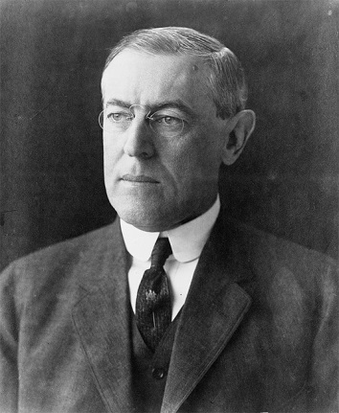
It was on the 11th hour of the 11th day of the 11th Month of 1918 an armistice between Germany and the Allied Nations came into effect.
In 1919, President Woodrow Wilson proclaimed the day should be filled with pride and gratitude. Many years later, November 11th was established as Veterans Day.

Your editor has a few questions for you. 1) How do you celebrate Veterans Day? 2) Do you ever think of the sacrifices made by all veterans? Are women included in your memories and thoughts of Veterans? 3) Do you know any patriotic songs? and
4) Do you look forward to another day off work with no thought of the reasons for celebrating Veterans Day?

This year Veterans Day in Hoke County may be different. Usually, we gather in front of the Court House at the Memorial and a planned program is presented. Sometimes its group (audience participating) singing or other times an individual sings a patriotic song. Yes, we pray together and honor those veterans who died since last year’s ceremony. It is a heartfelt service as each veteran’s name is called.

Wherever we may be on Veterans Day, we need to take a few minutes to remember the sacrifices of those who fought in the various wars, those who served in keeping the peace on foreign soil, and those who equally served here on the home front to ensure keeping the freedoms we enjoy in America. Thank you, God, for the privilege of living in the USA where we may serve and worship you. It is with a humble heart that I ask all to be grateful and honor God and those who have served. Google and play Kate Smith singing, “God Bless America.” The song is copied in the adjoining column for your convenience.

God Bless America
God bless America, land that I love
Stand beside her and guide her
Through the night with the light from above
From the mountains to the prairies
To the oceans white with foam
God bless America, my home sweet home
God bless America, land that I love
Stand beside her and guide her
Through the night with the light from above
From the mountains to the prairies
To the oceans white with foam
God bless America, my home sweet home

Traditional Services May not be Held

Usually this time of the year, we write articles about upcoming events: Thanksgiving and Christmas Day Worship, the Annual Pastors Appreciation Breakfast sponsored by the Hoke County Missionary Union, the Christmas Cheer Worship Services, two Martin Luther King, Jr., services, The Ministerial Council’s Breakfast and the Hoke County Civic League’s Scholarship Banquet. As far as we know now, the events will not be held as they normally are. It is possible some services may be on Zoom; but it appears doubtful at this moment. Brothers and sisters, be of good cheer. We can still worship Jesus in different locations, cheerfully contribute to the worthy venues that we normally support, and lift each other in prayer. Maybe we will use this time wisely in private prayer, reading and studying God’s Word and mediating on His Goodness. More later.

LUKE 2: 4-7
(Discoverer’s Bible NIV)

Joseph, also went from the town of Nazareth in Galilee to Judea, to Bethlehem the town of David, because he belonged to the house and line of David. He went there to register with Mary, who was pledged to be married to him and was expecting a child. While they were there, the time came for the baby to be born, and she gave birth to her firstborn son. She wrapped him in cloths and placed him in a manger, because there was no room for them in the inn.

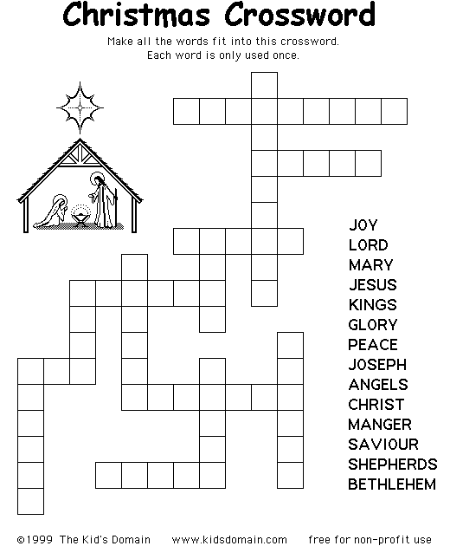

(Copied from the Internet)

John 1:1 In the beginning was the Word, and the Word was with God, and the Word was God. He was with God in the beginning.

We Wish You A Merry Christmas

John 1:14: The Word became flesh and made his dwelling among us. We have seen his glory, the glory of the One and Only, who came from the Father, full of grace and truth.
TIPS FOR REDUCING HOLIDAY STRESS
(Adapted from HealthLink www.healthlinkbcca//healtth-topics)

- Know your spending budget. Do NOT get in debt for the holidays. Be free of stress in the new year, by refusing to buy anything on credit.
- Give something personal. Choose something you have you know a friend or a relative cherishes and give it now; don’t wait to die to share with family and friends. Bake, sew or shop for others.
- Share the work. Get all family members involved. Each person in the household should share in the tasks, i.e. decorating, cooking, cleaning and shopping.
- Say “No!” You cannot accept invitations to large gatherings or attend events where you could be infected with Covid-19. Also, be sure that family and friends know this is not a “drop-in” holiday. Call first. Life is precious and you have to protect yourself and your family.
- Keep a regular sleep, meal, and exercise schedule. Take good care of yourself and of your family. Plan, prepare and eat nutritious foods. Limit your activities by planning to get proper rest and relaxation. Play Christmas music and meditate. Exercise to your favorite oldies, but goodies.
- Holidays are difficult for those who are in bereavement. Stay in touch with those who need to hear your voice or see your face. Be kind and considerate. Listen to others when they talk. Try not to interrupt, as they may need to vocalize their feelings.

Church Members are invited to write articles for our newsletter. You may submit poems, articles, photographs or drawings.

NEWSLETTER STAFF
emcneill1005@aol.com
Sister Ellen McNeill, Editor 910-875-3237
Reverend Mary C. Owens 910-670-5662
Deacon Joseph Johnson 910-425-3709
Sister Denise Wallace 910-257-1678
Dr. Adrienne Monroe 910-583-3693
Sister Pam Shaw 910-229-2500

. Page 8 of 8

