**The Voice**

***Mount Pisgah Missionary Baptist Church, 414 Pittman Grove Church Road, Raeford, NC 28376***

***Telephone 910-875-5744 Fax 910-875-0053***

***Website: mountpisgahmbc.com email:*** [***mtpisgahraeford@gmail.com***](mailto:mtpisgahraeford@gmail.com)

***121st Edition March-April 2021***

**--------------------------------------------------------------------------------------- -------------------------------**

****The Easter Story**

On Easter, or Resurrection Sunday, we celebrate what is arguably the most important event in all of human history: *Jesus rising from the dead*. All of Christianity and all eternity hinges on the truth of the resurrection. If Jesus did not rise from the dead, then our faith lacks meaning and is just another interesting philosophy. But if the resurrection is true, then it is the clearest proof that Jesus is exactly who he claimed to be – ***the Son of God and the Savior of the world.*** All of the evidence points to the truth of the Resurrection, and the results are changed lives. As Baptist we believe Jesus is God’s Son, born of a Virgin, suffered on Calvary and the grave couldn’t hold him down***. He Arose! Indeed He arose with all power in His Hands.***

We need to focus more on the importance of Jesus’ life and His teachings. Easter is not about bunnies and eggs. However, it does not hurt to give children baskets and to have fun with ‘the bunny.” Jesus wants us to live an abundant life. Because He Lives, we can do just that. He is Risen indeed. Thank God the blood of Jesus washes away our sins.

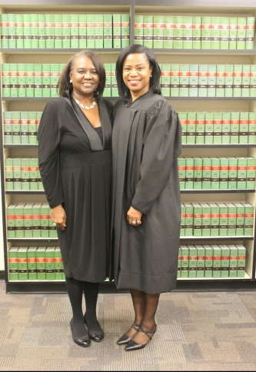

***Have a Blessed and Safe Easter Holiday!***

**Sharonda D. Amamilo, J.D., M.B.A.**

***Thurston County Superior Court Judge, Position 8***

***Thurston County, Washington State***

**71s t High School Grad, First Person of Color, to serve as Judge**

Sharonda is the first person of color to serve as a Judge in Thurston County. Sharonda’s experiences with her own family motivated her to learn the law so she could protect those closest to her from deep-rooted systemic injustice. It is because of those experiences that Sharonda is committed to protecting the constitutional rights of all citizens, bringing diversity of experience and background to objectively deliberate, educate, and render compassionate justice to litigants appearing before the court; many with traumatic backgrounds. She served as supervisor of the Thurston County Public Defense Juvenile and Dependency unit from 2014 until her departure. Sharonda received her Masters of Business Administration (’97) degree from Saint Martin’s College in Lacey, WA and her Juris Doctor (’03) from Seattle University School of Law.

Sharonda is the niece of member Sister Margie Thompson Powell.

***Proverbs 1:7 “The fear of the LORD is the beginning of knowledge: but fools despise wisdom and instruction.”***

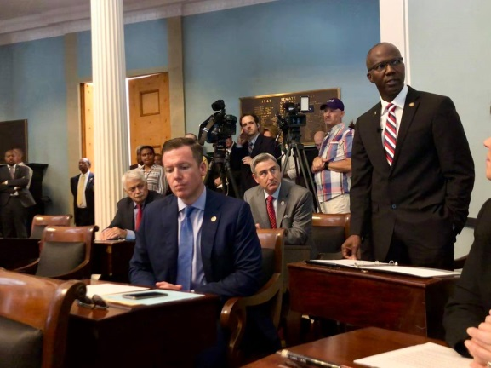**Updates from Senator Ben Clark**

***Senator Robert B. Clark was appointed to the following committees for the 2021-2022 term. We encourage you to visit his Facebook page and other sources he provides for current information on how he is working for his District in the Senate.***.

|  |  |
| --- | --- |
| |  | | --- | | **Base Budget Committee**  **Commerce and Insurance Committee**  **Finance**[**Committee**](http://r20.rs6.net/tn.jsp?f=001_bH5UnZykm1-ylXZlfR7Zw2_UnxWMnHHfXZZopF3nTZndL0Iztia7p89sVlY3RqwZGACCtNewPyEFg9jWbeS_WE3VM8UNG0sRsuRnxM-JFkK0dfmP4jcGQfggAm89ExR1NmbmSem1kSEL16o3YmkpViZq2Alys4chFTm-PDGfNQGvWBV9Y4aokntNpaSF0CwmkFw0ikpuvAv-zwArfpUJg==&c=VCFjgmitAUCbOkCQ1TfaUA1bCJRuUZOL1ux-Zh3WW3JGyeHA0b85AQ==&ch=X2wq6QLhFmDyxFaE1UdkNv2FAhVBR0OR20s2x5VnDqS7jb6StOOtUQ==)  **Redistricting and Elections**[**Committee**](http://r20.rs6.net/tn.jsp?f=001_bH5UnZykm1-ylXZlfR7Zw2_UnxWMnHHfXZZopF3nTZndL0Iztia7p89sVlY3Rqwa7EdFhh7-XJNOq65k8sCuejCuWkcevoH-p37QhubCzvif87SIj5Czp9h49RXFYjLtpjM4Qs07ZCRMew2WGH5_aQuYgMAwQ5cIL24aNNkd-CqeJrWm4cJpajgDX6-P_NLhAUyyxWJVDDTTypW_qbRzg==&c=VCFjgmitAUCbOkCQ1TfaUA1bCJRuUZOL1ux-Zh3WW3JGyeHA0b85AQ==&ch=X2wq6QLhFmDyxFaE1UdkNv2FAhVBR0OR20s2x5VnDqS7jb6StOOtUQ==)  **Rules and Operations**[**Committee**](http://r20.rs6.net/tn.jsp?f=001_bH5UnZykm1-ylXZlfR7Zw2_UnxWMnHHfXZZopF3nTZndL0Iztia7p89sVlY3Rqwt-BeN_evxo1sGxmoeHoG6YsRAgEHfyCKa3Eu5plLqdsujC1roSRbqgprnx2G6_BdDpwiLidXgtjeiktLvoR7Cn9IHvn5GzLNNPu-eBAqp-yOPVBIiWWyfuOrCzbvFU_JTzKQThmEVRKo8h6-YaBqkA==&c=VCFjgmitAUCbOkCQ1TfaUA1bCJRuUZOL1ux-Zh3WW3JGyeHA0b85AQ==&ch=X2wq6QLhFmDyxFaE1UdkNv2FAhVBR0OR20s2x5VnDqS7jb6StOOtUQ==) | |

****Golden LEAF has been a steady hand providing resources to increase the economic opportunity for the state’s rural and economically distressed communities through a variety of grant-making including building human infrastructure through workforce training and scholarships. Since its inception, the Golden LEAF Foundation has awarded over $48.5 million to help more than 21,900 students from rural North Carolina attend the state’s colleges and universities.

Scholarships are available to students from qualifying counties, who demonstrate financial need, to help them attend college at participating North Carolina public or private institutions or community colleges. Golden LEAF’s goal is for scholarship students to gain the talent, knowledge and skills needed to help their communities thrive.

**Golden LEAF has two scholarship programs:**

* 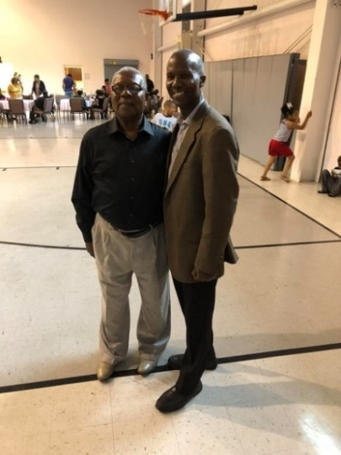Golden LEAF Scholarship Program (4-year) to attend NC 4-year colleges or universities
* Golden LEAF Scholarship Program (2-year) to attend NC community colleges

**Senator Clark is shown with Church Member Adale Clark on his day, Adale Clark Day, in Hoke and Cumberland Counties in 2018)**

***JAELAN BLACK SCORES IN ALL BOWL GAME***

On December 30, 2020, Jaelan Black, son of Aliza Newton and Chris Black  (grandson of the late Charles and Betty Kelly) was selected to play in the High School All American Bowl located in Myrtle Beach SC . Jaelan scored two touchdowns and a two point conversion to help his team win the game with a score of 22-10.

**Teach your children to use a Tape Measurer and a Measuring Cup**

They will then be better equipped to learn to do fractions if they have used some household tasks.

Tools are already in your house. Make a game of finding them while your family is isolating at home. Look around inside your house; you may be able to find many tools for teaching children in fun ways, i.e. a simple recipe requires measurements. Allow the children to bake a cake while you watch and supervise. You will be amazed at how excited they are to eat a cake that they prepared, eagerly watched it bake and then sit and enjoy the end product.

***Tell the old story of Jesus and His Love. Teach daily from The Word.***

**Vinnette Johnson**

***Newsletter Staff Member***

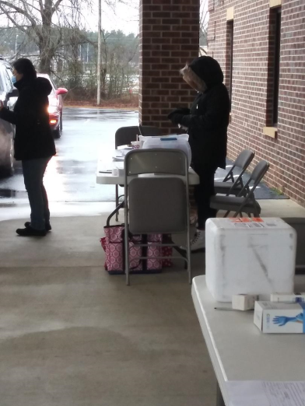Sister Vinnette is one of our newer members, joining Mount Pisgah in 2020. She joined us shortly after arriving to the area from Baltimore, MD where she was born and raised. She moved here to give companionship and assistance to her 90-year-old father, Deacon James Johnson. She attended Allen University before joining the USMC where she spent most of her enlistment stationed in Southern California. Sis Vinnette (Vie) has become deeply dedicated to The Mount. Currently she serves as Chairperson of the Shepherd’s Care Committee, enjoys teaching Sunday School, and contributes to the Newsletter.

Fun facts about Sis Vinnette:

* 10 years of private music lessons with Clarinet
* Married to Mitchell Samuels (39 years)
* Loves theater and dance.

**Anthony Kelly**

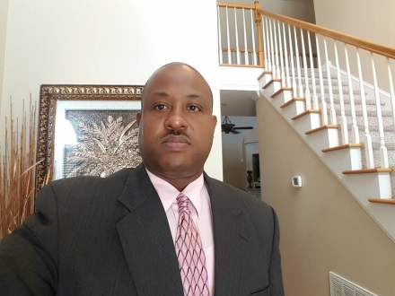

***Appointed to Crime Commission***

Governor Roy Cooper appointed Anthony Kelly to the **Governor’s Crime Commission.** Kelly is the Assistant Chief of Police for the Fayetteville Police Department. He has over 27 years of experience in law enforcement serving as a Patrol Officer, Police Sergeant and Police Lieutenant and Captain.

Anthony and his immediate family are members of our Church. Congratulations! We are proud of you.

***Deuteronomy 6:6-7***

**And these words that I command you today shall be on your heart. 7You shall teach them diligently to your children, and shall talk of them when you sit in your house, and when you walk by the way, and when you lie down, and when you rise.**

***COVID-19 VACCINES GIVEN AT THE MOUNT CRC – A SUCCESS STORY***

A great shout-out to all who made this happen. This was a tremendous project in Hoke County. Thank you to Mrs. McLeod, pastor, trustees, deacons, missionaries and other volunteers. You made the difference!

Nurses and volunteers dressed for the cold, wet day, and performed their tasks with excellence.

Folks from the region called, registered and showed up for the precious vaccine. To God be the Glory This is a testimony as to what can be done for the community through our CRC. A special thank you is to Reverend Robert Alford for the pictures and information.

***ENCOURAGE SENIORS TO APPLY FOR SCHOLARSHIPS***

**High School seniors of Mount Pisgah are eligible to apply for several scholarships: 1) Hoke County Civic League, 2) Hoke County Missionary Union, 3) Fayetteville/ Cumberland County Ministerial Council, 4) N. C. Cooperative Scholarship, 5) LREMC Scholarship, 6) State Employees Credit Union, 7) White Oak School Scholarship, (must be in Hoke County School System for the White Oak Scholarship).**

Parents, encourage your children to apply for many scholarships. They may win because no other person applied or they may be the best qualified.

***Why Children No Longer Play Outside***

A few years ago a news reporter asked why children no longer have an interest in playing softball/baseball.  My reply to him via email reads below:

* Once upon a time, land was available near homes, and every spare moment that young folks had they would gather and play ball.**It was fun, exercise and a chance to be with other children.**  Everyone had a favorite team and a favorite player.  Players didn't change teams just for the money and some of the players really were the children's heroes.  They encouraged children to be honest and to play fair.
* Now so many houses are squeezed together and there is no place large enough to play ball.  If you do, Heaven forbid if someone's window is hit.  Folks will not say, "They're just children, it was an accident."  No, they want to haul you off to court.  Children can't walk on the grass, go near the flowers or even step into the yard of their neighbors.  ***Where are they to play?***
* Children cannot get together and just be children without the interference of adults who try to settle each matter instead of letting them learn to work out their problems.  Two children fighting one minute will choose the best player for his/her team in a few minutes if only the adults would stay out of it.
* Children are scheduled and booked beyond your imagination.  The parents who can afford it, cart their children off to little league, soccer, boy/girl scouts, 4-H, tap, dance, etc.  Then they come home to scheduled events/activities ... prepare for the ACT, SAT, etc.  No time to use their imagination.
* Children are expected to be "little adults."  They are not, "little adults"; they are children.
* Coaches of children now act as if the children are in the pro arena.  Some coaches use language in front of children that is not acceptable in the Marines or any other branch of the armed services.  Parents are guilty too.  They try to make their children pro-athletes when in fact they are children.
* Some children do not have the money for uniforms, transportation to get back and forth to practice and adults who are willing to be there with them; therefore, they cannot participate.  If by chance, someone happens to see ability in the major sports, i.e. basketball or football, sometimes, someone may take that child.  ***The child with little or no ability is left behind.*** ***Few*** have time for that "poor" child unless they can see some type dollar sign for them in the child's future.  Sports are big business!  There is no space for average or little ability.  Most of the time children do not play for the fun of it.  They are encouraged to be good enough to make pro status.  Parents and coaches are guilty of lying and cheating to make "a winner."
* Children are also handed electronic items to get them "out of the hair of parents, teachers and coaches."  Look at this play and duplicate it!  "I'm busy!"  Later!
* Playing fields are scheduled for practice and for play by organized teams.

 I trust you understand what I'm trying to communicate.  I believe children would run and play together more if they had the space, the time and adults who are willing to sacrifice and volunteer to supervise their play time.



***Jaelyn Johnson dressed as 100 Years old on the 100th day in Pre-School***

***Jaelyn is the granddaughter of Deacon Darryl and Sister Pam Shaw.***

***She is the great-granddaughter of Deacon and Sister Willie McNeill***

***Teach Our Children***

***The Strength of our Nation depends on the Strength of the Family***

**

***1 John 3:1-2***

***See how great a love the Father has bestowed on us, that we would be called children of God; and such we are. For this reason the world does not know us, because it did not know Him.***

**FEEDING THE CHILDREN**

Mission Accomplished--When the Hoke County School System called for help from the local churches to deliver school lunches to students in the Hoke County community, with prayer and favor Mount Pisgah MBC answered the call. Our members wasted no time assembling the missionaries to assist in this worthy project for the community. For several weeks with God’s help and strength each morning regardless of the weather members of Mount Pisgah MBC were on the job. The children were very thankful that they were able to get their meals during the pandemic crisis. Mission was accomplished. Scripture says 1 John.3:18 “***Little children, let us not love in word, neither in tongue; but in deed and in truth”.*** Rev. Robert & Rev. Marciea Alford, Bro. Curtis White and Sister Elizabeth McNeill provided the much-needed help for their community. The Mount continues to be working in Hoke County and in the surrounding region.

***PASTOR’S ANNIVERSARY***

Our Pastor’s first anniversary will be celebrated on the first Sunday in March. To go lunches will be provided for those in attendance. Hopefully, we will have pictures and an article for the next edition of The Voice. You may be the individual who writes the article or take the pictures. Let’s do it!

***Romans 12:4-8***

***For just as we have many members in one body and all the members do not have the same function, so we, who are many, are one body in Christ, and individually members one of another. Since we have gifts that differ according to the grace given to us, each of us is to exercise them accordingly: if prophecy, according to the proportion of his faith***

***Find Happiness by Catina Hamm***

Find happiness in this world, it  is your destiny

Find happiness in this world, live and be free

Find happiness in this world, it is  the best choice

Find happiness in this world, and share it with everyone

Find happiness in this world, you would be surprised by what is fun

Find happiness in this world, it is your responsibility

Find happiness in this world, if not for you then for me

Find happiness in this world, it does not take a lot

Find happiness in this world because we all we got

Find happiness in this world, it requires less energy

Find happiness in this world, there is a lot for you to see

Find happiness in this world, is what we need today

Find happiness in this world, just a few people to show the way

Find happiness in this world, no matter how small

Find happiness in this world,  answer the call

Find happiness in this world, it takes but one or two

Find happiness in this world, let it grow root inside you

Find happiness in this world, you won’t get another chance

Find happiness in this world, go out in the rain and dance

Find happiness in this world, today because tomorrow is not here

Find happiness in this world, do it without fear

Find happiness in this world, do today better

Find happiness in this world, tears can’t get any wetter

Find happiness in this world, you control you

Find happiness in this world, is what you need to do.

Find happiness in this world, you have what it takes

Find happiness in this world. You never know the difference you make.

***On a hill stood an old rugged Cross***



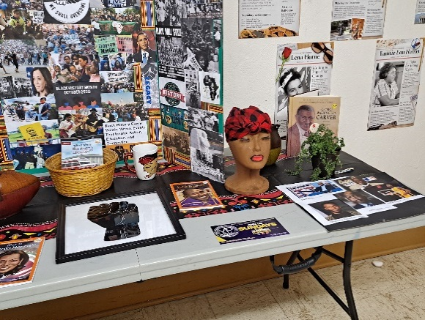***Mount Pisgah Socially Distanced Children’s Sunday School***

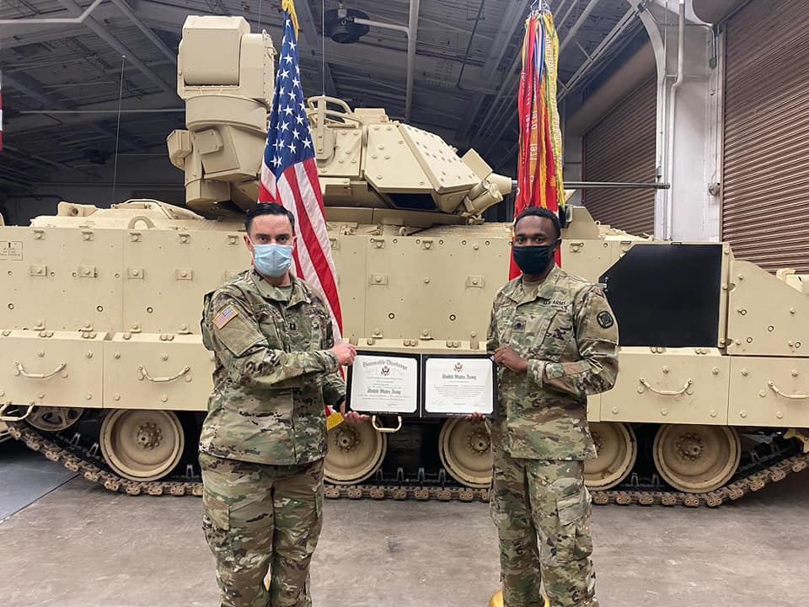As I watched the children (6-12) enthusiastically participate in their Sunday School Class, I thought to myself*, “Even in a pandemic, we can still learn about Jesus.”* The children first started meeting via Zoom on Sunday afternoons, but in December, when church worship moved to the CRC, the Christian Education Advisory Council recommended moving the class to the church fellowship hall for children church/Sunday School while parents attended the worship service. Achieving social distancing was feasible because only about 6-10 children came to Zoom. With 10 tables available, children could each sit at one table or double up if from the same household. Prior to our arrival to class, the faithful trustees always spray fog the area and wipe down everything to ensure maximum protection for our children and teachers.

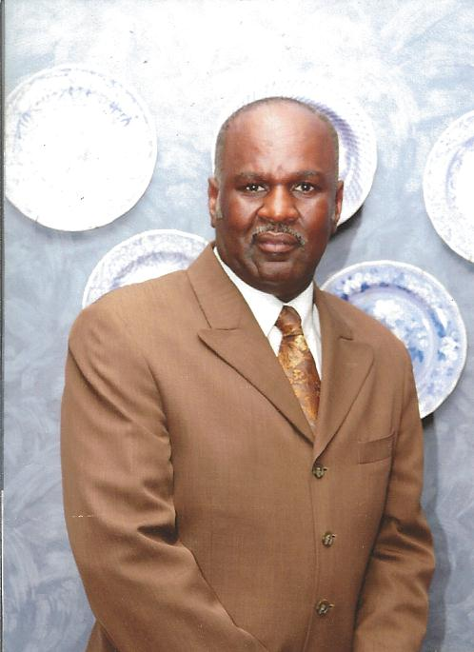The teachers, Sister Vinnette Johnson and Reverend Marciea Alford, have done an outstanding job of teaching, using interactive and hands-on strategies. It is heartwarming to see how much they put into their lessons. For the month of February, they integrated Black History into their activities. They created a Black History Museum the kids could visit, and each child received a book of his/her choice and could also borrow books. They made afro-centric paper cut-outs of themselves, portrayed Black heroes and more. On this day in particular, February21st, they were studying Priscilla and Aquila. After the lesson, they made tents from cloth and construction paper. If you get a chance, please commend our teachers for doing a fantastic job!

***Reverend Mary C. Owens, Christian Education Director***

***Daylight Savings Time begins, Sunday, March 14th***

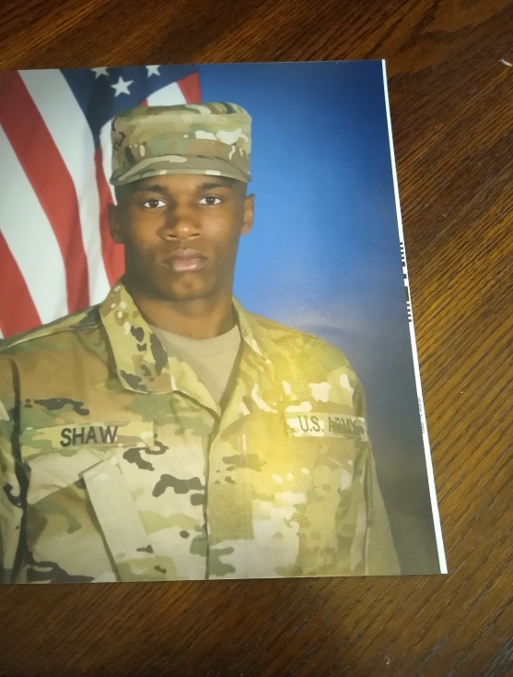***Congratulations***

***Brandon Shaw***

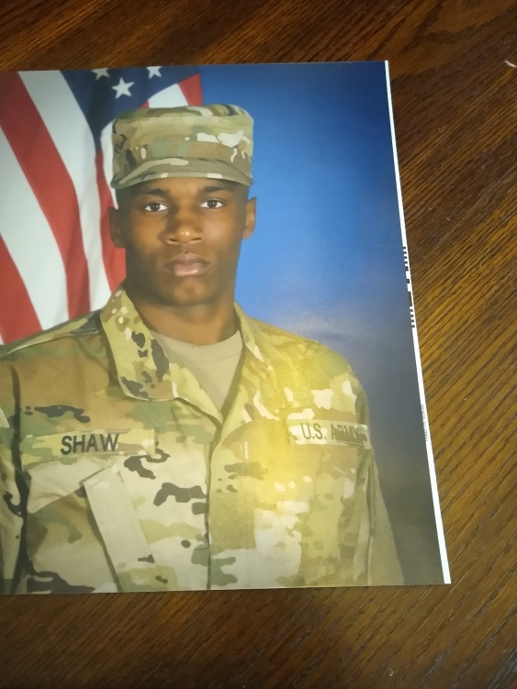 Brandon Steven Shaw received Soldier of the month in January and also Solider of the Quarter. Additionally, he was promoted to Sergeant (E-5). ***Way to go Brandon!*** He is the son of Trustee Steve Shaw and Sister Barbara Sims. He is the grandson of Trustee Emeritus Mallie and Sister Eunice Shaw and Sister Katrina McNair all of whom are members of Mount Pisgah.

**Hoke County Breaks Ground on $20 Million Leach Aquatics Center**

A large crowd turned out in spite of the rain and extreme cold on the 19th of February to witness the ground-breaking of Hoke County’s first Aquatic Center, named in honor of long term Commission member James A. Leach. Leach has served on the Board of Commissioners over 25 years, and he has always been a strong supporter of the youth and senior citizens.

From 2007-2020 Leach has served as either the chairman or vice-chairman of the Board of Commissioners.

**Mount Pisgah, the Church**

**by the Side of the Road**

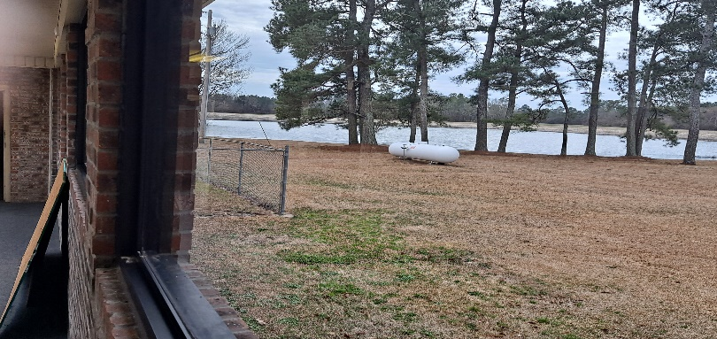

Whenever I picture Mt. Pisgah, I am reminded of the poem, *The House by the Side of the Road,* which is based in part on Psalm 1:2.

***Let me live in the house by the side of the road***

***Where the races of men go by’***

***The men who are good, the men who are bad***

***As good and as bad as I.***

***I would not sit in the scorner’s seat;***

***Nor hurl the cynic ban,***

***Let me live in the house by the side of the road***

***And be a friend to man.***

For over 120 years, Mt Pisgah has stood by the side of this road, hopefully being a friend to man, being a friend to the community, being a beacon of light, and being a friend to the lost. Over the years, the church has withstood some difficult times: burned to the ground two times when the church was a wood, clapboard structure, a church bombing in 1995, a foreclosure crisis, two subsequent splits, and often whispered plots to acquire our land and property. Yet, by the grace of Almighty God, the church still stands by the side of the road. God has shown us such favor that we can only bow in humble adoration and gratitude. Thank you, Lord, and may we prove ourselves to be those saints who *do not sit in the scorners seat or hurl the cynic ban,* but serve in the church by the side of the road.

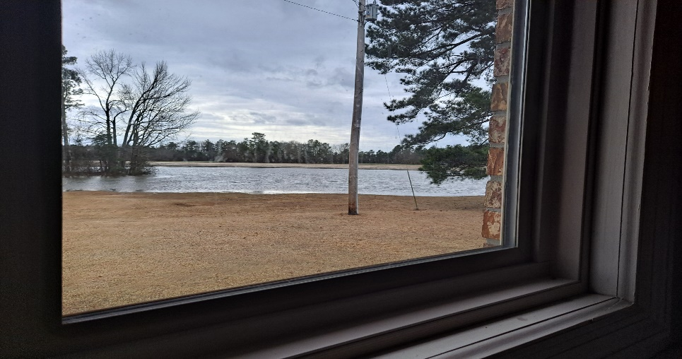

***The photos and article by Rev. Mary Owens. Photos are postal card pretty; however, looking at the water creeping closer to the Church is no joke.***

***Cavin Wilson***

***Student of the Month for January 2021 at 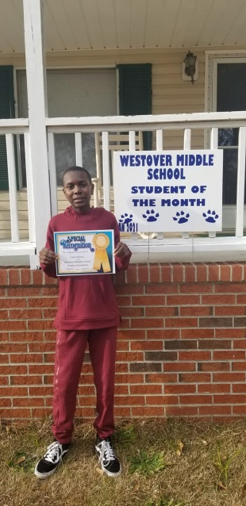Westover Middle School.   7th grade*.**

Cavin is the son of Sister Kim Wilson and Brother Cavin Wilson. He is the grandson of Deacon Calvin and Sister Flora Hadley, and the late Brother Junior Wilson and Sister Inez Wilson.

**HATTIESBURG, Miss.**-- Southern Miss junior guard [*Tae Hardy*](https://southernmiss.com/roster.aspx?rp_id=7183) has earned C-USA Player of the Week honors after his career-night in Friday's 85-72 win at FIU.  
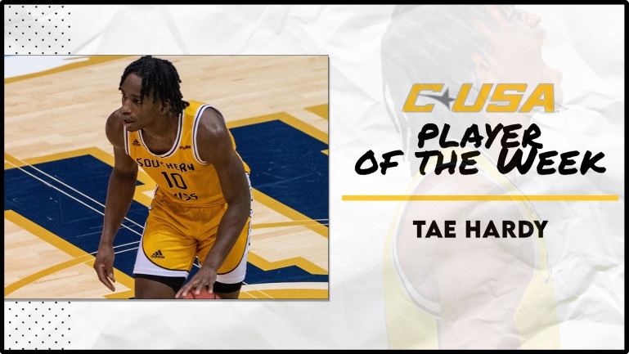  
Hardy posted a career-high 19 points (in the second half alone) enroute to a 20-point performance overall as Southern Miss turned an early 16-point deficit into a 13-point win. The Ellenwood, Ga., native was also 8-for-11 shooting with four assists and four rebounds in that half alone, while helping limit the Panthers' nationally-leading three-point attack to 2-for-16 in the period.  
  
The Pearl River CC transfer has scored in double-figures for six of his last seven road games. The 85 points were a team season-high, and Southern Miss shot 61 percent (including 70 in the second half) for its best-shooting game since defeating Marshall by 50 in January 2019. Saturday's game was postponed due to COVID-19 protocols.  
  
Hardy's accolade marks Southern Miss’s fourth of the season. Hardy is second on the team with 10.2 ppg and is 33-for-38 at the foul line (86.8 percent) since starting the season 3-for-8. Hardy is the grandson of Trustee Adale and Sister Sarah Clark**.(Copied from the Internet)  
 *Rev Mary C. Owens, CED***

**The Meaning of Easter**

(Ideas from the Internet)

The meaning of Easter is Jesus Christ's victory over death. His resurrection symbolizes the eternal life that is granted to all who believe in Him. The meaning of Easter also symbolizes the complete verification of all that Jesus preached and taught during His three-year ministry. If He had not risen from the dead, if He had merely died and not been resurrected, He would have been considered just another teacher. However, His resurrection changed all that and gave final and unquestionable proof that He was really the Son of God and that He had conquered death once and for all.

A good way to learn more about Jesus and His life on earth and what the Resurrection is would be to read some of the stories in children’s books, then go to easy reading Bibles. The story is the same; however, the writings may be easier to understand and to tell to children. The most important thing is to be able to learn of Jesus’ life and to live it so men and women, boys and girls can learn and to know Jesus as their personal Savior.

The last two verses of the song, “The Old rugged Cross” is copied below. Seldom do choirs sing all of the verses of many of the older songs; however they have meanings that tell stories.

To the old rugged Cross, I will ever be true

Its shame and reproach gladly bear

Then He'll call me some day to my home far away

Where his glory forever I'll share

So I'll cherish the old rugged Cross

Till my trophies at last I lay down

I will cling to the old rugged Cross

And exchange it some day for a crown

As an assignment, pick up a hymn book, select a song and read the words. Does the song teach anything about God, Jesus or the Trinity? Songs should help us to know more about living a Christian life, and how to find love, peace and joy in knowing Jesus died for us.

**TELL GOD THANK YOU**

***Now is the time to begin thinking of graduation, Mothers and Fathers’ Day, and other important events, therefore, be sure that Christ is on the top of the preparation list. Take time to thank our Lord and Savior for the many blessings you receive. Also, pick up a box of cards and say “thank you” to others who bless you.***

**My Personal Fasting Journey**

Pastor McCrimmon asked the church to participate in a 21 Day Fast beginning February 1, 2021. At first, I thought are we just doing this because 21-day fasts have become a popular trend over the past 15 years or so on, usually beginning first day of January. I mulled over it for a few days, seeking God for guidance, until it was revealed to me that this is just what I needed for the unfed hunger in me to have a deeper, abiding relationship with the Lord.

Before Jesus left the upper room to go to the garden to pray, He prayed that His disciples would know the oneness of God abiding in them and they, likewise, abiding in Him. What a beautiful thought! To know and be assured of the deep relationship with God to be able to say, ***“We are one.”*** It was also a time of renewal and refreshing, of returning to things I used to do to nourish my spirit in striving to grow more in Him. Each day as I prayed over the things on my heart, I would study and meditate over related Scriptures. Then, I would journal my thoughts, prayers, and any other revelations. This was a practice I use to do every morning but got lost in the busyness of life. It also brought conviction because fasting at least once a week had been part of my regular lifestyle.

How did I grow so far from doing what I knew strengthens me? It is all about subduing the flesh. Do I hunger more for those things that make my flesh feel good rather than for hungering and thirsting after God? One thing I did learn from this time of fasting is that making time for God has to be intentional. My commitment to Him must be intentional, not hit and miss. In short, I am so thankful for this fast and pray my continued growth in the Lord and in His Holy Spirit, that He abide in me and I abide in Him. ***Rev. Mary C. Owens, CED.***

***NEWSLETTER STAFF***

[***emcneill1005@aol.com***](mailto:emcneill1005@aol.com)

***Sister Ellen McNeill, Editor 910-875-3237***

***Reverend Mary C. Owens 910-670-5662***

***Sister Vinnette Johnson 404-240-0644***

***Deacon Joseph Johnson 910-425-3709***

***Sister Denise Wallace 910-257-1678***

***Dr. Adrienne Monroe 910-583-3693***

***Sister Pam Shaw 910-229-2500***

***Show love by protecting yourself and others***

***Be Safe, Wear your Mask, Wash your hands, and Social Distance***