The Voice
Mount Pisgah Missionary Baptist Church, 414 Pittman Grove Church Road, Raeford, NC 28376
Telephone 910-875-5744 Fax 910-875-0053
Website: mountpisgahmbc.com email: mtpisgahraeford@gmail.com
120th Edition January-February 2021
----------------------------------------------------------------------------------------------------------------------------------

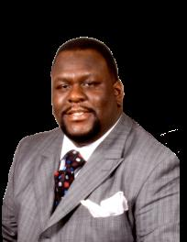
Black History and the Black Church

Holmes, D. (n.d.). https://goblackcentral.com/2013/02/black-history-and-the-black-church/
As we celebrate Black History and the African-American role in the development of this country, we should take a moment to focus in on the most integral component of that movement, the Black Church. It is impossible to talk about black history without talking about the part that the Black Church has played in it. Unknown and unappreciated by many is the role that the organized members of the household of faith played in changing the social landscape of America. The Black Church arises as a byproduct of the reality of racism in America. Prevented from worship with our white counterparts, we worshipped God with one another. And from there, the Black Church has always been significant. In the 25th chapter of the book of Genesis, we find a very familiar tale. The story of two brothers: Esau & Jacob. The Bible tells us that Esau, returning home famished from laboring in the fields, begged Jacob to give him some of the stew that he had just prepared. Jacob, jealous of the favor and royalty that Esau had been born into, offered to give Esau a bowl of stew in exchange for his birthright. Esau foolishly agrees to his brother’s proposal and barters his birthright for something uneven in worth. Even deeper, Esau values his personal position more than the legacy he is not only born into but privileged to be a part of.
The historical context for the Watch Night services that are currently held around the country on New Year’s Eve is found in the beginnings of the Black Church. In the 1800’s, slaves and freeman were gathered in churches on New Year’s Eve praying together while awaiting the signing of the Emancipation Proclamation.
The Montgomery Improvement Association that later started the Montgomery bus boycott back in 1955 was not the brainchild of an elected official or government
Continued on page 4
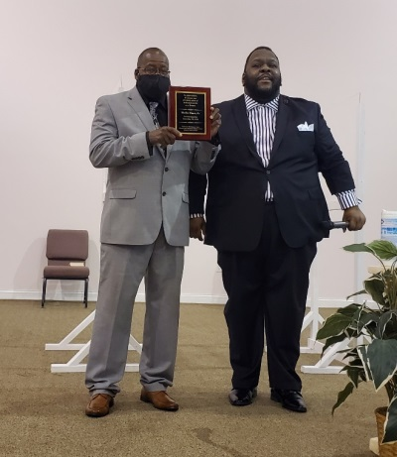
BROTHER
MALLIE SHAW
Honored
Trustee Emeritus

Growing up in Mount Pisgah, there were a few things that you could count on seeing. You knew Deacon Will Ray was going to pray; Deacon Campbell was going to sing, I Am Thine O Lord, and you were going to see the two Shaw brothers, Mallie and Archie Shaw faithfully serving as trustees. They, along with their other brother, Charlie, would always help cook when the men use to fry the chicken outside for Men’s Day and Homecoming. Once upon a time, before churches paid for jobs to be done around the church, the trustees and men of the church always handled major clean up jobs and were responsible for keeping the grounds manicured and the grass cut. The two brothers were both quiet, but if the trustees were doing anything, they would be quietly, diligently working. Brother Shaw was recommended for this honor because he is the longest living trustee in Mount Pisgah and he served faithfully for more than 50 years as a trustee.

Mr. Shaw born in 1927 is 91 years old. He is married to Sister Eunice Shaw and they have been married for 62 years and are the proud parents of four children. Mr. Shaw also served in the United States Army and he and his sons have a proud history of serving in the military. Mr. Shaw could not be present to accept his award and the title was conferred upon him, but his faithful son, Steve, was present to accept the award on his behalf. Members of the church voted to honor Brother Mallie Shaw as Trustee Emeritus because he served faithfully for all these years and is worthy of the honor bestowed upon him. Congratulations Brother Shaw, thou good and faithful servant!
Reverend Mary C. Owens
Luke 16:10
He that is faithful in that which is least is faithful also in much: and he that is unjust in the least is unjust also in much. Page 1
KAMI DALE, MS QP
Congratulations Kami. We are so proud of you and of your achievements.
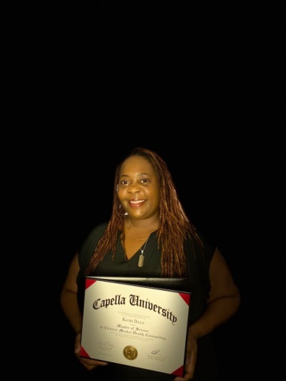
Kami has been employed by Precious Haven, Inc. about 12 years. She is a residential supervisor. She is originally from Newport News, Virginia, by the way of Wilson, North Carolina, where her parents currently reside.

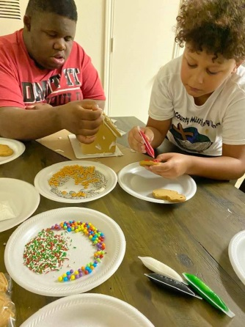
Kami, a graduate of Fayetteville State University in 2003, has been working in the mental health field for about 17 years. Her bachelor’s degree is in banking and finance. She recently received her Master of Science in Clinical Medical Health Counseling. In the spring she plans to take the National Counseling Exam as she works to become a licensed clinical mental health counselor.

Ms. Dale enjoys spending time with her boys Kalil and Kristian and their friends. Recently they spent time making Christmas crafts and cookies. Yes, boys enjoy doing those things too.
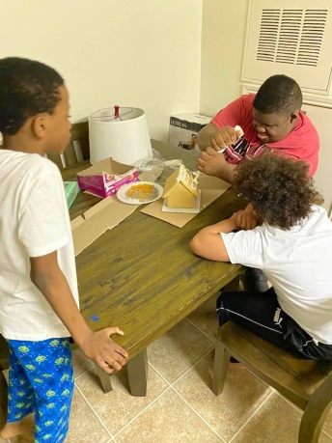
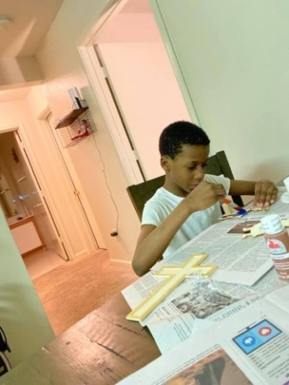
She enjoys mentoring and helping teens as they navigate life. She sings with a choir, and assists wherever she is needed in our Church.
Congratulations Kami, we are proud of you.
We will not conceal them from their children, But tell to the generation to come the praises of the Lord, And His strength and His wondrous works that He has done. Psalm 78:4
History Making All-Black Crew
Officiate NFL Football Game

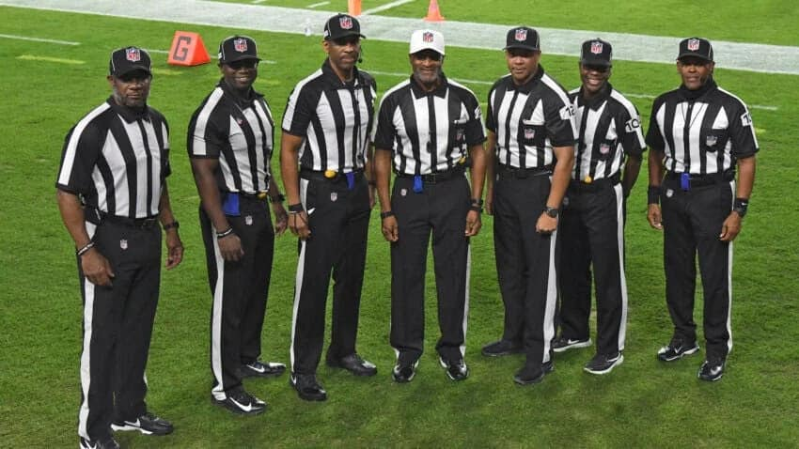
Monday, November 23rd turned into a black-lettered day in the NFL. The first time in league’s history, the Los Angeles Rams played the Tampa Bay Buccaneers in Tampa, Florida with an all-Black officiating team. Referee Jerome Boger, umpire Barry Anderson, Julian Mapp, Carl Johnson, Dale Shaw and Greg Steed. Additional information is available by googling and reading newspaper accounts from your favorite media.

We long for the day when there will be no need to write about blacks “firsts” in any area. Thankfully, times have been slowly changing and more and more people of color, different religions and creeds are moving into mainstream America. A good thing about America is that with preparation, including very hard work, many are able to realize their dreams. Those who have been a first pave the way. Once the ceiling is cracked, it is easier for others to enter.

Congratulations to the men who participated in this historical event.
--------------------------------------------------------------------
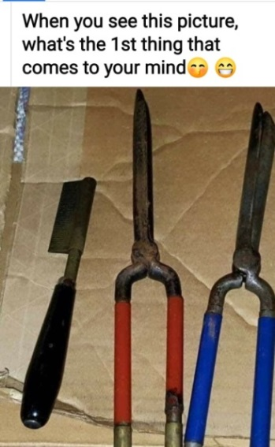
Saturday afternoons and nights getting hair done for Church. Tools for being sure your hair was properly styled and clothes ironed.
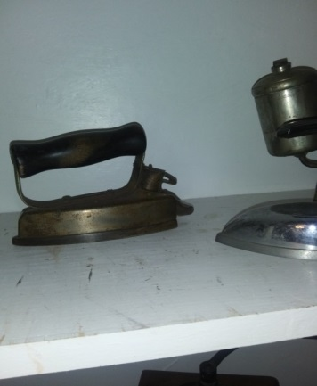

Older irons were placed in a fire place to heat before ironing clothes. The good old days were not all good! Page 2
MISSION IN ACTION
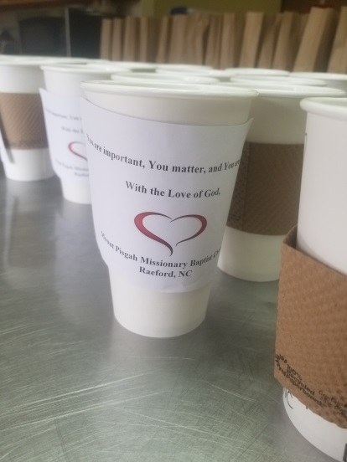
In today’s society, helping others is more important now than ever. The Word of God says “The fields are white with harvest, but the laborers are few” in Matthew 9:37. The goal of an A1 Missionary Circle in every Missionary Baptist Church is to have all three departments; Senior, Young Adults, and Youth to be fully operational. The motto of the Women’s Baptist Home and Foreign Missionary Convention of North Carolina (an auxiliary of the General Baptist State Convention of NC, Inc. and the governing body of local Missionary Circles) is: “Christ in Every Home”. The brunt of Covid19 halted many of the plans of the Missionary Department of Mount Pisgah, but now is the time that we are to do what we can, while we can.

In the spirit of providing aid to the less fortunate, the Mount Pisgah Missionary Department, led by Sister Elizabeth McNeill was able to prepare 50 bag lunches filled with hot soup, crackers, a snack cake and a bottle of water and passed them out to citizens in Fayetteville found in tent cities, under bridge ways, and in a FEMA sponsored hotel downtown Fayetteville. Holiday care bags were prepared for the sick and shut in of Mount Pisgah for Christmas, and we are giving school supplies to assist with the Fayetteville-Raeford Cares Mentoring Program. Mission project ideas are always welcomed. Please contact Sister Elizabeth McNeill or Sister Deborah Baker.
Sister Alison White

GIRLS WITH PEARLS: A WOMEN’S MINISTRY VIRTUAL EVENT
The Women’s Ministry held its first virtual chat and chew luncheon. Participants were inspired to wear their pearls and join in as they listened to spiritual nuggets based on the theme: “The Power, Prosperity, and Perseverance of a Woman”. Inspired by the recent election of Senator Kamala Harris to the office of Vice President of the United States and the coming together of women all over the country, we were blessed to hear from three dynamic speakers and an anointed psalmist.
Minister Rosa McAllister-McRae a Hoke County native, Board of Education, Chairman Hoke County Board of Education, and the mother of Mrs. Krystal Cooper, drummer for our Music Ministry, spoke on the Power of a Woman. Mrs. Rolanda Clark Thomas, daughter of Trustee John and Minister Vina Clark spoke on the Prosperity of a Woman, and Minister Rayvonda Rowe, an Associate Minster of the Leach Springs Missionary Baptist Church spoke on the Perseverance of a Woman. All three of these wonderful speakers left those in attendance with encouraging and thought-provoking messages. Mrs. Robianna Kelly Tucker, daughter of the Late Dr. Robert Kelly and Evangelist Ruby Shields Kelly gave us two soul stirring selections. Everyone left, or “logged off” feeling revived, empowered, and rejuvenated! Minister Rosaland Loyd and Sister Alison White, the Women’s Ministry leaders, gave remarks and departing blessings to all. Please see them if you have any ministry ideas or suggestions.
Sister Alison White

THE FOOD PANTRY
On December 12, 2020, the Food Pantry Ministry of the Church held its monthly food giveaway. Many families were blessed. Volunteers worked tirelessly to accommodate all who came. After receiving bags of food and a turkey, the recipients were also blessed with a hot dog, chips and a soda. To God be the Glory for the Great things He has done!
Sister Kimberly Wilson
Page 3
December 2020 Youth Calendar
The month of December was an incredibly special month for Mount Pisgah Youth Department. This brings about the lessons of the Birth of Jesus, the promised one, and Jesus the Christ. In their many activities during December they sponsored a family for Christmas. They learned the importance of giving and being a blessing to others.

They were busy designing and decorating a gingerbread house, painting Christmas ornaments, and playing Christmas games all while enjoying the spirit of giving. Their teachers Rev. Marciea Alford and Sister Vinnette Johnson have been teaching virtual/classroom time this year. To end the year of 2020 on behalf of the youth department and Mount Pisgah family, we would like to say “God bless you and may the peace of God be upon many families this Holiday Season”
Reverend Marcia Alford

Continued from Page 1 – Black History and the Black Church (Submitted by Pastor McCrimmon)
agency, but rather the product of community churches coming together and organizing strategic ways to mobilize people and speak out against racial injustice in the Jim Crow south.
In the 50’s & 60’s, the Black Church was not only a place for praise and worship but also a bulletin board for the African-American Community; a center of political activism. Not only Martin Luther King Jr, but also Ralph Abernathy, CT Vivian, Fred Shuttlesworth, Bernard Lee, Otis Moss Jr., Andrew Young, Joseph Lowery, Gardner C. Taylor and a host of others find the beginnings of their national influence in the black churches they preached in on Sunday morning.
The Black Church has always represented the spiritual and moral foundation for the United States; allowing the Love of God that overflowed in their churches to spill over in our communities. So as we celebrate another Black History month, crediting those brightest among our people, we must be certain to give credit to that which has always been the backbone of our community & the conscience of our country, the Black Church. The Black Church is literally founded fighting for freedom; seeking to establish our spiritual and social identity; and in times such as these, where many work to make a minimum wage lower than the living wage in our country…where brothers & sisters are still violently victimized because of the color of their skin…where many in power are more concerned with economics than ethics, if we choose not to re-embrace the history that the church is steeped in and cease to fight for freedom, then we have maddeningly sold our birthright just as Esau did to Jacob centuries ago.
It is impossible to talk about Black History without talking about the Black Church. And in February, we ought to take time to celebrate her and all God has done for our people through her. But, as we celebrate her, we must also see this time as a call to arms; a reminder of whom we are accountable to. We are accountable to the God we serve and of all of His children who we are charged to introduce Christ to. Knowing what legacy was left to us, this month, we must ask ourselves: what is the legacy we will leave behind?
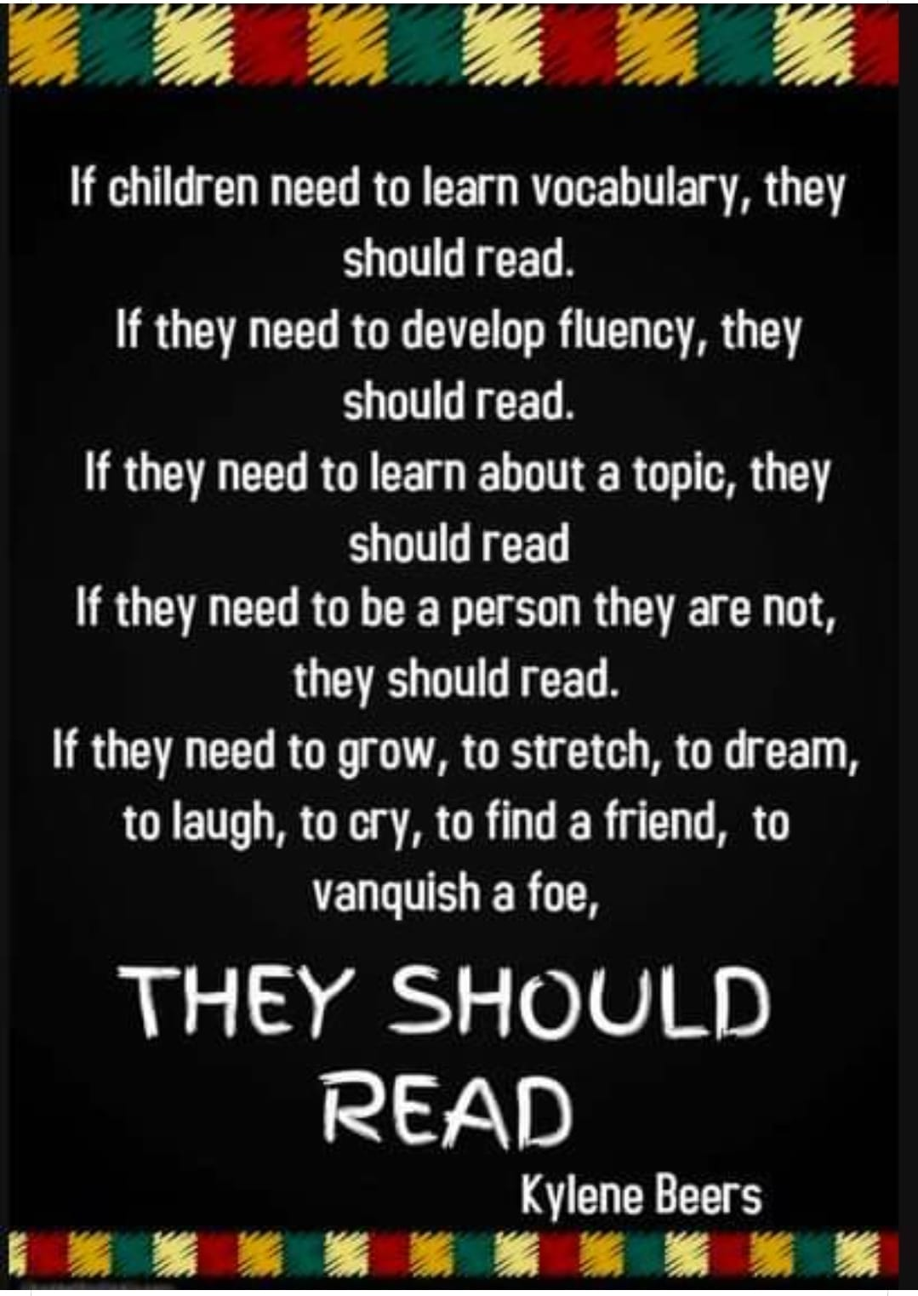
“But I would not have you to be ignorant, brethren, concerning them which are asleep, that ye sorrow not, even as others which have no hope.” 1st Thessalonians 4:13 Page 4

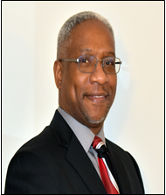
Mount Pisgah Ordains Three Deacons and Two Ministers

Mount Pisgah has long been known as a pacesetter or for introducing new ways of doing things. The 21st of November was one of those red-letter days as three deacons and two ministers were ordained in the same session.

Social distancing was practiced during the services with a limited number of family, friends and members of the church in attendance.

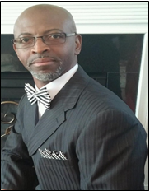
Reverend
Robert E. Alford

Rev. Alford has been preaching over 20 years. He and his wife have actively been working in Mount Pisgah since January 2019. He is retired from the military after having served 26 years.
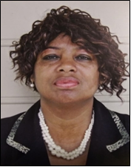
Reverend
Marciea B. Alford

Rev. Alford is a middle school teacher. She has extensive experience in preaching, teaching and evangelism. She is a dedicated worker, who enjoys serving.
She has authored two books, and is writing a third one that will soon be published. She has an interest in Christian Education and is pursuing a Doctorate in Ministry.
1 John 3:24

Whoever keeps his commandments abides in God and God in him. And by this we know that he abides in us, by the Spirit whom he has given us.
Deacon Carlos Agard

He was born in Panama, reared in New York, confessed Christ as Savior, and married to Marcia. The couple spent from 1998 until 2018 in Florida. They have two children, Nathaniel and Joanna.

Deacon Agard worked for the county school system in the IT department and earned his Master Degree in Information Systems.

Deacon
Randy Geiger, Sr.

He was born in Kershaw County, South Carolina, and reared in a loving and, hard- working family. He and his wife Caroline have two children, Randy Jr. and Kiara. They have on grandchild, Kaleb. He served in the military and was honorably discharged. He has served faithfully in our church in many positions. The family moved its membership and returned later, and continues to be dedicated and hard-working individuals.

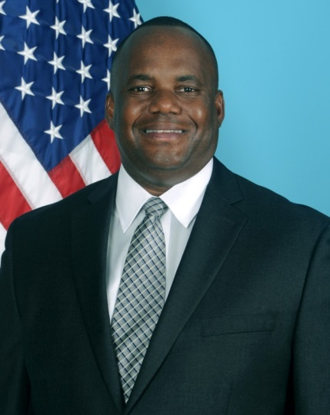
Deacon
Darryl Shaw, Sr.

He was born and reared in Miami, Florida and spent 25 years in the military. He and wife Pamela have two children, Darryl Jr. and Candace. They are also proud grandparents of Naomi and Jaelyn
His Bachelor of Science Degree is in electrical engineering, a Master of Arts from Webster University and is currently pursuing Master of Arts Degree from Liberty University. Page 5
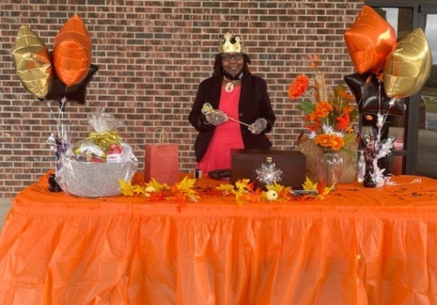
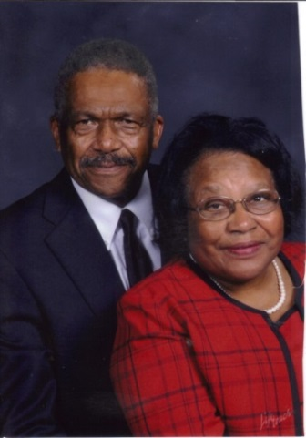
Willie and Ellen Celebrated 55 Years
December 3, 2020

Both were born and reared in Hoke County, and are life members of Mount Pisgah. They attended the rural White Oak School across from the Church, and all of their married life they have lived within 10 miles of Mount Pisgah. The Church has always been an integral part of their lives.

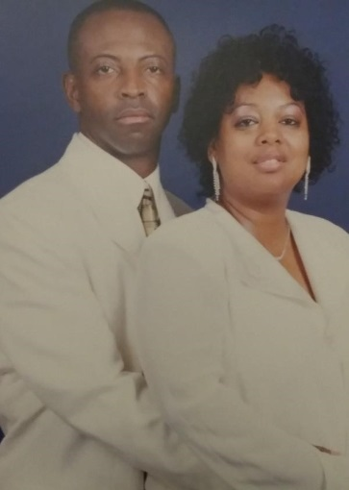
Reverend Marciea Alford and
Reverend Robert Alford
Dedicated and hard-working members
of Mount Pisgah

Christmas is a wonderful time of celebration! The Alfords announce two special blessed events within their home this month.
Reverend Marciea Alford will be celebrating her 60th Birthday on December 24th.
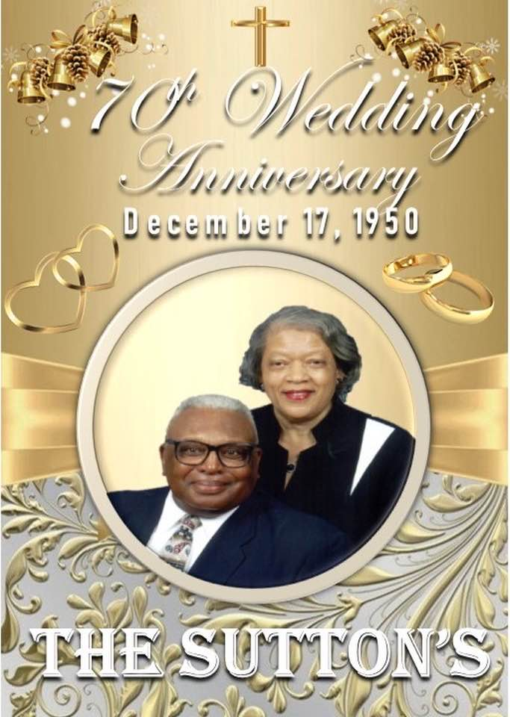
Moreover, Reverend and Reverend Alford will be celebrating 40 years of Marriage on December 27th. “Wont God do it!”
Roy and Jeanette Sutton
70 Years and Counting

Roy and Jeanette have seen many things in the 70 years of marriage. Young couples should spend time learning how to live with each other for three-fourths of a century.

Congratulations to the KEENAGERS with 165 years of marriage among the three couples!

Saying Goodbye to a Faithful Servant
Rev. Vermatine (Verma) Williams moved to Raeford in 2005 and within a few months, became a member of Mount Pisgah. At first glance, we all thought Verma was very much on the quiet side and not much on voicing her opinion. Wow! Did we learn differently! She was a great talker and communicator. Also not only did she have her own mind and opinions, but neither did she mind voicing them. To many of us female ministers, she was like a liberator. Verma was open and transparent and did not fear questioning the status quo. We just accepted some things, but in minister meetings, she did not mind asking why;” whereas, the rest of us would tread lightly or would be somewhat hesitant to speak our true thoughts. We all hate to see Verma move back to her beloved family and port city, Charleston, South Carolina, but we always knew that one day, she would return home. Most of us probably have a favorite Verma story, but I think most of us remember her as a praiser, a prayer warrior, and as one who could and would preach the Gospel. She was anointed to do them all, but so often her praying seemed to open the door for the move of the Holy Spirit.
Over the past six years or more, Verma served as the Senior Services Coordinator for our church through the Hoke County Seniors Program. She found her niche for serving others in this daily two hour program which fostered a relationship of love and trust. While most of us as mothers and grandmothers always have our eyes on the look-out for our sales or things for our children and grandchildren, she was always looking out for what her seniors would like, then of course, would buy whatever it was. We jokingly, referred to the seniors as her babies. Her love and dedication for them went beyond the job. They became her extended family and although she was younger than all of them, she became the protective mother hen, loving, scolding, and correcting them as needed. Verma came here unknown to all of us, but I think we can say that our church and many of us are much better for her passing this way.
Reverend Mary Owens

“For I was an hungered, and ye gave me meat; I was thirsty and ye gave me drink; I was a stranger, and ye took me in.”
Matthew 25:35
Page 6
COMMUNITY EMERGENCY AID TRAINING
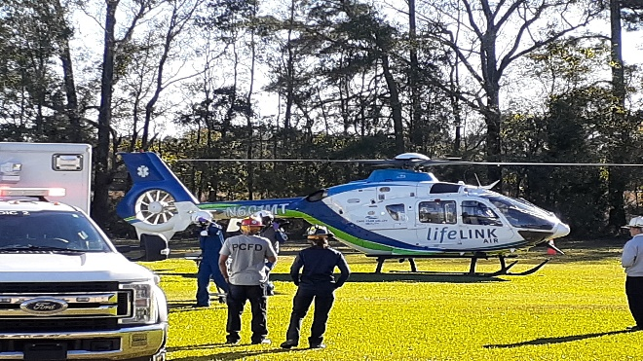
On November 16, 2020, the Hoke County Sheriff Department, various Hoke Fire Departments, and Cape Fear Valley EMT conducted an Emergency Training Drill on the grounds of Mount Pisgah MBC. The site came alive with action as the vehicles arrived with a flurry of activity conveying a sense of urgency. The different emergency teams focused on attending a victim while waiting to transport him to a medical site via the Life Link Helicopter from CFVMC.
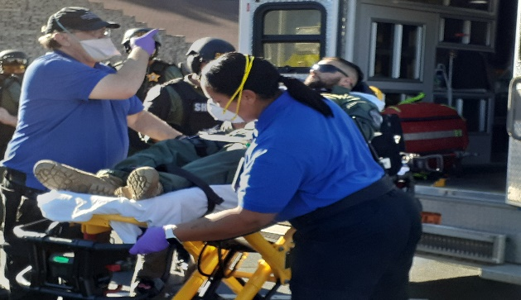
We, the church staff, were allowed to watch the proceedings. I told them I would like to write an article about the training for our newsletter, and they cordially invited me over for a closer look and patiently answered my questions while waiting for the copter. Everyone waited with anticipation for the helicopter to arrive. It circled a couple of times before the pilot chose the spot for landing. Once it landed, the first responders sprang into action. It was interesting to watch, particularly knowing I was not watching a real, life threatening accident. I came away with a greater appreciation for how critical time and precision are in saving a life in critical situations. We commend all of the emergency agencies and first responders for the herculean jobs they perform daily putting their lives on the front line. God bless you all!

But seek ye first the kingdom of God, and his righteousness; and all these things shall be added unto you. Matthew 6:33

Why Is the FASFA Important?

(Copied from the Internet)
The FAFSA, or Free Application for Federal Student Aid, is a form that students fill out to apply for federal grants or student loans. The government assesses the information you submit to determine which types of financial aid you may qualify for. The 2020-2021 FAFSA form is now available—and the maximum Federal Pell Grant amount you may receive, if you’re eligible, is $6,345.^{i}
Five Things You’ll Need to Apply For the FAFSA^{ii}
- Your FSA ID: This is a username and password that allows you to fill out the FAFSA online. You create it when you access the form.
- Your social security and driver’s license numbers: If you don’t have a driver’s license, just include your social security number.
- Your tax records: You’ll need to report your taxed and untaxed income (or your parent’s information if you’re a dependent).
- Records of your assets: This includes your (or your family’s) checking and savings account balances and the value of any investments including real estate.
- A list of schools you’re interested in attending: You can include up to 10 schools that you’re considering, even if you haven’t applied or been accepted yet.
Check with your school guidance counselor for additional information or research further. The time you use to research will pay great dividends.
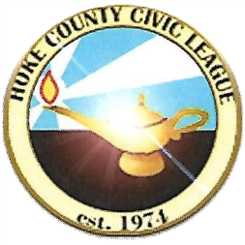
Reverend Larry Simmons Resigns as
Civic League President

Effective January 1, 2021, Reverend Simmons will no longer be president of the Hoke County Civic League. He has turned in his resignation after having served faithfully and progressively for two years. He ushered in modern technology—updated Facebook page which portrays pictures of the most active churches, emails and texts of information, and working with others supported a food drive at the Mount Pisgah Church Community Resource Center.
.
Virtual services were held for annual days, except last year the MLK Banquet was on schedule before the pandemic. Congratulations Rev. Simmons and staff for many jobs well done! Enjoy your retirement as you continue to support the League and its efforts to make Hoke County and surrounding areas better for all people.
Page 7
3 John 1, 2 “Beloved, I wish above all things that thou mayest prosper and be in health, even as thy soul prospereth.”

We are in a day and age not unlike any other, if we take time to consider the various habits we indulge in that have the ability to build us up or tear us down. There are countless ones of us suffering silently, and too often turn to substances to ease our pain. Choosing this route is called “Self-Medicating,” and it will not solve your problems. Alcohol is not the answer; nor are drugs the cure. If you need to talk to someone, help is available. Pray and ask the Lord to guide you and then follow through. Recovery, healing, and deliverance are unquestionably gifts from God, but there is work for us to do. Find a good therapist. If you need help locating one, we are happy to assist you. Prayerfully this story will help someone who is going through.

The Unsympathetic Destroyer
I destroy homes, tear families apart, take your children, and that's just the start. I'm more costly than diamonds, more costly than gold, the sorrow I bring is a sight to behold. If you need me, remember I'm easily found. I live all around you, in schools and in every town. I live with the rich, I live with the poor, I live down the street, and maybe next door. My power is awesome; try me you'll see, but if you do, you may never break free. Just try me once and I might let you go, but try me twice, and I'll own your soul. When I possess you, you'll steal and you'll lie; you do what you have to just to get high. The crimes you'll commit, for my narcotic charms will be worth the pleasure you'll feel in your arms. You'll lie to your mother; you'll steal from your dad. When you see their tears, you should feel sad. But you'll forget your morals and how you were raised, I'll be your conscience, I'll teach you my ways. I take kids from parents, and parents from kids, I turn people from God, and separate them from friends. I'll take everything from you, your looks, and your pride, I'll be with you always, right by your side. You'll give up everything—your family, your home, your friends, your money, then you'll be alone. I'll take and take, till you have nothing more to give. When I'm finished with you, you'll be blessed to live. If you try me, be warned, this is no game. If given the chance, I'll drive you insane. I'll ravish your body; I'll control your mind. I'll own you completely; your soul will be mine. The nightmares I'll give you while lying in bed, the voices you'll hear from inside your head, the sweats, the shakes, the visions you'll see; I want you to know, these are all gifts from me, But, then it's too late, and you'll know in your heart, that you are mine, and we shall not part. You'll regret that you tried me, they always do, but you came to me, not I to you. You knew this would happen. Many times, you were told, but you challenged my power, and chose to be bold. You could have said no, and just walked away. If you could live that day over, now what would you say? I'll be your master; you will be my slave, I'll even go with you, when you go to your grave. Now that you have met me, what will you do? Will you try me?
Submitted by Dr. Adrienne Monroe, Health Ministry
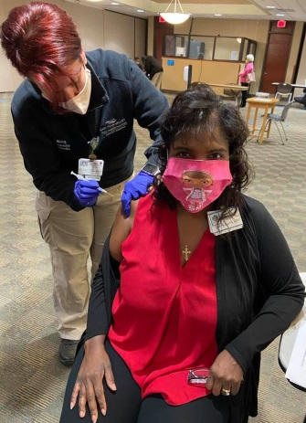
Dr. Karen Smith Receives
Covid-19 Vaccination

On the 23rd of December Dr. Smith rolled up her sleeve and received the first dose of Pfizer-Bio vaccination. Speaking with her on my last visit, I asked her about the vaccine, and was assured that she planned to take the vaccine. “I will not ask my patients to take a medication that I will not take.” I like that. Yes, I too, plan to take the vaccination and encourage others to do so.

THANKS TO ALL OF THE CONTRIBUTORS TO THE CHURCH NEWSLETTER

As you read this edition, you will notice several new contributors. We are grateful for the ones who stepped up. We also have an additional proofreader. I am not naming them so you can read, see who participates and let them know you appreciate their work for Mount Pisgah. Yes, we are better together! The staff of the Newsletter expresses grateful appreciation for whatever volunteer work you do in The Mount!

NEWSLETTER STAFF
emcneill1005@aol.com

Sister Ellen McNeill, Editor 910-875-3237
Reverend Mary C. Owens 910-670-5662
Vinnette Johnson 404-240-0644
Deacon Joseph Johnson 910-425-3709
Sister Denise Wallace 910-257-1678
Dr. Adrienne Monroe 910-583-3693
Sister Pam Shaw 910-229-2500

Be Safe, Wear your Mask, Wash your hands, and Social Distance

