The Voice
Mount Pisgah Missionary Baptist Church, 414 Pittman Grove Church Road, Raeford, NC 28376
Telephone 910-875-7544 Fax 910-875-0053
Website: mountpisgahmbc.com email: mtpisgahraeford@gmail.com
Centennial Edition 100 Editions Strong March –April 2019
----------------------------------------------------------------------------------------------------------------------------------

General Assembly Back in Session

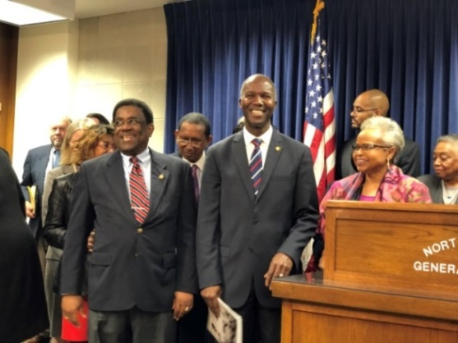
Representative Pierce, Senator Ben Clark and Senator Gladys Robinson at the Medicaid Expansion Press Conference at the NC General Assembly in Raleigh, NC (Copied from FB)

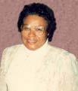
100th EDITION OF
THE VOICE

It is difficult to believe we have prepared 99 issues of The Voice, and this makes the historic 100th edition. I thank God for the opportunity to have served the Mount Pisgah Church Family as its editor. The work continues to be a challenge; however, I learn something new with each edition.

I extend a hearty “Thank you” to each individual who has submitted an article, photo, poem and/or constructive criticism. Thank you, too, for those words of encouragement. Much of my encouragement comes from outside our Church Family. Two individuals continually reinforce the need to share good news through The Voice; namely, Ms. Emma Mims, my former Physics Instructor and Mrs. Jessie B. McNeill, a former co-worker when I was Upchurch High School Secretary. Rev. Mary Owens submits articles each month on behalf of the Christian Education Department, and other members periodically send material. Sister Ligeia Robinson has been consistent over the years in sending poems and articles. To each person who aids in the publication of The Voice, thank you. You make it happen!
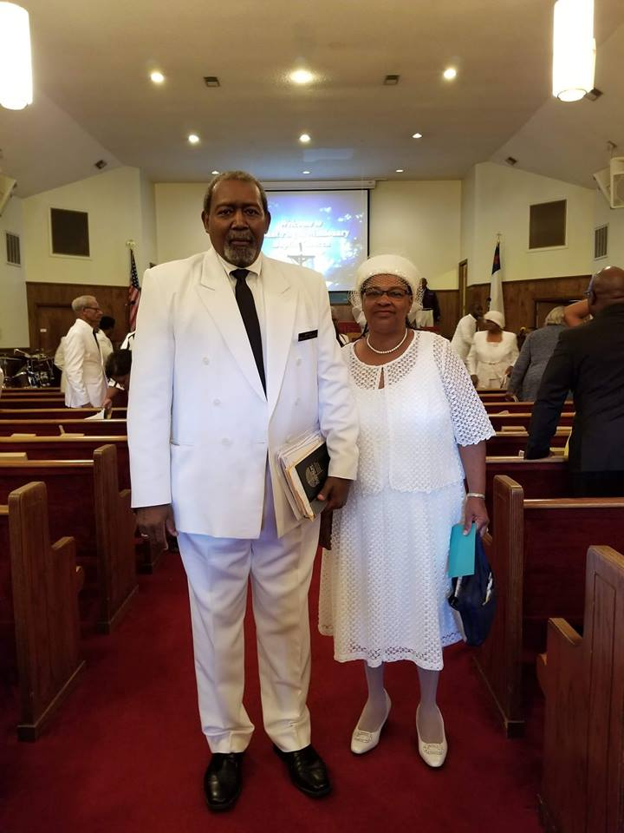
Deacon and Sister Hadley 45 Years of Marriage, January 5, 2019

They are the parents of two children, Kim and Ricky and two grandchildren.

Deacon and Sister Hadley are lifelong members of Mount Pisgah, and they have been actively working in the church since joining as youth. They exemplify a family worshipping together. Congratulations on 45 years of marriage, and each of those years have been a part of the Mount Pisgah Church Family.

ON A HILL STOOD AN OLD RUGGED CROSS
Luke 24:47-49

It is written, it behooved Christ to suffer, and to rise from the dead, the third day. And that repentance and remission of sins should be preached in his name among all nations, beginning at Jerusalem, and ye are witnesses of these things. Behold I send the promise of my Father upon you; but tarry ye in the city of Jerusalem, until ye be endued with power from on high.
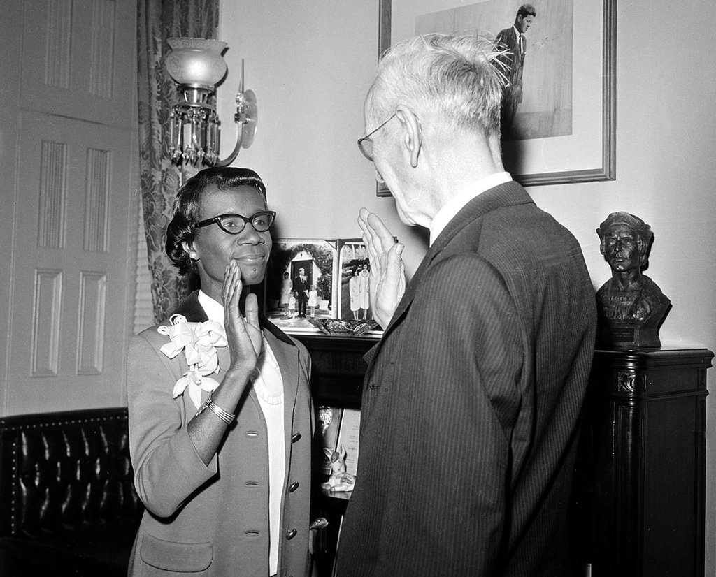
Shirley Chisolm first Black woman sworn in Congress

As a member the Board of Commissioners in Hoke County, Sister McNeill adopted Shirley Chisolm, mantra, “Unbought and unbossed!

Dr. Gladys West, Black Woman, Invented the GPS

Did you know that a black woman from Virginia was instrumental in creating a convenience we use every day and almost can’t live without? Yes indeed, Dr. Gladys West invented the GPS or the Global Positioning System and has finally received the recognition she deserves by being inducted into the Air Force Space and Missile Pioneers Hall of Fame by the United States Air Force during a ceremony held at the Pentagon.

The 87-year-old scholar knew as a child that she did not want to work in fields, picking tobacco, corn, and cotton or in a factory, beating tobacco leaves for cigarettes and pipes like her parents did. She said, “I realized I had to get an education to get out.” And that she did, studying math at Virginia State University and graduating top of her class. She became a teacher for two years, then went back to school for her Masters.
In 1956, West began to work at Naval Surface Warfare Center Dahlgren Division, where she was the second black woman ever to be employed. There, she collected data from satellites, and that job is what eventually led to the development of the Global Positioning System.
Youth Day, Sunday, January 13th
10 A.M. Worship Service
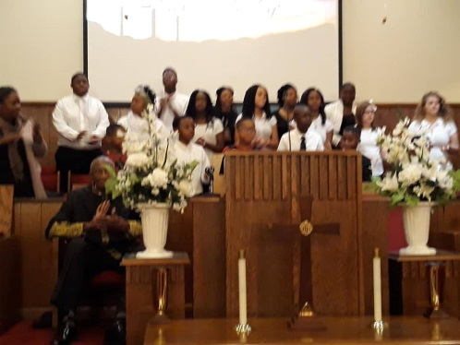
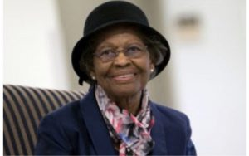
The new Youth Group had never sung before the congregation prior to the second Sunday. Thanks to Sister Alison White and others, they were enthusiastic and excited to be able to sing. They poured their hearts out, and God blessed the Worship Services. Later they sang at the Hoke County Missionary Union, and again God blessed the Worship.

Words Have Meanings

Encourage yourself. You are stronger than you think you are. Believe you can achieve and you will. Pray and work on yourself.

Be Kinder than Necessary: It does not take any money to be kind. Hold the door open for the next person. Smile. Say encouraging words to others, and by all means soften your voice. The old saying, “If you can’t say something nice, don’t say anything!”

At every opportune time, use your magic words, “Please, Thank you, May I and you go First!” Those words will help you achieve your goals in the home, school, church or in the business world.

Be Strong; yet Gentle: You do not have to be mean. Be gentle of other folks’ feelings. When angry, hold your words until you can speak them in a nice way. Practice the Fruit of the Spirit!
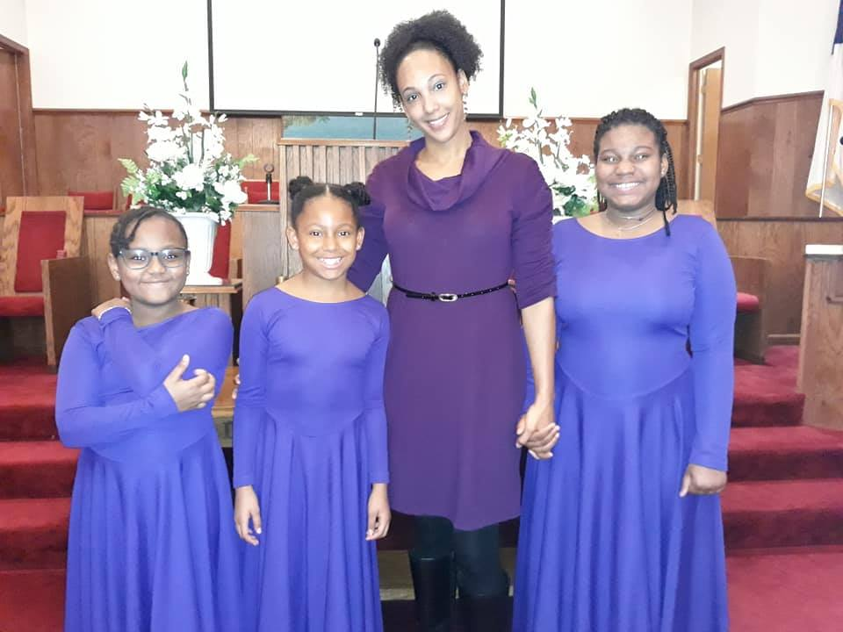
Praise
Dancers Youth Day
Jan 13, 2019

Mount Pisgah Praise Dancers are reorganized under the direction of Sister Ligeria Robinson. They danced in front of the church for the first time on the 13th of January in the 10 a.m. services. They also danced for the Hoke County Missionary Union Youth Day Services. Little is much when God is in it. They moved both services with their grace, smiles on their faces, and some really exciting twirling! Yes, God is blessing Mount Pisgah as He lifts our spirts and revives us again.

KITCHEN COMMITTEE THAT WORKED FUNERAL REPAST FOR ALEX CLARK

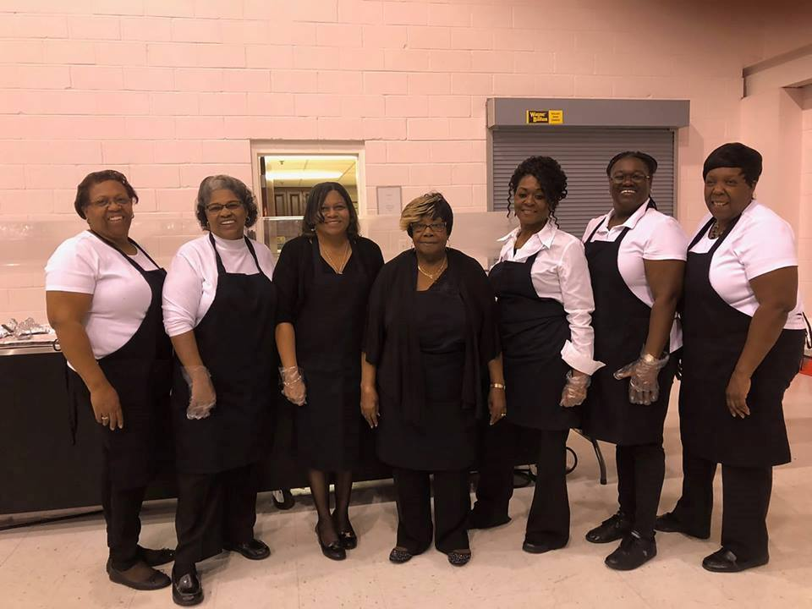

The family of the late Alex Clark expresses sincere appreciation to all who supported the family during his illness and home going services. Thank you.

MONEY ENERGY SAVING TIPS
(Copied from The Voice 2007)

Home heating prices are up. Tips below will help you keep some of your hard-earned money, as we will still experience cold weather for two more months.
- Turn your thermostat down several degrees when leaving the house for an extended time.
- Be sure your water heater is in good condition and keep the temperature down between 115-120 degrees.
- Limit your time in the shower and use cooler water.
- Turn off lights when you are not in a room.
- Shut the doors to rooms you do not use—including closets.
- Use your smallest oven or burner when cooking. Use crock pots and the smallest burners.
- Seal your home for air leaks.
- Clean and/or replace your filters often.
- Turn off the water while brushing your teeth.
- Keep the doors of the refrigerator and freezer closed as much as possible.
- Cook two or three meals when using the oven. Use one and freeze two for days when you are tired or don’t feel like cooking.
- Select the appropriate levels of water for washing clothes.
ENERGY SAVING TIPS FOR YOUR CAR
- Check tire pressure often—under inflated tires causes increased wear and decreased gas mileage.
- Go easy on the brakes and gas pedal. Reduce time spent idling.
- Unload the junk from your trunk. Extra weight uses more fuel.
- Get regular tune-ups and scheduled maintenance to increase efficiency and to prevent a breakdown on the road.
- When practical, carpool, take the bus or walk
- Consolidate trips. Make a list and pickup items from the store on your way to or from work or meetings.
Cold months of winter will provide time to rediscover the joys of reading or cooking. Turn down the heat and bake an apple pie, chocolate cake, or consolidate your pictures and make a collage.
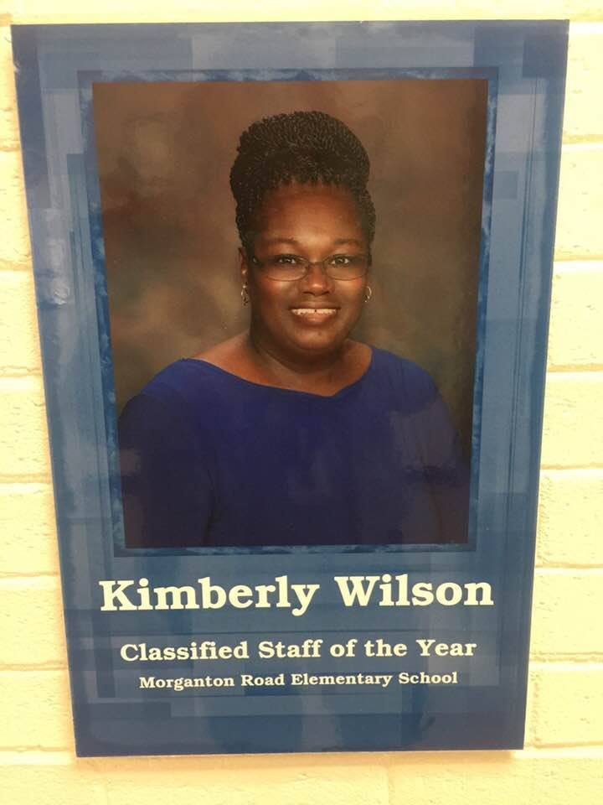
Kim is the Classified Staff of the year at Morganton Rd Elementary School for 2018 - 2019 school Year. I work in Kindergarten and drive a bus. Kim has been working at this school for three years.

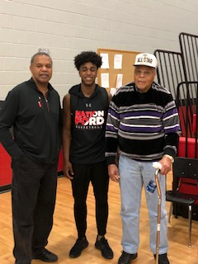
Great Example
Any time and any place is the right time to read

African American Read-Ins are held across the nation in February

Proverbs 22:6

Train up a child in the way he should go: and when he is old, he will not depart from it
Zeb Graham
South Carolina Basketball
Association announced Zeb T. Graham, Jr. of Nation Ford High School 5-A Player of the Year. Zeb excels on the court as well as in the classroom with a 3.6 GPA. He is a 1000 point scorer accomplished during his Junior Year, 3x region player of the year, and currently ranked number 5 in the state of South Carolina. Graham has college scholarship offers from Hampton, Presbyterian, and USC Upstate just to name a few. Zeb is the Great-Great Grandson of the late Alex and Daisy Clark, Grandson of Zebedee Graham, son of Zebedee T. Graham.
Three Generations of Zeb Graham

Big Zeb has been a member of our Church for more than 60 years. Andrea Graham

PROVERBS 4:6-7
Do not forsake wisdom, and she will protect you; love her, and she will watch over you.
The beginning of wisdom is this: Get wisdom. Though it cost all you have, get understanding.

Picture copied from Facebook.

Challenge: Set a goal and work to earn your dreams. You can do it!
Young Adult Day, Fourth Sundays

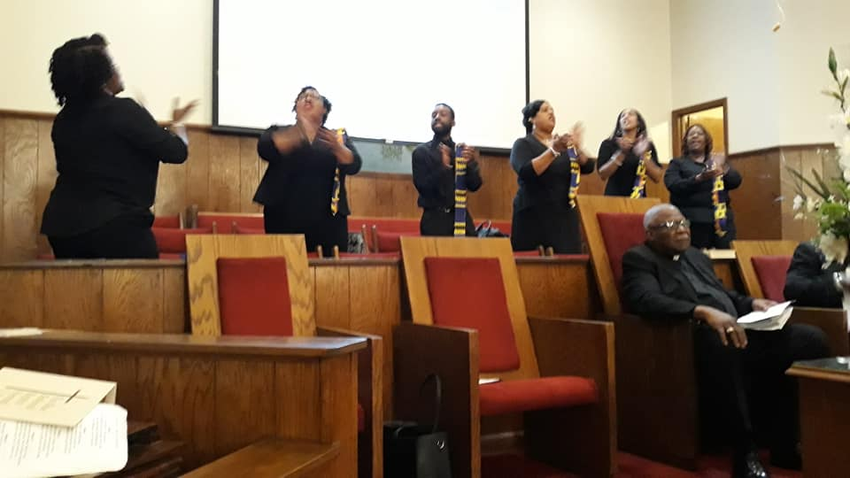
`
EACH WEDNESDAY
NOON – 1 P.M.
COME, LEARN AND GROW WITH US

--------------------------------------------------------------------------
HOKE COUNTY
FRIENDS OF THE LIBRARY. BOOK SALE March 14-16, 2019.

To Be Black
To be black is an amazing thing, and also a struggle.
They look at me funny, they look at me wrong,
They judge me before getting to know me,
And I know if they knew me they would love me.
They scream at me in anger because they don’t know,
That I am just as intelligent as them, as I say so.
They, the other races, can’t compare to my black,
For when I look in the mirror, I am looking back.
My father that sits high on his throne,
Said I am made in his image and this is known.
I will stand proud of my color and let it show,
For black is always more beautiful than snow.
My black will shine from the inside out,
You will know I am great without a doubt.
To be black is just such a blessing you see,
For everyone else wants to be like me.
We created so many things we don’t get credit for,
So when you see me know that my ancestors fought,
For me to be where I am and to be much more.
I am living history that my black is beautiful.
To be black, is to be me, and to be the best person I can be.
Ligeia Robinson

Teach a child to grow at least one vegetable. Pass on information they can use.

Children who play in dirt are not sick as often as others. This picture shows happiness of a child in Africa; however, we can help children in America learn to grow food.
The results of long-term cell phone use!

Question: What can go all around the world while staying in one corner? ____________
Greg ‘Amene’
Sports Commentator for
Alpha Academy
Greg, Jr. is an avid fan of almost all kinds of sports, even watching NASCAR racing with his grandfather, Robert Owens, Sr. This year, he was chosen as one of the Basketball Commentators for his school, Alpha Academy where he is a fifth grader. In between practicing for his own Parks & Recreation team, playing on Saturdays, keeping up his academics, he could be found at the Mic on Tuesday evenings announcing the game and running commentary on the games. This has been a busy school year for Greg in that along with his busy schedule, he was once again inducted into Alpha Academy STEM Honors Academy. To remain in the Honors Academy, they must qualify each year. This will be his third year in the STEM Program.
Mount Pisgah Marriage Ministry Valentine’s Celebration
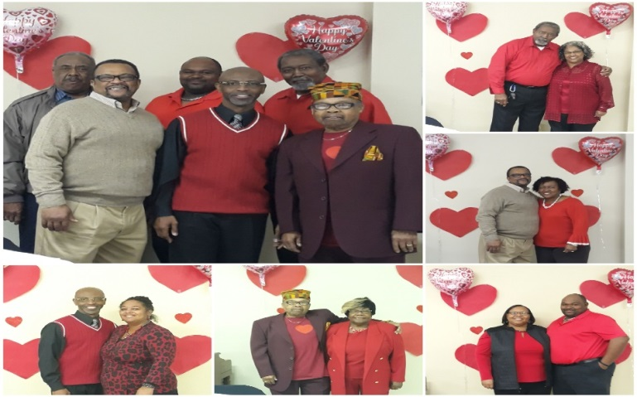
What God has put together, let no man put asunder!” The Marriage Ministry of Mount Pisgah recognized Valentine’s weekend with a Celebration of Marriage on Saturday, February 16, 2019 from 2:00-4:00 p.m. It was a lot of fun, fellowship, and sharing with each couple telling a little something about themselves and how long they had been married. Deacon Willie McNeill and Sister Ellen McNeill have been married the longest (53 years) with Brother Ricky and Deidre Hadley being the newly-weds in the group. Sister Deidre coordinated the celebration with posted Scriptures, games and activities and closed out the event with a delectable spread of heavy horderves.
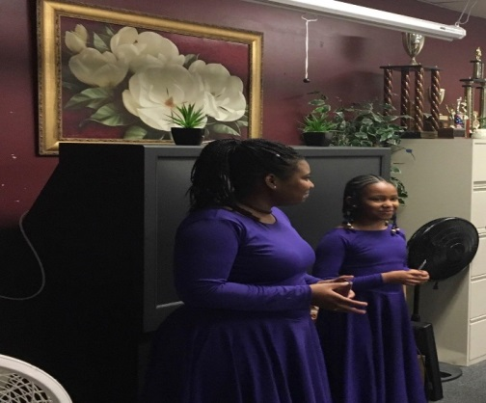
MOUNT PISGAH PRAISE DANCERS
AT FT. BRAGG BLACK HISTORY PROGRAM

Two of Mount Pisgah’s Praise Dancers, Jaiden Pittman and Zamiah Robinson, were invited to dance at the Black History Program at 82nd Finance Division at Gavin Hall, Ft. Bragg, North Carolina. The invitation was unexpected but both girls quickly said yes, and to all accounts, represented their church and families exceptionally well, dancing to Our God is an Awesome God. Ms. Massenberg picked up both girls from their respective schools, transporting them to and from the event. After the program, they enjoyed a Soul Food Feast before going back to school and both girls each, received a $25 MasterCard Gift Card. Congratulations girls for a job well done and for helping to promote the name of Jesus for others to see!

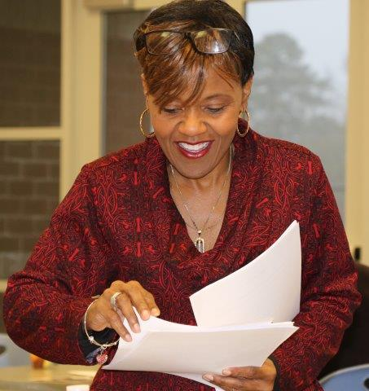
WOUNDED HEALERS

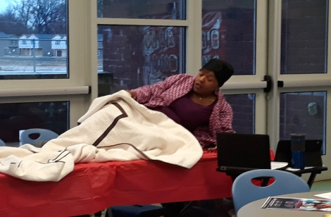
On Saturday, February 16, 2019, Dr. Adrienne Monroe gave a presentation to Fayetteville Cumberland County Ministerial Council on: Wounded Healers, Leading While Bleeding. Note, Dr. Monroe began with a dramatization of a tired pastor going to bed only to wake up next morning still tired and exhausted. Even before getting out of bed, she looks at her long to do list which includes 8 appointments, a hospital visit and more; then, she awakens her kids to begin mommy duty. From there she shares how pastors are often viewed as infallible and super heroes when in fact, they hurt and bleed like everyone else. Sometimes while soothing others, their own lives are broken and crumbling, trying to be healer for others while neglecting their own mental health. Grim statistics show increase in pastoral suicides and divorces. Pastors and ministers must acknowledge vulnerability and also seek help. At the same time, churches and families must refrain from making depression, mental illness, and other stressors a stigma. Blacks, possibly more than any other race, associate “shame” with mental illness. She gave the example that if your child needed insulin, you’d give it to him but because of shame/stigmas associated with some illnesses, same parent would not give their child mediation for ADHD. She encouraged pastors and ministers to help lead the cause in fighting in promoting health and healing for the whole person, mind, body and soul.
. Rev. Mary Owens, Christian Education Director
New Living Translation, Matthew 11:28
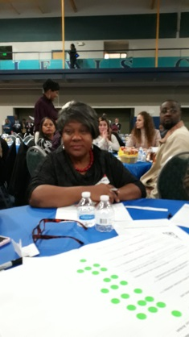
Then Jesus said, "Come to me, all of you who are weary and carry heavy burdens, and I will give you rest.
Dr. Marvin Connelly Developing a Strategic Plan for
Cumberland County Schools

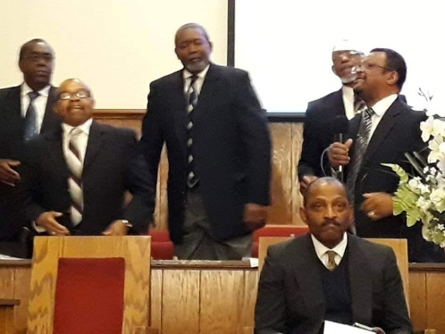
.Dr. Marvin, Superintendent for Cumberland County Schools (CCS), recently presented his First 100 Days to the Community and to the Cumberland County Board of Education. Within that 100 days,

Dr. Connelly visited all 87 schools in the district, completed 30 speaking engagements, and participated in 60 meetings within the community, including his CLC3 Tour (Connelly Listening to Cumberland County Citizens). From those meetings, he gathered information that led to the creation of a team for developing Cumberland County Schools Strategic Plan for covering the next five years. The Strategic Plan Team is a diverse group composed of persons from the community, with representatives to include parents, students, educators, government, faith community and more. Reverend Mary Owens, former President for FCCMC, was selected as the representative from the Faith Community. The process started with a Town Meeting held Thursday evening, 6:30 p.m. at the Fuller’s Center with more than 100 community members present along with Dr. Connelly and CCS members representing all levels within the system. CCS seems to be off to a very positive direction under Dr. Connelly’s leadership.

The Male Chorus Singing with Joy

The group may be small in numbers; but is large in the Spirit of the Lord. Happiness is shown in their faces as they share their love of God through songs.

IT IS TAX TIME

If you receive a large refund, pay 10% tithe, 10% to saving and pay off all bills, if possible.
- Pay your rent or mortgage ahead 2 or 3 months; this will help you if you have any large unforeseen bills, such as need a set of tires, car repairs, plumbing or electrical repairs, etc.
- Do not ask for an immediate refund which costs too much money. File electronically and wait for the money to go into your account or the check come to you in the mail. That extra money benefits the company filing your taxes and costs too much.
- Do not go and buy more things unless you are debt free. Plan and use your money wisely.
- Uncle Sam is going to get his money, so keep as much of yours as you legally can, and use it wisely.

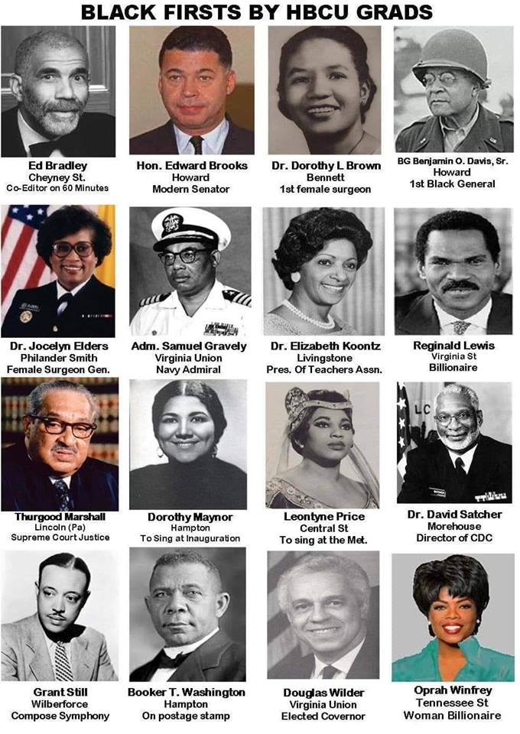
What does HBCU mean? Without looking at the list, are you able to name five HBCUs along with the city/state of locations?

Answer to riddle on page 5: A postage stamp!
- On a hill far away stood an old rugged cross,
The emblem of suff’ring and shame;
And I love that old cross where the Dearest and Best
For a world of lost sinners was slain.
  - Refrain:
So I’ll cherish the old rugged cross,
Till my trophies at last I lay down;
I will cling to the old rugged cross,
And exchange it someday for a crown.
- Oh, that old rugged cross, so despised by the world,
Has a wondrous attraction for me;
For the dear Lamb of God left His glory above
To bear it to dark Calvary.
- In that old rugged cross, stained with blood so divine,
A wondrous beauty I see,
For ’twas on that old cross Jesus suffered and died,
To pardon and sanctify me.
- To the old rugged cross I will ever be true;
Its shame and reproach gladly bear;
Then He’ll call me someday to my home far away,
Where His glory forever I’ll share.
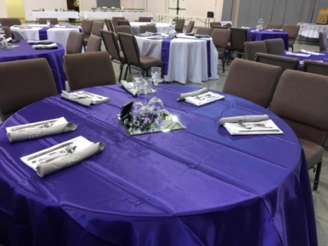
Wanted Volunteers to aid in the work of the Community Resource Center

Help is often needed to setup and take down after events. Contact the CRC Volunteer Mrs. Sandra Lambert and let her know when you are available to assist in ensuring that the CRC is clean, inviting and ready for guests.

NEWSLETTER STAFF
emcneill1005@aol.com

Sister Ellen McNeill, Editor 910-875-3237
Reverend Mary C. Owens 910-670-5662
Deacon Joseph Johnson 910-425-3709
Sister Melissa McAllister 910-308-6067
Sister Marie Daniel 910-875-5146
Sister Denise Wallace 910-257-1678
Dr. Adrienne Monroe 910-583-3693
Sister Pam Shaw 910-229-2500

Greater love hath no man than this, than to lay down his life for his friends. John 15:13 KJV

