The Voice
Mount Pisgah Missionary Baptist Church, 414 Pittman Grove Church Road, Raeford, NC 28376
Telephone 910-875-7544 Fax 910-875-0053
Website: mountpisgahmbc.com email: mtpisgahraeford@gmail.com
102nd Edition July-August 2019
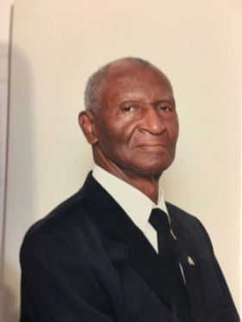
----------------------------------------------------------------------------------------------------------------------------------

Dr. Samuel Norman, Sr.

2ndTimothy 3:1-7 NIV
But mark this: There will be terrible times in the last days. People will be lovers of themselves, lovers of money, boastful, proud, abusive disobedient to their parents, ungrateful … Have nothing to do with such people.

As we have been studying the early church in the Book of Acts, it is time to be serious about our walk with Christ. Each adult knows what is right and what is wrong. Each one knows the responsibility to teach those things to our children and other youth. The Gospel of Jesus Christ tells the good news. In spite of who some are, we are free to serve Christ, who is our hope. It is our duty to teach others and to win souls for Christ.

It is believed that Luke is the writer of Acts. In the second chapter, Peter boldly tells the people that the prophet Joel had spoken “In the last days God says I will pour out my Spirit on all people, Your sons and daughters will prophesy, your young men will see visions, and your old men will dream dreams.” The story continues as instructions are given to believers. The Word to us today is a reminder that we are to pray and allow the Holy Spirit to work within us. He will strengthen the church. Brothers and Sisters continue to pray that God is worshipped and that the Holy Spirit guides us and Jesus saves us. As in the early church, we must rely on the Godhead for all of our strength, wisdom and knowledge as we strive to do God’s will. To know God’s will, we must study and prepare; therefore, we need to take advantage of each opportunity to be in Prayer Meeting, Bible Study and Sunday School. No one can learn too much from the Book of Wisdom. My challenge is, I’ll see you in the various classes as we learn more about God and His Will.

“Do your best to present yourself to God as one approved, a worker who does not need to be ashamed and who correctly handles the word of truth.
2 Timothy2:15 NIV.

Trustee John A. (Jake) and Reverend Vina Clark Celebrate their 50th Wedding Anniversary

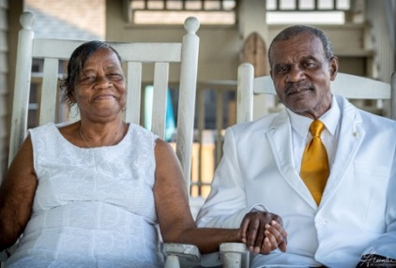
John "Jake" and Vina (McGill) Clark were married in Raeford, N.C., June 14, 1969. They met while attending Upchurch High School.
In their 50 years together, they were blessed with 3 daughters, 2 sons, 20 grandchildren, and 5 great grandchildren. They celebrated their anniversary with a vowel renewal celebration and beach retreat given by their children and grandchildren. The beach front ceremony was held in Folly Beach (Charleston), South Carolina on Saturday, June 15th. Reverend Kimani Wright was the officiator.

Congratulations Ellen Ross

Math Teacher at HCHS, Ms. Ellen Ross, has been selected to participate in the North Carolina High School Mathematics Master Teacher Fellows Program at North Carolina State University.

Ellen regularly attends worship services and Bible Study as her time allows. She is valued by those who know her. We are very proud of her achievements.

Congratulations Sister Ross! May God continue to bless and keep you. Page 1 of 8

GIVE THANKS FOR THE
90 PERCENT
(Copied from The Voice July-August 2003, 8th Edition
You have $100 in your bank account, and there is a person who needs financial help, would you be willing to give this individual $90 and keep the $10 for yourself? God does better than that for us! First, it be understood that God owns everything, including your last $100 in your bank account.

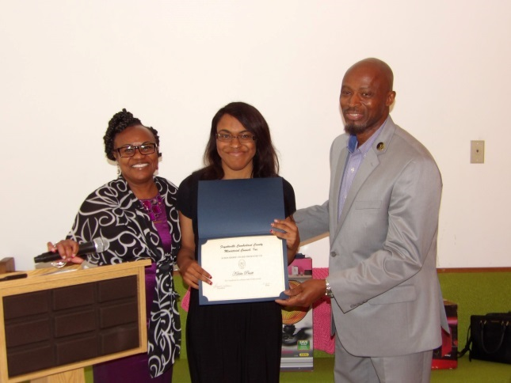
When God blesses you with a job, he owns the job and blesses you with the pay you earn. He also owns the pay that you earn. Yes, God owns us too! He can set the rules (and there are certain rules he established). However, because of God’s nature, He will not force us to follow His rules. We must freely choose to obey. We receive the entire $100, but first must give back $10 to God. Remember He owns the whole $100. We have freedom to choose how we use the other $90.
Written in 2003 by Deacon Joseph Johnson

Editor’s note: I have a copy of each newsletter printed by Mount Pisgah Missionary Baptist Church. Every now and then I open the notebooks and look at past editions; therefore, other articles from past editions will be repeated in future newsletters.

PLEDGE OF ALLEGIANCE

I pledge allegiance to the flag of the United States of America and to the Republic for which it stands, one Nation under God, indivisible, with liberty and justice for all.” The pledge was approved June 22, 1942; however, it was first published in 1892 to celebrate the 400th Anniversary of the discovery of America. The phrase, “under God” was added to the pledge as an Act of Congress June 14, 1954.

My two-cents worth of information follows. I salute the flag and what it represents; however, I also support Colin Kapernack in what he is doing. Kneeling is a form of respect. I read that some veterans suggested that he kneel, after all that is what military personnel do when they present the flag to deceased family members. With the 4th of July (Independence Day), we can choose what we wish to do. I will stand with my hand over my heart and repeat the Pledge at the Veterans Memorial Service on the holidays at the Court House in Hoke County, if the Lord allows. I invite you, too, to be there to honor those who gave the ultimate sacrifice, and others who served our country, but have gone to their days end reward. Think and pray on this.

KRISTA PRUITT
FAYETTEVILLE/CUMBERLAND COUNTY MINISTERIAL COUNTY RECEIPTANT 2019

LEBRON JAMES AND FAMILY

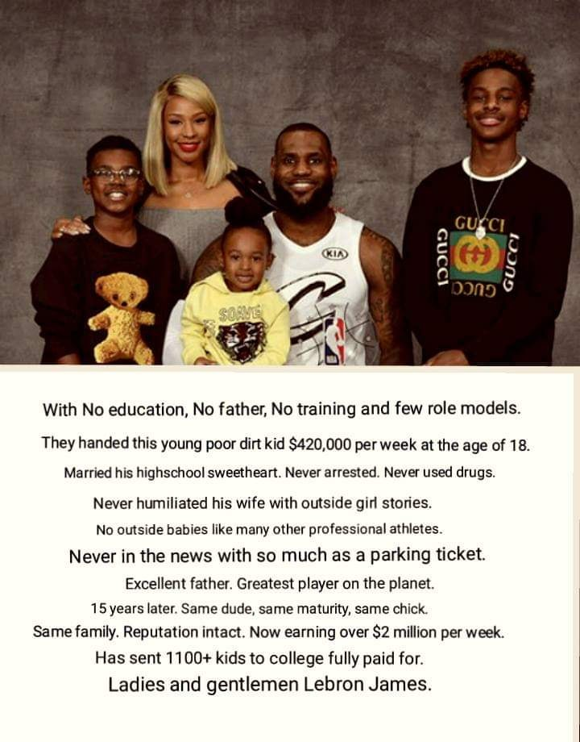

“Let the peace of Christ rule in your hearts, since as members of one body you were called to peace. And be thankful.” Colossians 3:15 Page 2 of 8
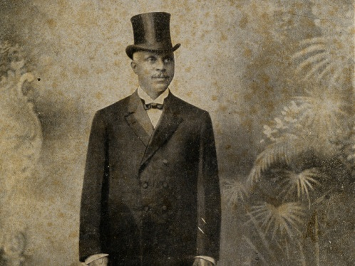
GEORGE EDWIN TAYLOR
(Information copied from Facebook
First African American to campaign for President of the USA

Despite what you read in some history books — such as the Biographical Dictionary of Congressional Women — Rep. Shirley Chisholm (D-NY) was not in 1972 the first African-American candidate to run for president of the United States. In 1904, George Edwin Taylor — often forgotten in the discussion of black American political pioneers — ran for president as the candidate of the National Negro Liberty Party, sometimes known as the National Liberty Party.

Son of A Slave
A journalist by trade, Taylor — who lived in Iowa — attained distinction, according to the Tacoma, Wash., Times on Aug. 17, 1904, as a leader in the Republican National Convention of 1892, "to which he was an alternate delegate-at-large from his state. The next campaign he was delegate-at-large to the Democratic convention."

In 1904, 36 states sent representatives to the Liberty Party Convention. According to the Times, the party denounced the Democrats' disenfranchisement of black Americans. It questioned Theodore Roosevelt's fidelity to African-Americans and it stood for "unqualified enforcement of the constitution," reparations for ex-slaves and independence for the Philippines.

The candidate Taylor, the paper announced, was one of a dozen children whose father was a slave and his mother was born a free person in the South. "When his mother died," the paper notes, "young Taylor was left a waif and slept in dry goods boxes. He finally drifted north and attended the Baptist academy at Beaver Dam, in Wisconsin. Feeble health and an exhausted pocketbook caused him to leave school within a year of graduating."

Therefore take up the whole armor of God, that you may be able to withstand in the evil day, and having done all, to stand. Ephesians 4:13
PREPARE FOR HURRICANE SEASON
Atlantic hurricane season officially started June 2, 2019.. Ensure you are prepared by taking these steps:
• Create an emergency communication plan with your family.
- Build an emergency kit;• buy or renew flood insurance (standard homeowners insurance does not typically cover flood damage).

To learn more about protecting your home, visit Know your evacuation routes and sign up to receive alerts.#ReadyNC #SevereWX
An emergency supplies kit is simply a group of items your family may need in or after an emergency. You most likely have the items around the house. You just need to put them together in a box.
- Water - 1 gallon per person per day for 3 to 7 days
- Food – non-perishable and canned food supply for 3 to 7 days
- Battery-powered or hand crank radio and National oceanic and Atmospheric Administration (NOAA) Weather Radio with extra batteries
- Cell phone with charger
- First aid kit and first aid book
- Flashlight and extra batteries
- Manual can opener for food
- Anti-bacterial hand wipes or gel
- Wrench or pliers to turn off water
- Blanket or sleeping bag – 1 per person
- Prescription medications and glasses
- Seasonal change of clothing, including sturdy shoes
- Toothbrush, toothpaste, soap, feminine supplies
- Extra house and car keys
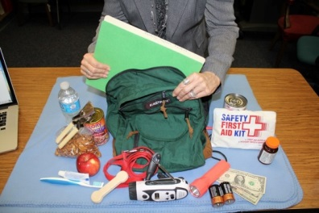
- Important documents – insurance policies, copy of driver’s license, Social Security card, bank account records
- Fire extinguisher
- Cash and change
- Books, games or cards
God is not the author of confusion, but of peace, as in all churches of the saints. 1 Corinthians 4:13
Page 3 of 8
Blue Jay on the Bell at the Church –

Picture June 3rd by Sister Kim Hadley
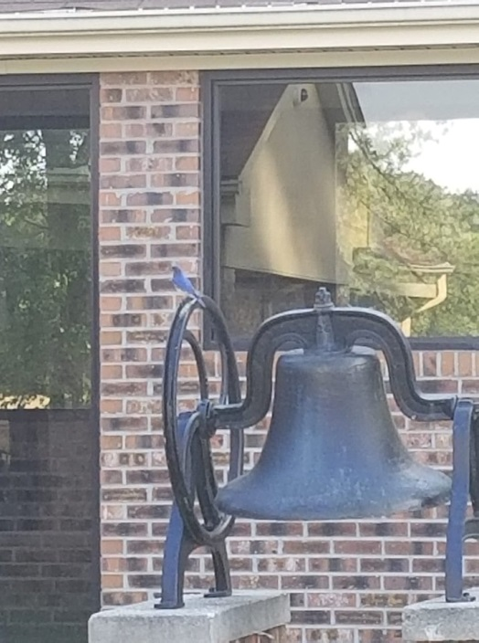
Years ago, the bell would be rung to announce services, a funeral or anytime the congregation needed to gather at the Church. The bell was on top of the old church and is a part of Mount Pisgah’s history.

WMFA RADIO STATION 1400 AM
A BLESSING IN HOKE COUNTY
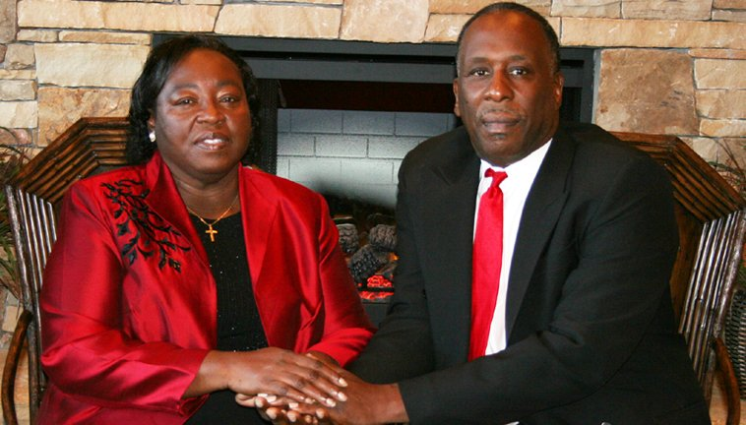

WMFA Radio Station is a rare jewel in Hoke County. Over the years Deacon Hollingsworth, his wife and family have served the community with news, announcements, Gospel music and other entertainment.

Too often we fail to recognize those who serve. This tribute is to let the Hollingsworths and others know of the service they render to Hoke County. We are blessed to have a radio station—and one that is minority owned, representing us, is an extraordinary benefit.

Congratulations Deacon Hollingsworth, Elder Hollingsworth and Family. We love you and thank you for the service you provide. We pray God’s blessings on you.

Hoke County Seniors Participate in Elder Walk
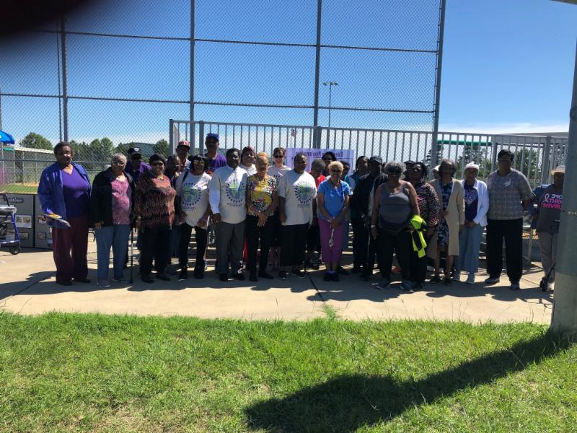
Representative Pierce participated in the Elder Abuse Awareness Walk at the Pembroke Complex Park. The other participants shown were from Hoke County Senior Center.

A Book of Puzzles can add hours of pleasure
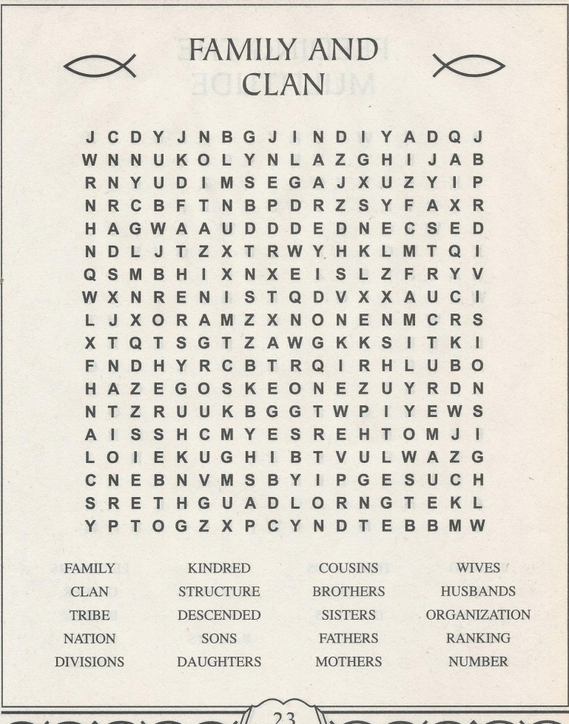
And the most important piece of clothing you must wear is love. Love is together is what binds us all perfect harmony.
Colossians 3:14 NLT

A wise man will hear and increase in learning, and a man of understanding will acquire wise counsel.
Proverbs 1:5 NASB
Page 4 of 8
Mount Pisgah Summer
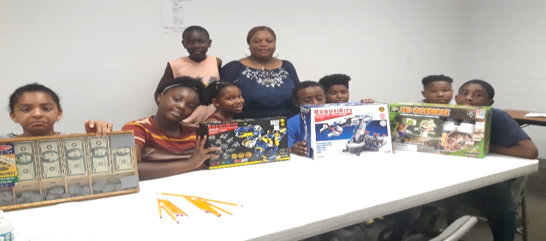
Enrichment Camp

For several years, it had been a vision of some members to sponsor a summer camp ministry. Because of various circumstances, it never manifested until now, the summer of 2019, exactly six years from when the seed was first planted. God, in His wisdom and benevolence, allowed the vision to finally come to fruition by opening doors and sending willing, helping hands to get the job done.

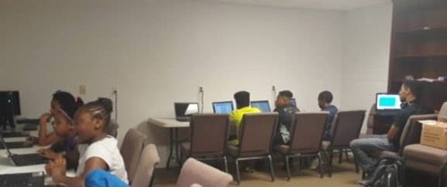
The purpose of the camp is manifold. First, it is to provide affordable summer placement for children whose parents must work but cannot afford exorbitant prices. Second, it is to help children retain the learning they acquired the previous school year. Education statistics say that students lose 25-30% of their learning over the summer. This is called the summer slide. By the time students reach middle school, they will have lost the equivalent of 2 years of learning to summer slide.

Mount Pisgah summer program includes an academic component composed of Reading/Social Studies, Math, and Technology, with some STEAM components. From 9:00-11:00, students engage in interactive academics supported by technology and teacher-guided instruction. Students have use of a Computer Lab with 13 new computers through the sponsorship of two church families, community friends, and especially H4 Enterprises, LLC which donated 6 computers.
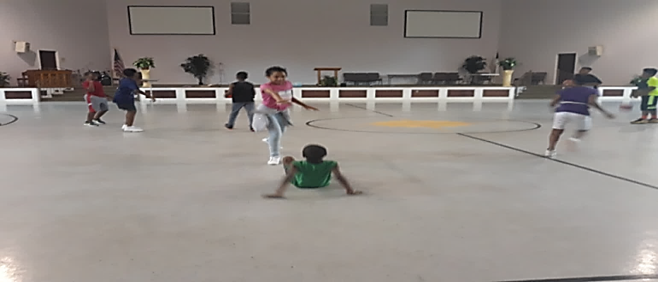
A fitness component is also integrated into the curriculum because one of the major health indicators in Hoke County is Juvenile Diabetes and Youth Obesity. Students participate in a daily walking challenge and weekly Nutrition demonstrations from Hoke Cooperative Extension on healthy but delicious treats. The Grand Champion Walker at the end of the summer receives a Fitbit watch.

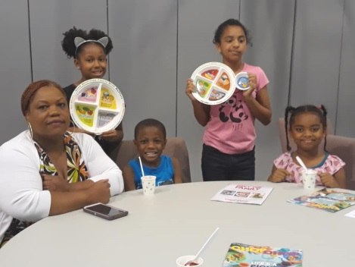
The camp opened Monday, June 17th with 15 students. The day begins at 8:00 with prayer and Pledge of Allegiance, followed by an early morning walk while waiting for the arrival of breakfast, which is served daily, as well as lunch through the Hoke County Schools Child Nutrition Services. We praise God from whom all blessings flow.

The Cooperative Extension Office Staff Teaches “My Plate”
The Enrichment Camp is provided in a clean and safe environment. The first week was a success. There is still time for young people to come to camp and learn.

Students from Camp Enjoy an Outing at the Splash Pad , Hoke County Park Complex, Highway 211
He will yet fill your mouth with laughter and your lips with shouts of joy. Job 8:21.
Page 5 of 8
Congratulations to the graduates 2019
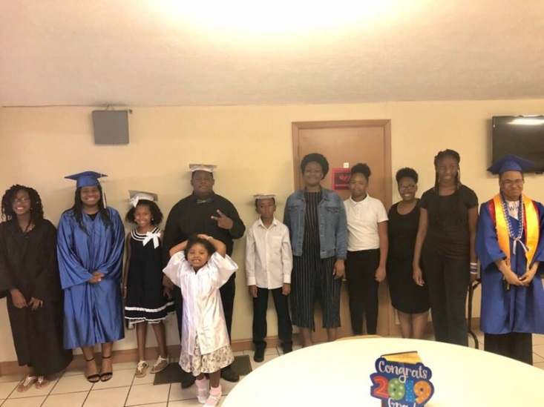
Graduates from Kindergarten through College were recognized on the second Sunday in June. It is always impressive to see the graduates march in wearing their school colors, caps and gowns and scarves.

Darryl Shaw, Jr., Graduated from two schools @ UNC Chapel Hill on the 11th of May
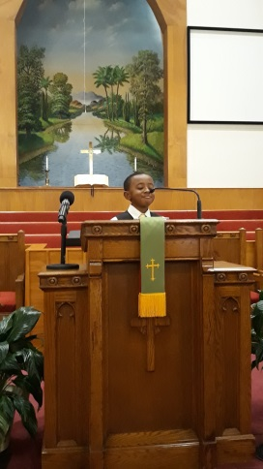
DJ is congratulated for graduating in four years with degrees from two of the UNC Schools. Additionally, he was on the track team. DJ, a quiet and modest young man, always gives credit to Jesus for his successes. His parents, grandparents and other family members are thankful to God for his achievements.

Gregory Keith Owens, Jr. Places 3rd in UMBA Oratorical Contest

The UMBA Congress of Christian Education held its Annual James F. Wertz Oratorical Contest on Saturday, May 4, 2019 at First Missionary Baptist Church, Moore Street in Fayetteville, NC. Students from local churches in our Association gathered with a mixture of confidence, nerves, and real fear. More than 20 youth participated in the Contest in four different divisions. Gregory (Amene) participated in the Division I: Preparatory competing with students in 6th 7th 8th grades. Students, with help, must prepare and completely memorize their speeches which are 3-4 minutes long. They cannot use any notes. Amene was nervous, particularly since he and one other student were the two youngest ones in the group with the others having participated previously. His topic was The Power of Love, which he presented at our church on regular 2nd Sunday, Youth Sunday.

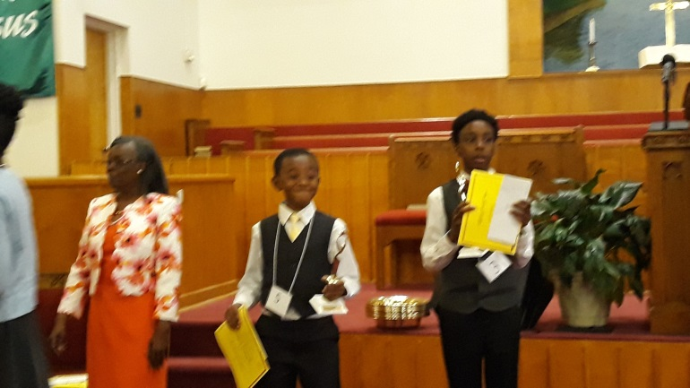

Congratulations Keith, Jr.

Noon Community Bible Study
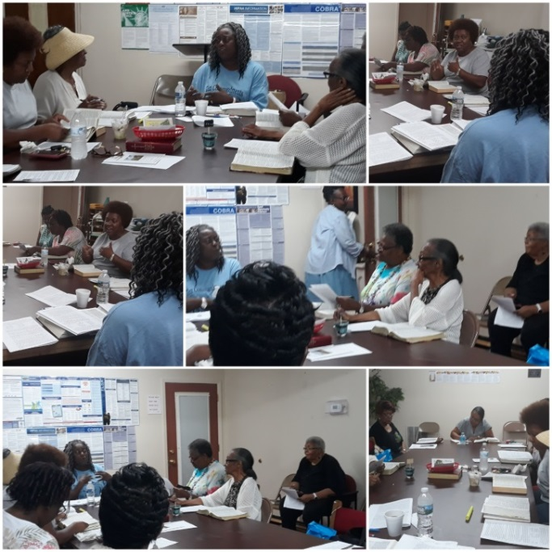
Photos by Rev. Mary Owens
The Noon Community Bible Study Class continues to grow and individuals who attend enjoy the fellowship. On the 26th of June Sister Marie Daniel taught a class on Spiritual Gifts.

11. John 4:14 but whoever drinks the water I give them will never thirst. Indeed, the water I give them will become in them a spring of water welling up to eternal life.” Page 6 of 8
AKI GOES TO THE GENERAL ASSEMBLY

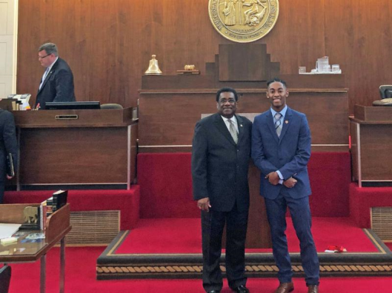
Aki Morehead a rising junior at Sandhills Hoke Early College, was selected from among hundreds of youth across North Carolina to serve as a Governor’s Page during the spring.

Established in 1973, the Governor’s Page Program gives high school students from all over North Carolina the opportunity to come to Raleigh for a week of hands-on participation in their state government. The Governor’s Page Program offers students an in-depth view of state government. During the week, pages are assigned to assist staff in the Governor’s Office. They tour multiple government buildings and historic sites during their stay including the Legislative Building, the State Capitol, the Executive Mansion, and the North Carolina Museum of History. They had opportunity to meet with government officials and discuss how state government works and how it impacts the lives of North Carolinians. This is a great honor to have been chosen, and Aki was the one of two youth, chosen from this area, to include Hoke, Cumberland, Robeson, Richmond County, Moore County, and other surrounding counties. Additionally, he was the only Black selected from across the State for the Congressional Pages and the only Black male chose for either the House of Representatives or Senate pages. Two Black females served as Senate pages.

Aki said that he was truly honored to have been selected, particularly when realizing how competitive the process is and more so, being the only Black male in attendance. Aki, as other qualified youth of Mount Pisgah, was recommended to apply. He applied under the office of Representative Elmer Floyd but actually served under Representative Garland Piece who represents this district. He and his family completed the application process and by God’s grace, he was chosen! Aki is the son of Sister Sophia Morehead, beloved nephew of Sister Shanise Hadley, and proud grandson of Deacon Marshall Hadley. They are proud, and his Mount Pisgah church family is proud. Well done, Aki!
Rev. Mary C. Owens, Christian Education Director

John 4:11 Beloved, if God so loved us, we ought also to love one another.
`SUMMER CAMP SPONSORS
Individual and Business Sponsors
“Supporting & Strengthening our Most Precious Resource, Our Children”

The Pastor and Camp Coordinators thank all persons who financially and prayerfully supported the camp. The Following Persons donated at the Gold Sponsor Level ($200 and above) for computers for the Technology Lab or Bronze Level for sponsoring campers or General Donations $50 or above. Also thanks for all donations and support.

COMPUTERS SPONSORS
H4 Enterprises, LLC. Food Lion
230 Donaldson Street 7071 Raeford Rd
Fayetteville, NC 28301 Fayetteville NC

Cunningham Funeral Home John & Vina Clark
3809 Raeford Rd.
Fayetteville, NC 28304 Alphonso & Wilhelmina
Robertson

Harry Southerland
County Commissioner Robert & Mary Owens

Calvin & Flora Hadley Willie & Ellen McNeill
Robert & Marciea Alford Darryl & Pam Shaw
Sister Marie Daniel Derrick Garner
Dangers in the home that may cause you to fall

Kitchen: Never stand on chairs or boxes to reach up in cabinets. Use a step stool. Use non-skid floor wax and immediately clean up spilled liquids, grease and food. Do not use throw rugs in the kitchen.

Bathroom. Do not grab a towel rack, shampoo holder or soap tray for support. Clean up water immediately. Install grab bars.

Bedroom: Arrange clothes where they can be easily reached. Clear clutter from the floor and have a flashlight near the bed. Place nightlights from the bedroom to the bathroom.

Living Room: Arrange furniture to create clear paths between rooms. Secure loose rugs, and keep electric cords out of the way.

Philippians: 1:3 & 4: I thank God upon every remembrance of you. Always in every prayer of mine for you all making request with joy.
Page 7 of 8
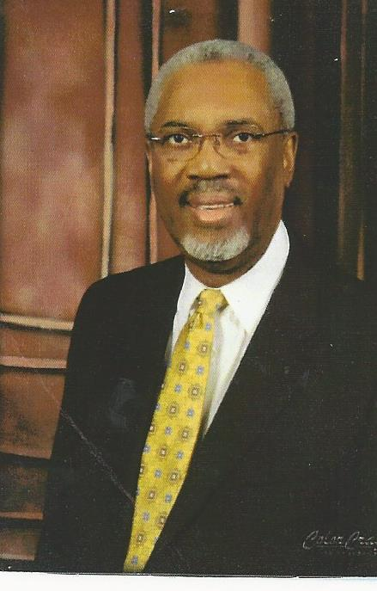
IN MEMORY OF
REV. DR. JOHN D FULLER, SR.

Few individuals make an impact on an entire region as did Dr. Fuller. In this area, he was known as the “Community Preacher/ Pastor.” He was also noted for his love of people and support of missionary work and projects. He placed his money where his heart was and helped those who were in need of help.

On a personal note, the day our Dad passed away, Dr. Fuller was at my Mom’s house quicker than I could get there. He was that type man, a preacher who loved people. Later, in the process of helping Mount Pisgah Hurricane Matthew wreaked havoc in Robeson County. He took food from freezers--his home, Lewis Chapel Church, and Mount Pisgah. He drove into the area Representative Pierce advised where help was most needed. He had to drive around washed out bridges, trees and other debris in the roadway and even places where there was only the basic of travel way to get to the people. He did it. He did not wait on others to accompany or help. Dr. Fuller pushed ahead and, he made a way to get to the people. Years earlier he had led the General Baptist State Convention to go to Princeville and help there, after a very bad storm.

From the Cumberland-Hoke region, the State of North Carolina and numerous other states in the USA, and into Africa, he was known for mission work and support of those who needed help. He was a pastor’s preacher. Many pastors sought his advice and called on him in their times of need.

More times than others know, he worked behind the scenes and helped. He supported candidates he felt had the best interest of the people and their needs. He supported education—Shaw University, Morehouse, Fayetteville State and others. Young people in school often never found out where the extra money came from so they could meet their school requirements, and he supported scholarships. Individuals who really knew Dr. Fuller know that he had a heart for giving and sharing. He received many accolades, awards proclamations, resolutions and plaques recognizing his achievements.
Editorial by Ellen C. McNeill

The steps of a good man are ordered by the LORD
Psalm 37:23
NOTEABLE QUOTE

“The Holy Spirit creates unity in the midst of our differences” From a sermon on The Holy Spirit by Rev. Dr. Howard-John Wesley.
Submitted by Sister Marie Daniel

ANNOUNCEMENTS
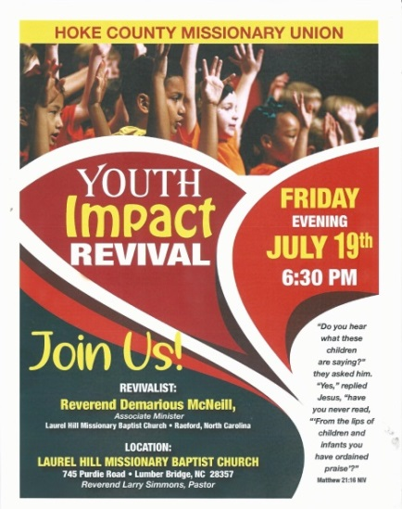

July 12 & 13 Laymen League & Boys in CRC
July 20 Men Community Fellowship
July 21 Men’s Day Ministry
July 28-31 WBH&FM, Greensboro, NC
Aug 25 Women’s Day Ministry

UPCHURCH HIGH SCHOOL ALUMNI AND FRIENDS, LABOR DAY WEEKEND. See Sister Ellen McNeill or the Church Bulletin Board for a Schedule of Events and the cost for each event. Each year Upchurch Alumni gives three $1,000 Scholarships to a student graduating from the Hoke County School System. Come one, come all and share in clean and wholesome fun.

NEWSLETTER STAFF
emcneill1005@aol.com

Sister Ellen McNeill, Editor 910-875-3237
Reverend Mary C. Owens 910-670-5662
Deacon Joseph Johnson 910-425-3709
Sister Melissa McAllister 910-308-6067
Sister Marie Daniel 910-875-5146
Sister Denise Wallace 910-257-1678
Dr. Adrienne Monroe 910-583-3693
Sister Pam Shaw 910-229-2500

Philippians 4:8 Finally, brethren, whatsoever things are true, whatsoever things are honest, whatsoever things are just, whatsoever things are pure, whatsoever things are lovely, whatsoever things are of good report; if there be any virtue, and if there be any praise, think on these things. Page 8 of 8

