The Voice
Mount Pisgah Missionary Baptist Church, 414 Pittman Grove Church Road, Raeford, NC 28376
Telephone 910-875-7544 Fax 910-875-0053
Website: mountpisgahmbc.com Dr. T. Z. McCrimmon, Pastor email: mtpisgahraeford@gmail.com
105th Edition Black History Edition January-February 2020
----------------------------------------------------------------------------------------------------------------------------------

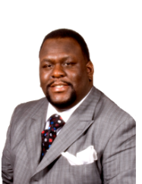
I barely graduated high school and pursuing higher education was not on my list of priorities. However, I enrolled into Sandhills Community College the Fall after graduation, merely because I felt it was the right thing to do. I honestly was not prepared for college. It was not that I did not have the capacity to learn. I simply did not apply myself. Needless to say, I had an unsuccessful semester at Sandhills. I did not continue my studies that following Spring. I felt that perhaps college was not for me. So, I decided to enter the workforce fulltime. While working, I took courses here and there, accumulating college credits. It was not until 2006 that I decided I was ready to obtain a degree and attended a small Bible college. By the grace of God, I obtained a Bachelor of Arts in Theology.

Excited about finally obtaining an undergraduate degree, I enrolled in Liberty University School of Divinity in Fall 2008. I will admit that I did not do very well the first two semesters at Liberty. It was very rigorous, and I did not do a very good job with balancing school, working fulltime, and pastoring, which resulted in me taking a few semesters off. In 2012, I decided to re-enroll in Liberty. With a determined mind, learning time management skills, and remaining focused, I obtained two master’s degrees in May 2014 and December 2015, respectfully. In Spring 2016, I was accepted into the Doctor of Ministry program at Erskine Theological Seminary. However, being more confident and wanting to prepare myself for a career in higher education, in Fall 2016 I dually enrolled in the University of Sioux Falls (USF) and Gardner-Webb University (GWU).
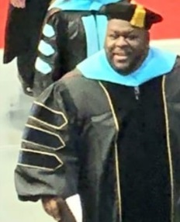
In Fall 2017, I earned a Master of Education in Adult and Higher Education Administration from the USF and in Fall 2019 I received my Doctorate in Education from GWU. Wanting to better serve my congregation, I have already resumed the Doctor of Ministry program at Erskine.

This academic journey was not easy. I had a lot of obstacles along the way, was on academic probation at one point, and had given up several times. However, with making up my mind not to be defeated, having faith in God, and surrounding myself around people who achieved what I desired to achieve, I am humbled to be Dr. Terence Z. McCrimmon today. I pray that my determination and achievement inspire someone to pursue their goals.

History Made as 2019 Year of Black Winners

The sky is the limit, set your goal and objectives for 2020 and make it your banner year. If your mind can conceive it, you can achieve it. One of my favorite quotes from Michael Jordan is, “If you’re trying to achieve, there will be roadblocks. I’ve had them, everybody has had them. But obstacles don’t have to stop you. If you run into a wall, don’t turn around, and give up. Figure out how to climb it, go through it or work around it.” 2020 is here and it is up to you to make it your best year!

THE MOUNT

Stay tuned as The Mount logo becomes better known in the church and in the community.

Praise ye the Lord!
SUMMER CHILDCARE EXPENSES AND THE DEPENDENT CARE CREDIT

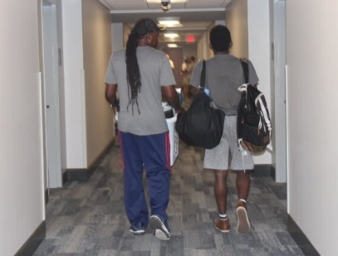
IRS Publication 503, Child and Dependent Care Expenses can be used for summer childcare and also for dependent care credit. Many families fail to take advantage of this tax credit. The Child and Dependent Care Credit may be available if you have earned income and you pay someone to care for a qualifying person while you work or look for work. A qualifying person is:
- Your dependent who is under the age of 13 or
- Your spouse or dependent who is not able to care for themselves.
Daycare, before and after-school programs, and even summer camps qualify. However, you cannot pay a school age child to care for younger brothers or sisters.

The credit amount is up to 35% of qualifying expenses depending on the taxpayer’s income. You may use up to $3,000 of unreimbursed expenses paid for one qualifying person, and $6,000 of expenses for two or more qualifying individuals.

It is worth the time and effort to go to www.irs.gov or to ask your tax preparer to determine if you qualify.

A LITTLE OF THIS AND THAT

- Get Outside: In cold weather, take a brisk walk, if snow is on the ground, help your grandchildren or someone build a snowman, don’t stop moving.
- Stretch: 15 minutes of yoga or exercise can help your flexibility and strength, and it also helps you to relax.
- Dance: Play you favorite music, and dance. You don’t need a partner, just move!
- Sing and act out “Father Abraham:” The complete child’s song will start the heartbeat rapidly moving. Yes, you may google it and let the recording sing with you.
- To Clear Your Mind: Take a 15-minute breather. Yes, meditate, rest, read, write or listen to relaxing music.
- Make a To Do List: This will help you plan and be able to mark off projects.
- Play a Memory Game: Find someone who enjoys the games you do and play.
This quote has been used for years by the NAACP and others fighting for the rights of minorities. I love seeing this by President Obama, as our young people can easily identify with him. We need more positive statements by leaders and others who have influence. However, the best influence can be made by parents, guardians, church members, teachers and friends. Use your talent, skills, and abilities to teach our young people to work toward positive goals. Commend their good work! Steer them away from negatives that can have a huge impact on their future.

AWESOME PICTURE OF FATHER WALKING HIS SON TO KINDERGARTEN AND YEARS LATER TO COLLEGE
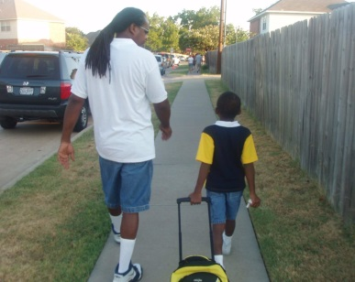
STARKVILLE, Miss. Posted in 2017 Real Father, Real Man
Charles Brockman III, an incoming college freshman at Mississippi State, shared emotional photos on Twitter to thank his father for helping him navigate through life.
In one photo, taken in 2004, a young Brockman walks next to his father on their way to his first day of kindergarten. In the other, the two are also walking side-by-side, but this time Brockman is moving into his college dormitory. "From the first day of kindergarten to college move in. Thank you dad," Brockman tweeted.

Memories of Positive Male Role Modeled

Picture of father and child reminds me of times of sickness, when our Dad would help care for sick children. My sons-in-law are all good fathers. They help care for children. They’re also in the Church. Real men help with rearing children and they continue to work in the Church.

HOKE COUNTY MISSIONARY UNION
YOUTH SESSION

The annual Youth Session will be in Mount Pisgah on the second Sunday in January beginning at 3 p.m. Everyone is encouraged to attend and to participate, especially youth. Anyone who desires to do so may wear their church, school or team shirts and/or hoodies. A short business session will be held to adopt the budget, calendar and other annual projects.

Philippians 4:6-7 ⁶Do not be anxious about anything, but in every situation, by prayer and petition, with thanksgiving, present your requests to God. ⁷And the peace of God, which transcends all understanding, will guard your hearts and your minds in Christ Jesus.

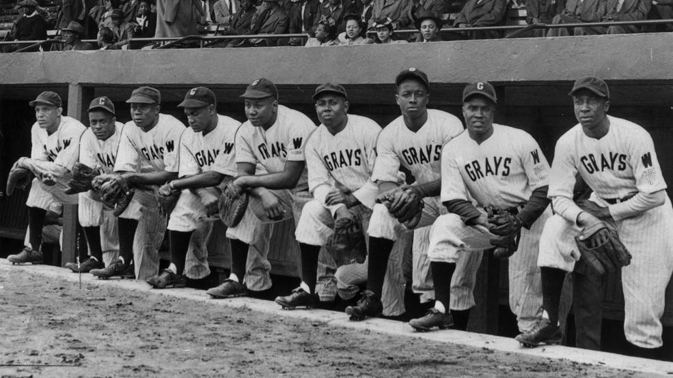
A MNI HISTORY LESSON
So you mean to tell me that someone down your ancestry line survived being chained to other human bodies for several months in the bottom of a disease-infested ship during the Middle Passage, lost their language, customs and traditions, picked up the English language as best they could while working free of charge from sunup to sundown as they watched babies sold from out of their arms and women raped by ruthless slave owners.
Took names with no last names, no birth certificates, no heritage of any kind, braved the Underground Railroad, survived the Civil War to enter into sharecropping ... Learned to read and write out of sheer will and determination, faced the burning crosses of the KKK, everted their eyes at the black bodies swinging from ropes hung on trees...
Fought in World Wars as soldiers to return to America as boys, marched in Birmingham, hosed in Selma, jailed in Wilmington, assassinated in Memphis, segregated in the South, ghettoed in the North, ignored in history books, stereotyped in Hollywood and in spite of it all someone in your family would get here and you receive one rejection, face one obstacle, lose one friend, get overlooked, and you want to quit? How dare you entertain the very thought of quitting? People you will never know survived from generation to generation so you could succeed. Don’t you dare let them down!!
Author Unknown
This is so true!!!!!! Give this to your young people who don’t know their history and want to get weak!
It is NOT in our DNA to quit!
(Copied from Facebook)
DC had a baseball dynasty in the beloved Homestead Grays.

Some people may not know about the Homestead Grays, a Negro League team that, according to the Negro Leagues Baseball Museum, won the final World Series played between the Negro National League and the Negro American League in 1948. The last time a Major League Baseball-affiliated D.C. team played in a World Series was 86 years ago. But the Grays played, and won, 71 years ago.
The Grays also played in four of the other World Series between the Negro leagues. They lost to the Kansas City Monarchs in 1942 and to the Cleveland Buckeyes in 1945, but defeated the Birmingham Black Barons in each of the other three series, in 1943, 1944 and 1948.
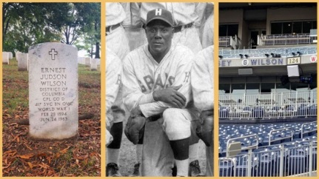
In 1948, the Grays didn't physically play their games in Washington, according to The Washington Post. The Redskins were using Griffith Stadium for their matches, so the Grays and Barons played games in Birmingham and other host cities. So a 1945 Griffith Stadium game in the series against the Buckeyes was the last time a World Series game was actually hosted in city limits. As the Nationals prepared for Game 3 of the series coming to Nationals Park November 3rd, the team acknowledged the Grays' legacy in the District Jud Wilson WWI and Negro League player was laid to rest in Arlington National Cemetery. (Copied from the Internet)

Editor’s note: Black or African American History is a part of all of the USA history. We need to learn, reach and teach about our history.
Be strong and of good courage, do not fear nor be afraid of them; for the LORD your God, He is the One who goes with you. He will not leave you nor forsake you. Deuteronomy 31:6
Letter from Frederick Douglas to Harriet Tubman
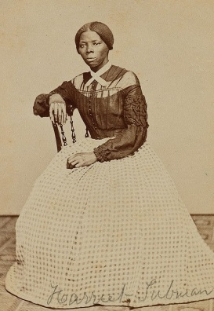
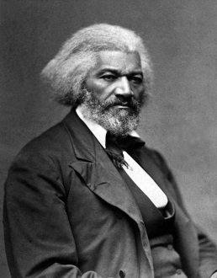
Rochester Aug. 29, 1868

Dear Harriet:
I am glad to know that the story of your eventful life has been written by a kind lady, and that the same is soon to be published. Y you ask for what you do not need when you call upon me for a word of commendation. I need such words from you far more than you can need them from me, especially where your superior labors and devotion to the cause of the lately enslaved of our land are known as I know them.
The difference between us is very marked. Most that I have done and suffered in the service of our cause has been in public, and I have received much encouragement at every step of the way. You, on the other hand, have labored in a private way. I have wrought in the day – you in the night. I have had the applause of the crowd and the satisfaction that comes of being approved by the multitude, while the most that you have done has been witnessed by a few trembling, scarred, and foot-sore bondmen and women, whom you have led out of the house of bondage, and whose heartfelt, “God bless you,” has been your only reward. The midnight sky and the silent stars have been the witnesses of your devotion to freedom and of your heroism. Excepting John Brown – of sacred memory – I know of no one who has willingly encountered more perils and hardships to serve our enslaved people than you have. Much that you have done would seem improbable to those who do not know you as I know you. It is to me a great pleasure and a great privilege to bear testimony for your character and your works, and to say to those to whom you may come, that I regard you in every way truthful and trustworthy. Your Friend, Frederick Douglass
We Ouchere
Gullah/Geechee Culture
(Gullah typically describes the culture while
Geechee describes the people.)
When most people think of the Gullah/Geechee Culture they think of the low country of South Carolina. But, did you know that North Carolina has a low country too? There are parts of North Carolina that are further south than some South Carolina Cities. North Carolina’s Brunswick Islands (just below Wilmington, NC) and Cape Fear are in North Carolina, however, they lie to the south of Columbia, the capital of South Carolina.
Geechee is a distinctive group with a strong sense of identity whose origins were formed before and during slavery. They/we retained many aspects of our African culture and speak a blended language, similar to what is still being spoken there. (Believe it or not, if you’re reading this, YOU probably speak the language without realizing. Have you ever said “Bout” instead of “About “or “Chillun” instead of “Children”?)
Just like most cultures, food plays a vital role in the community and is often the core of our tradition. Traditional gullah foods are generally a mix of both cultural and agricultural resources available to the gullah people throughout history with the diet composed of locally available items such as okra, rice, seafood, root vegetables, etc. The food is delicious but if you ask an elder for a recipe, you’re more than likely will get an answer like “ ah ‘on measur”. Our recipes are usually based on taste handed down from generation to generation and can be impossible to explain in words and must be experienced.
Until recently, the Gullah language was considered to be a broken language. I know when I listened to my own Grandmothers talk, sometimes I couldn’t tell what they were saying. But, the Gullah language is actually a living testimony to the human endurance of Africans away from home. During those times our people came from different language and culture groups and different geographical regions. But, we had an auxiliary languange that was developed on African soil, pidgin, that had been developed for the purpose of being spoken among various African groups in business transactions and intertribal affairs. Our African pidgin was mixed with American words to form what we now call the Gullah/Geechee language, a language that still exists containing African words and language features that can be traced to today’s African groups.
Talk to your elders, ask to hear about their oldest memories and listen to the words they use. You just might be a Geechee, a tradition and culture worth exploring and saving. Cause God lob all de people een de wol sommuch dat e gii we e onliest Son. God sen we um so dat ebrybody wa bleebe pon um ain gwine dead. Dey gwine lib faebamo..” (John 3:16 New Testament in Gullah, Sea Island Creole, 1st Ed ©2005, American Bible Society)
(Article contributed by Sister Vinnette Johnson)
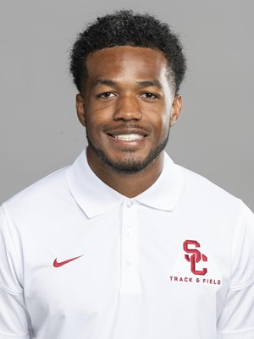
USC ARTICLE (Copied)

Redshirt senior Darryl Shaw is in his first season as a jumper on the USC track and field team. He transferred to USC from North Carolina in the Summer of 2019.
BEFORE USC Shaw did not compete outdoors as a senior at UNC and was limited to three indoor meets due to injury. He was first team All-ACC in the triple jump in 2018 and was a second team All-ACC performer three times. He set his triple jump PR of 51-8.50 (15.76m) in placing third at the 2017 ACC Championships. He set his long jump PR of 23-5.25 (7.14m) at the 2017 Virgina Challenge. He was a USTFCCCA Academic All-American and was named to the All-ACC Academic Team three times. He was a member of the UNC Student Athlete Advisory Committee.
HIGH SCHOOL: Shaw is a 2015 graduate of Jack Britt HS in Fayetteville, N.C. He was the 2015 North Carolina 4A Indoor and Outdoor State Champion in the triple jump. He also played football for three years as a defensive back and earned All-Conference honors, including 2014 defensive back of the year honors. He had a 4.6 GPA in high school and was a member of the National Honor Society.
PERSONAL: Darryl was born on January 31, 1997 at Andrews Air Force Base in Maryland...His parents are Pamela and Darryl Shaw and he has one sister, Candace Hargrove...He lists his favorite musicians as Drake and Mahalia...His favorite sports teams are the Los Angeles Chargers and the Los Angeles Lakers...He says Kobe Bryant is his sports hero because of how he carried himself and how hard he worked. Darryl is a member of Omega Psi Phi fraternity and a member of Athletes in Action...After school, he would like to produce award-winning sports pieces for ESPN, TNT, Fox, etc...He is working on a Master's of Science in Digital and Social Media.
CAREER BESTS: LJ - 23-5.25 (7.14m)TJ - 51-8.50 (15.76m)

2ND ANNUAL HOPE GALA

Embassy Suites in Fayetteville is the place to be Saturday, April 25th. Miyoshi Gordon-Matthews is presenting the Gala supporting patients with myositis and breast cancer diseases. See www.united-adivinepurposeinc.com for details. Prepare and support this worthwhile project.
Zamiah Robinson, a 6th Grader at John Griffin Middle School, received the Citizenship award for the 1st nine weeks. She also made All A’s and B’s on her progress report during this first nine weeks. Zamiah is also participating in the pep squad at her school. Go Pirates!

Congratulations Zamiah! Your immediate family and Church family are so proud of you.

Kam’ryn Lucas is a first grader at Rockfish Elementary School in Hope Mills. His teacher is Ms. Lewis. Kam received two awards in November. He was honored for having the best manners and also recognized as a Terrific Kid.

Kam loves sports and is an excellent softball player. He also enjoys helping with chores in the house and playing computer games.

Men of the Church Congratulating our Pastor
Dr. McCrimmon on receiving his Doctorate
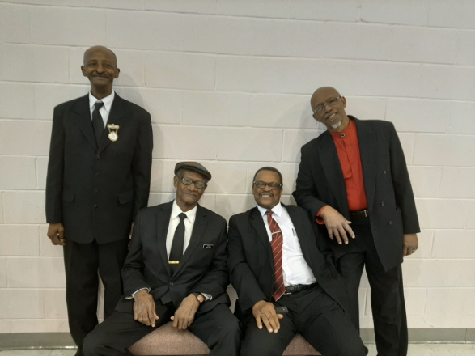
Brother Beulas Alford, Deacon Joseph Johnson,
Deacon Al Robertson, and Trustee John Monroe

It was a great celebration as the congregation fellowshipped with Dr. McCrimmon on the great achievement.

2nd Timothy 3:15-16 “And how from infancy you have known the Holy Scriptures, which are able to make you wise for salvation through faith in Christ Jesus. ¹⁶All Scripture is God-breathed and is useful for teaching, rebuking, correcting and training in righteousness.”

Lewis Chapel West shares with us in the Christmas Crafts Event

Mount Pisgah hosted its second Annual Christmas Craft Fellowship on Saturday, November 23, 2019. It is open to all members and community friends. This year, a group of about eight friends from Lewis Chapel West joined us in an afternoon of fun and fellowship.
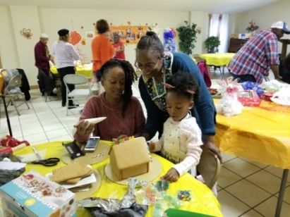
During the event, there is something for all ages, young and old. The children up to 12 years old, along with a parent or guardian, constructed gingerbread houses.
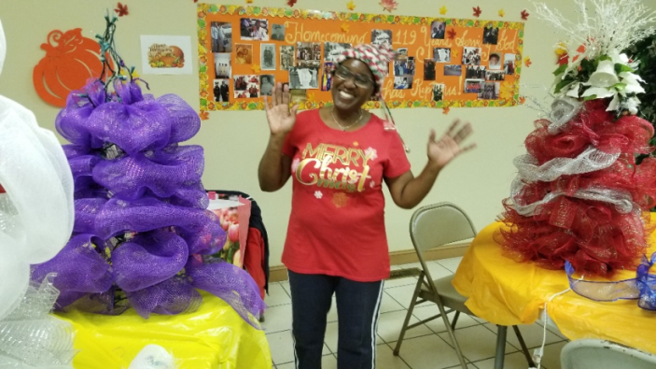
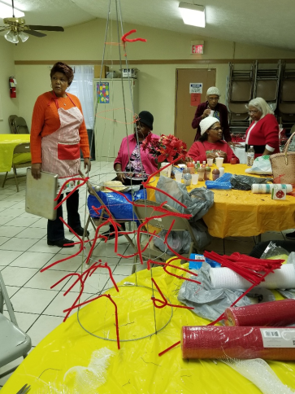
The adults, worked on various craft and decorations for the holiday such as wreathes, ornaments, and Christmas trees made from wire tomato cage frames. It was such good fun and laughter that our guests suggested we do it every month! I don’t know about that, but we discussed the possibility of coming together a few other times during the year because it did promote a spirit of community love and unity.

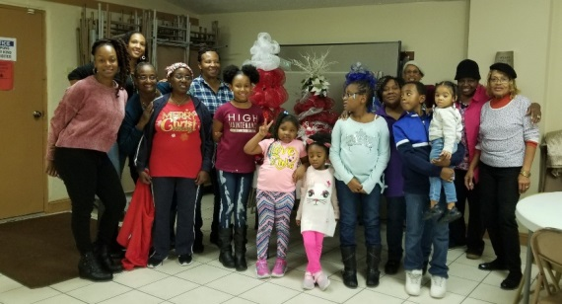
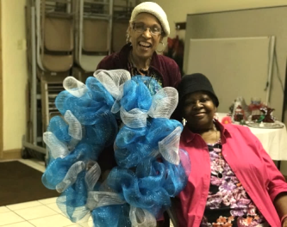
Puppy Creek Fire Department and Mount Pisgah Partnership make Christmas merry for others with Toys and Clothing Drive

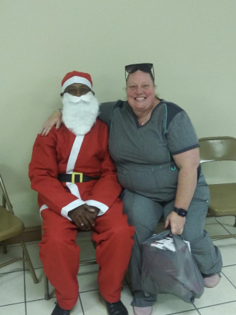
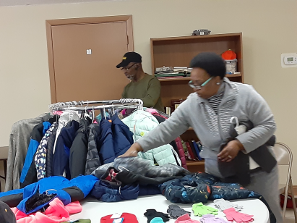
Reverend Alford, chairman, assists as Sister Deborah Carter sorted and sized coats for easier distribution.

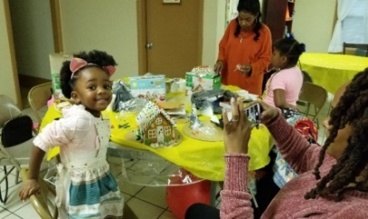
Area children were able to select toys and clothing, as Bother Beulas Alford, Santa’s helper in Raeford, presented children and adults with candy canes.
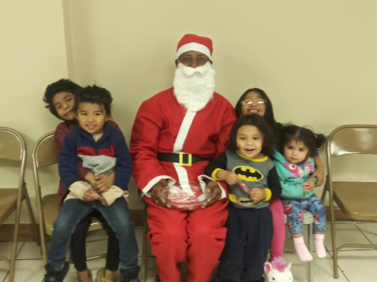
Truly, this was a community effort. Puppy Creek Fire Department collected the toys and clothing. Mount Pisgah’s members sorted, labeled and assisted individuals and families as they made their choices.

Many families left happy knowing that their children would have gifts for Christmas.
Annual Christmas Ministry
The Promise of a King
In a break with tradition, the Annual Christmas Ministry was presented on Wednesday night rather than on a Sunday evening. Surprisingly, there was quite a large crowd to see the long-awaited production of excited children, nervous parents, and adult workers putting on the program. Amid the anticipation, there was the usual anxiety over forgotten speeches, missed lines, and collapsible props, but God gave us favor and all, for the most part, went well.

The younger children, in angel robes, led the processional, singing, Joy to the World. The Junior Class, introduced our new Puppet Ministry, under the leadership of Reverend Marciea Alford. They gave us a joyous welcome performing Go Tell It on the Mountain as the puppets. Then, various children recited speeches, along with Sister Flora Hadley reciting the meaning of the candy cane. Iris Monroe and her mom, Adrienne sang a duet, and Ligeia Robinson sang an original song she had written. The final presentation was the skit, Who Could Imagine a King, performed by a broad spectrum of ages in the church from six-year old Kaleb Geiger, teens to adults of various ages. Sophia Hadley narrated the story based upon the prophetic promises of the coming Messiah. A scene within the play featured Zamiah Robinson singing the title song, Who Could Imagine a King, the Praise Team singing Angels We Have Heard on High, and a culminating performance of the Praise Dancers dancing to O Holy Night as the Christ child and Holy Family were highlighted above the choir loft of the church.
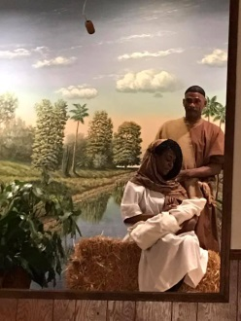
The congregation gasped in awe at beholding Brother and Sister Newson portraying Mary and Joseph with breathtaking authenticity. Well done to all the participants and to those working behind the scenes.
Reverend Mary C. Owens, CED

“This shall be a sign to you: You will find a baby wrapped in cloths and lying in a manager.” Luke 2:12

The Newsletter Staff Welcomes
Two New Members

Hello! My name is Courtnie Lutz. My birthday is September 22nd and I’m 17. I am currently a senior at Seventy-First High School. This is my 4th school in 4 years and I’m planning on graduating here. I was born in Pennsylvania and my family and I moved to North Carolina 5 years ago. I have three siblings; an older brother (24), older sister(21) and a younger brother(16). My little brother and I share a birthday, we’re considered Irish twins. My little brother is my world. I love him with all my heart.

I wasn’t raised in a Christian household. I honestly thought God hated me and the feeling was mutual. It wasn’t until a long conversation with a teacher that I accepted God into my life. It’s a constant struggle to keep believing but I do it because I know He loves me and I love him. I was baptized on May 18, 2018, (best decision of my life) A few more things about me: I write poetry, I love school and learning, I put everyone else first, I love reading (200 words per minute) and I love music-singing and just listening to it. Thank you for accepting me as one of your own. I hope to bring happiness and joy with God by my side. God bless every single one of you!
(Editor’s Note: This is Courtnie’s first article)

Mr. and Mrs. Roy Murchison celebrated their 75th Anniversary
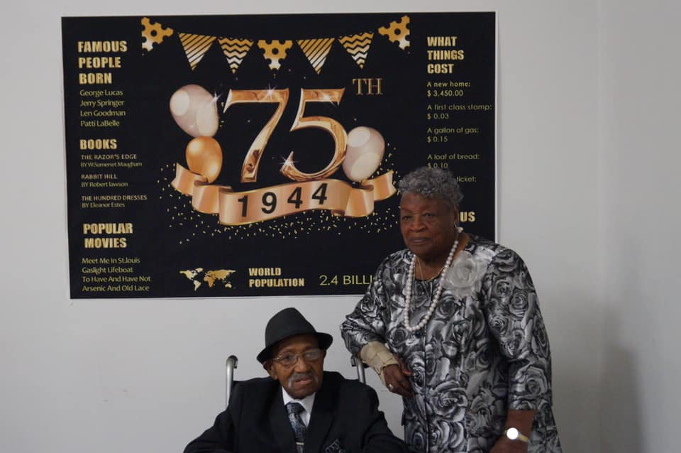

They are members of one of our sister churches, Beauty Spot. Mrs. Murchison is an active member of the Senior Citizens group that meets in the church weekdays.

We are happy to offer Congratulations and Best Wishes for many more years with good health and happiness.

1 Corinthians 13:13: And now these three remain; faith, hope and love. But the greatest of these is love.
Lift Every Voice and Sing
By James Weldon Johnson

Lift every voice and sing
Till earth and heaven ring,
Ring with the harmonies of Liberty;
Let our rejoicing rise
High as the listening skies,
Let it resound loud as the rolling sea.
Sing a song full of the faith that the dark past has taught us,
Sing a song full of the hope that the present has brought us,
Facing the rising sun of our new day begun
Let us march on till victory is won.
Stony the road we trod,
Bitter the chastening rod,
Felt in the days when hope unborn had died;
Yet with a steady beat,
Have not our weary feet
Come to the place for which our fathers sighed?
We have come over a way that with tears has been watered,
We have come, treading our path through the blood of the slaughtered,
Out from the gloomy past,
Till now we stand at last
Where the white gleam of our bright star is cast.

God of our weary years,
God of our silent tears,
Thou who has brought us thus far on the way;
Thou who has by Thy might Led us into the light,
Keep us forever in the path, we pray.
Lest our feet stray from the places, our God, where we met Thee,
Lest, our hearts drunk with the wine of the world, we forget Thee;
Shadowed beneath Thy hand,”
May we forever stand.
True to our God,
True to our native land.
(This song is often called the Negro National Anthem)

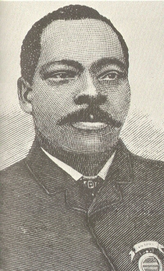
Granville T. Woods was a prominent inventor and electrical engineer who developed over 50 significant patents over the course of his life. Because of his significant electrical inventions he is known as the “Black Edison. Woods was born on April 23, 1856 in Columbus, Ohio. He attended school until he was 10 years old and then, as was typical of the era, he left school to start work. Employed in a mechanic’s shop, he developed a fascination with railroad equipment. Woods, an avid reader and astute learner, began to focus all his spare time and attention to mastering electrical engineering. At the age of 20 he enrolled in a technical college and trained for two years in electrical and mechanical engineering. After graduation, with no prominent jobs prospects in Ohio, he worked as an engineer on a British steamer which allowed him to travel the globe. Woods eventually settled in Cincinnati, Ohio where he formed the Woods Electric Company. His decision to become an independent entrepreneur stemmed in part because of his difficulty in finding work.
By 1887 Woods developed the first of his inventions, the Synchronous Multiplex Railway Telegraph which allowed communication between moving trains and train depots. One year later he developed a system for overhead electric conducting which helped power locomotives. In 1889 he filed his first patent for an improved steam-boiler furnace. Woods competed with more prominent inventors of the era including Thomas Edison who claimed invention of the multiplex telegraph and filed a lawsuit to support his claim. Woods won the legal challenge prompting Edison to offer him a prominent position in the engineering department of Edison Electric Light Company in New York. Woods declined the offer, preferring to maintain control over his inventions. Granville T. Woods died in Cincinnati in 1910. Over the course of his lifetime he held over 35 patents including a dozen for inventions which made electrical railways safer and more efficient.
(Copied from the Internet)

75 Years Ago in Hoke County – 1944
(From The News Journal Browsing the Files)

White schools will open September 7th and the Negro and Indian Schools will open October 2nd.

Editor’s note: Folks that’s a month’s difference in classroom time yet Negro and Indian children were expected to work as tenants on farms. What were they thinking? Learn your history!
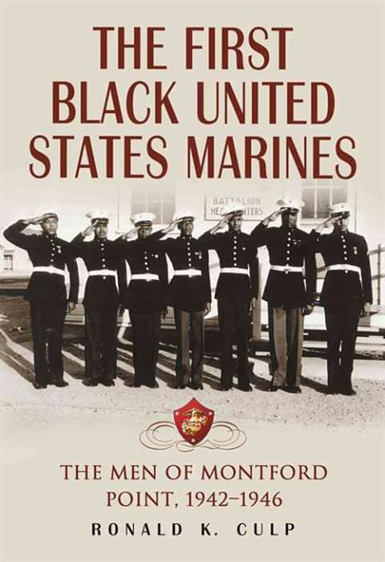
NEWSLETTER STAFF
emcneill1005@aol.com
Sister Ellen McNeill, Editor 910-875-3237
Reverend Mary C. Owens 910-670-5662
Deacon Joseph Johnson 910-425-3709
Sister Melissa McAllister 910-308-6067
Sister Marie Daniel 910-875-5146
Sister Denise Wallace 910-257-1678
Dr. Adrienne Monroe 910-583-3693
Sister Pam Shaw 910-229-2500
Sister Courtnie Lennanne Lutz 910-868-6092
Sister Vinnette Johnson 410-240-0644

